REAL-TIME STOCK MARKET WATCHLIST & ALERT SYSTEM

PROJECT REPORT
Submitted by

Group Member 1 Aditi Bajpai (24BCE0372)
Group Member 2 Arshmeet Kaur Marhala (24BCE0378)
Group Member 3 Yatharth Tongia (24BCE0825)

Prepared For

DATABASE SYSTEMS (BCSE302P) -Lab PROJECT

Submitted To

Dr. Anand Bihari

School of Computer Science and Engineering



Abstract
In financial markets around the world, the prices of instruments change every second. This is not an issue for large organizations or for people whose career is trading, but for a casual investor it is a big challenge to keep track of them. Our tool – Real-Time Stock Market Watchlist & Alert System – aims to solve this problem. By allowing users to create personalized watchlists and price alerts, we reduce the effort between keeping track of instruments and actually investing.
Our tool allows users to create multiple watchlists, each with its own set of instruments. Every price of an instrument is stored as a price tick, which contains the instrument, the observed time, the price, the volume and the data source. The user can also set custom ABOVE/BELOW alerts, which notify the user when the price crosses above or below a threshold. All price ticks and fired alerts are stored in the database, and a deterministic replay feed lets us play back recorded prices even when the market is closed.
The tool is implemented using PostgreSQL 18 as the database. We chose PostgreSQL because our schema is highly relational, with seven related tables. PostgreSQL gives strong support for keys, constraints, triggers and indexes, and it provides reliable transactions with ACID guarantees. The backend is written in Python with FastAPI and talks to the database using plain parameterized SQL.
In this third and final review we present the complete, working system. The database is fully populated and can be rebuilt from scratch with one command. On top of the Review 2 work (36 named constraints, 38 SQL queries, 10 complex queries, 3 views, stored procedures, functions, 2 triggers, cursors, role-based security and an index benchmark), this report adds a corrected ER diagram, a concurrency test with two database sessions, 221 automated test checks that all pass, the six-step live demo, and screenshots of every working module of the web application with its input and output.
Table of Contents
Contents
1. Introduction 5
2. Project SCOPE 5
3. Key Contacts and Stakeholders 5
4. Project Resource Requirements 5
4.1 Software Resource Requirements 5
5. ER Diagram 7
6. Tables and Constraints 9
6.1 Table Name : users 9
6.2 Table Name : instruments 10
6.3 Table Name : watchlists 11
6.4 Table Name : watchlist_items 11
6.5 Table Name : price_ticks 12
6.6 Table Name : alert_rules 13
6.7 Table Name : alert_events 14
6.8 All Constraints and Relationships 15
6.9 Normal Forms 16
7. SQL Implementation 19
7.1 Database Setup and DDL 19
7.2 DML: INSERT, UPDATE and DELETE 21
7.3 Constraints Rejecting Bad Data 25
7.4 Transactions (COMMIT, ROLLBACK, SAVEPOINT) 27
7.5 A. Basic Queries 28
7.6 B. Aggregate Queries 31
7.7 C. Joins 32
7.8 D. Subqueries 35
7.9 E. Set Operations 39
7.10 F. Advanced Functions 40
7.11 G. Window / Analytic Functions 43
7.12 Indexes and EXPLAIN Comparison 44
8. Advanced SQL Implementation 48
8.1 Complex Business Queries 48
8.2 Views 54
8.3 Stored Procedures 56
8.4 User-Defined Functions 58
8.5 Triggers 59
8.6 Cursors 63
8.7 SQL Security Implementation 65
8.8 Review 2 Requirements (checklist) 69
8.9 Design Changes Since Review 1 69
9. Review Requirements (Review 3) 71
9.1 Review 3 Checklist 71
9.2 Live Demonstration Flow 72
9.3 Building the Database From Scratch 73
9.4 Transactions and Concurrency 74
9.5 Indexing and Query Optimization 75
9.6 Testing 76
9.7 Working Modules of the Project (Web Application) 77
9.8 Design Changes Since Review 2 89
10. Work break down 90
11. REVIEW EVALUATION 90

Introduction
In financial markets around the world, the price of each instrument changes every second. This makes it difficult for individuals to keep track of the instruments they are interested in. Our tool allows users to create watchlists through which they can monitor the price changes of instruments, define custom rules on the price of an instrument and be notified when an event of their interest happens.
This is achieved by a database-driven monitoring approach: most of the work, such as storing prices and checking alert rules, happens inside the database, which keeps the application simple and the data consistent. Every new price enters the database through one PostgreSQL function, ingest_tick(). It stores the price tick, and a trigger on the price_ticks table then checks the alert rules of that instrument. An alert fires only when the price crosses the threshold (edge-triggered), and a cooldown stops the same rule from firing again too quickly.
For the demo we use a replay feed that reads prices from a CSV file, so the system works offline even when the market is closed. Live crypto prices from Binance can also be used, but the demo does not depend on them.

Project SCOPE
The Real-Time Stock Market Watchlist & Alert System covers the following:
- Multiple named watchlists per user; add and remove instruments; latest price for each instrument
- Price history stored as price ticks, with latest-price and history views
- Custom ABOVE/BELOW alert rules – edge-triggered, with a cooldown
- Durable alert history for analysing and monitoring instruments
- Offline, deterministic replay feed to simulate the movement of instruments (optional live crypto prices from Binance)
- Reporting views, stored procedures, functions and role-based access for different kinds of users
- Web user interface for simple interaction
The system is not a trading platform: it does not place orders and does not give investment advice.

Key Contacts and Stakeholders
Name | Registration Number | Phone Number/Email
Aditi Bajpai | 24BCE0372 | 8595997102
Arshmeet Kaur Marhala | 24BCE0378 | 8360762414
Yatharth Tongia | 24BCE0825 | 7619687973

Project Resource Requirements

Software Resource Requirements
- PostgreSQL 18 (with the psql command-line client)
- Python 3.13
- FastAPI
- Uvicorn
- psycopg 3 (PostgreSQL driver for Python)
- HTML, CSS
- JavaScript
- Git

ER Diagram
The ER diagram below shows the 6 entity types of our system and the 7 relationships between them, drawn in Chen notation (rectangle = entity, diamond = relationship, oval = attribute, underlined = key, double line = every entity on that side must take part). The diagram was corrected after Review 2; the changes are listed in the table after the relationship list.
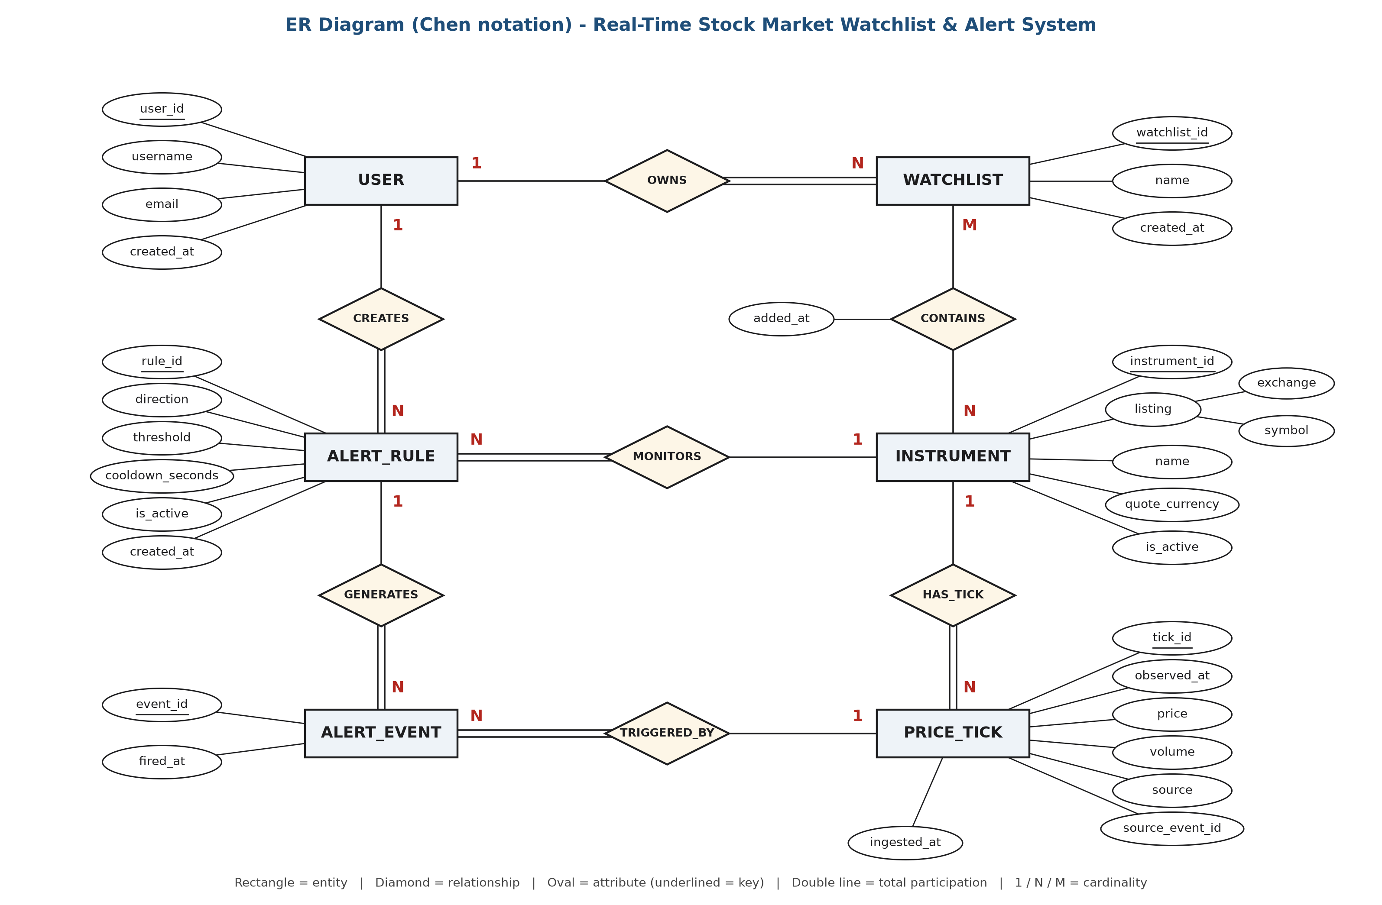
Figure 5.1: ER diagram (Chen notation) of the Real-Time Stock Market Watchlist & Alert System
Relationships in the diagram:
- A user OWNS many watchlists (1 : N). Every watchlist must have exactly one owner (double line).
- A watchlist CONTAINS many instruments, and an instrument can be in many watchlists (M : N). The relationship has its own attribute added_at. In the database it becomes the table watchlist_items.
- An instrument HAS many price ticks (1 : N). Every tick belongs to exactly one instrument.
- A user CREATES many alert rules (1 : N), and each alert rule MONITORS exactly one instrument (N : 1).
- An alert rule GENERATES many alert events (1 : N), and each alert event is TRIGGERED_BY exactly one price tick (N : 1).
Corrections made to the ER diagram after Review 2
Problem in the Review 2 diagram | What we changed
The lines had arrow heads. | All lines are now plain lines. In Chen notation the direction is not shown with arrows; the numbers 1, N and M next to each line show the cardinality.
Watchlist_item was drawn as a weak entity (double rectangle). | It is now the M : N relationship CONTAINS between WATCHLIST and INSTRUMENT, with the attribute added_at. It is not a weak entity because it has no partial key of its own: a row is identified only by the watchlist and the instrument it connects.
Attributes that only join tables were shown, e.g. watchlist_id and instrument_id inside Watchlist_item. | All foreign-key (join) attributes are removed. In an ER diagram a link between two entities is shown by a relationship diamond. The foreign-key columns appear only later, when the diagram is turned into tables (section 6).
Some relationship names did not match the tables (ADDED_TO, HAS_RULES). | Relationship names now read as sentences: USER OWNS WATCHLIST, ALERT_RULE MONITORS INSTRUMENT, ALERT_EVENT TRIGGERED_BY PRICE_TICK.

ALERT_EVENT is drawn as an entity (not as a relationship) because every alert has its own number (event_id) that the application uses on its own: the trigger sends it with pg_notify and the Alert History page lists alerts by it.

Tables and Constraints
The database has 7 tables in the public schema. Every primary key, foreign key, unique and check constraint has a name, so error messages clearly say which rule was broken. In total there are 36 named constraints: 7 PRIMARY KEY, 8 FOREIGN KEY, 7 UNIQUE and 14 CHECK. Prices are stored as NUMERIC (never FLOAT), so there are no rounding errors, and all times are stored as TIMESTAMPTZ.

Table Name : users
Description: This table stores the people who use the system. Each user has a unique username and a unique email address. A user can own many watchlists and many alert rules.
Attribute | Data Type | Constraint
user_id | BIGINT | PK (pk_users), generated identity
username | TEXT | NOT NULL, UNIQUE (uq_users_username), CHECK: 3–30 lower-case letters, digits or _
email | TEXT | NOT NULL, UNIQUE (uq_users_email), CHECK: lower-case and contains @
created_at | TIMESTAMPTZ | NOT NULL, default current timestamp
Relationships: users (1) → watchlists (N) and users (1) → alert_rules (N). Both foreign keys use ON DELETE CASCADE, so deleting a user also deletes the user's own data.
Normal form: BCNF. Candidate keys: user_id, username and email. The only other column, created_at, depends on the key and decides nothing else.
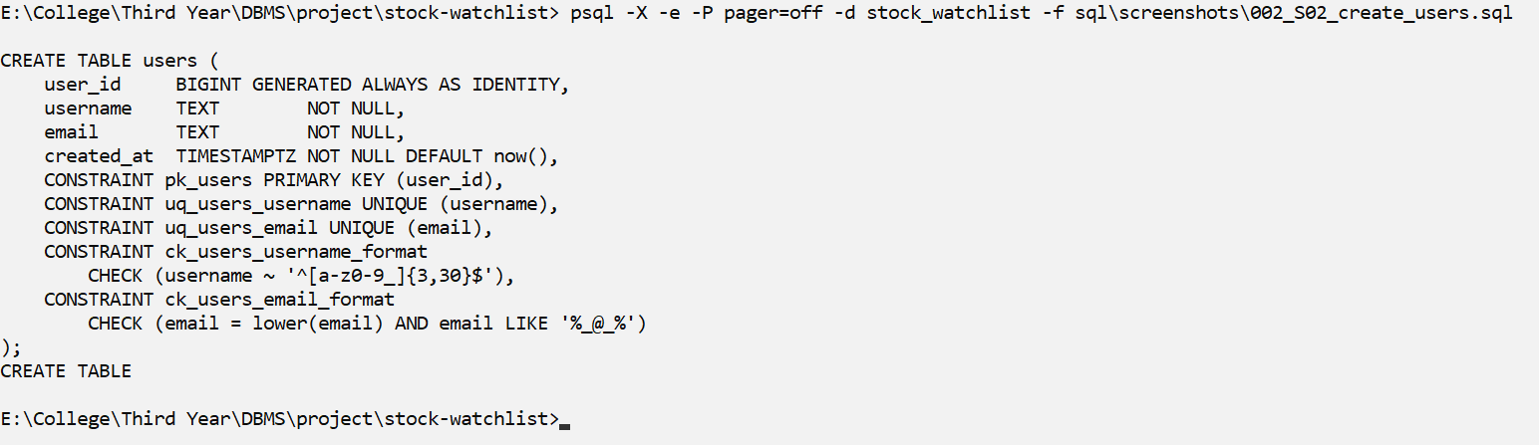
Screenshot S02: CREATE TABLE users
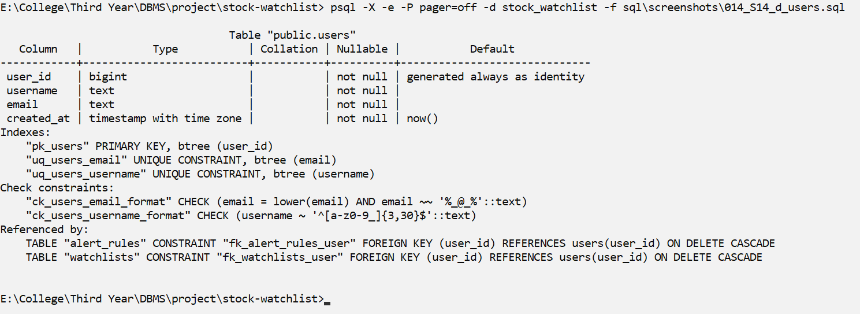
Screenshot S14: structure of users (\d users)

Table Name : instruments
Description: This table stores the stocks and crypto pairs that can be watched, for example NSE RELIANCE or BINANCE BTCUSDT. An instrument is identified by its exchange and symbol together.
Attribute | Data Type | Constraint
instrument_id | BIGINT | PK (pk_instruments), generated identity
exchange | TEXT | NOT NULL, CHECK IN ('NSE', 'BSE', 'BINANCE')
symbol | TEXT | NOT NULL, CHECK: 1–20 characters (A–Z, 0–9, & . _ -)
name | TEXT | NOT NULL, CHECK not blank
quote_currency | TEXT | NOT NULL, CHECK: 3–5 capital letters (INR, USDT)
is_active | BOOLEAN | NOT NULL, default TRUE
UNIQUE (exchange, symbol) – uq_instruments_exchange_symbol
Relationships: instruments (1) → price_ticks (N), instruments (1) → watchlist_items (N) and instruments (1) → alert_rules (N). All three use ON DELETE RESTRICT, because market data is shared and must not be deleted while it is in use.
Normal form: BCNF. Candidate keys: instrument_id and (exchange, symbol). Symbol alone does not decide the name, and exchange does not decide the currency (proof in N01). We did not add an asset_class column, because exchange → asset_class would break 3NF.
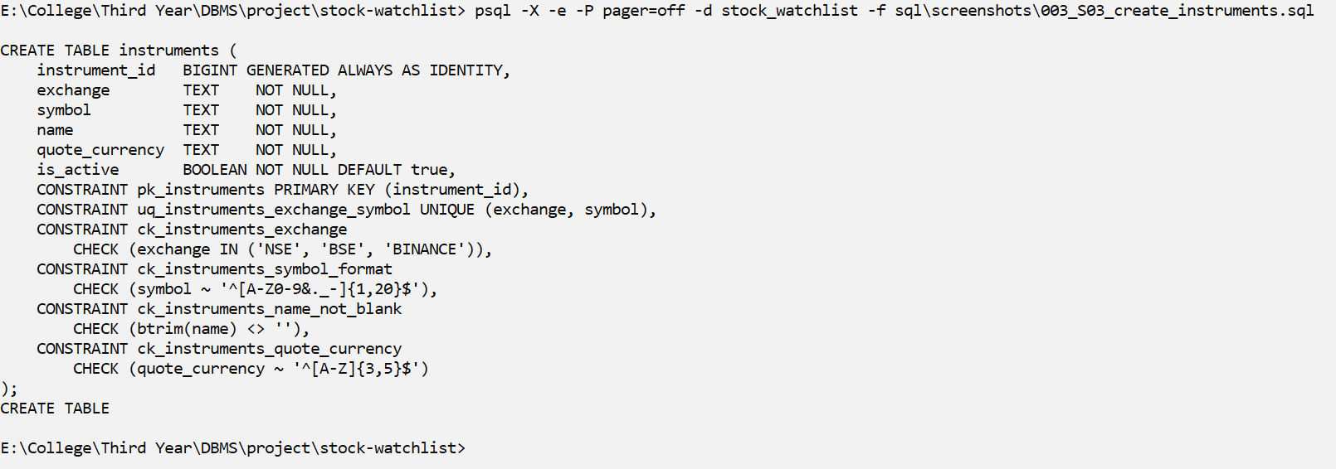
Screenshot S03: CREATE TABLE instruments
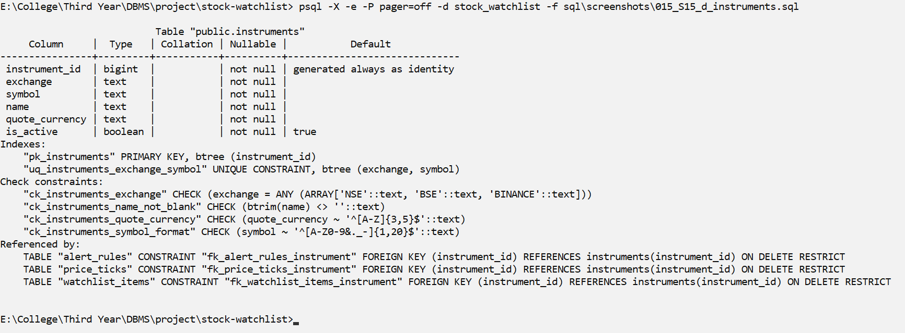
Screenshot S15: structure of instruments (\d instruments)

Table Name : watchlists
Description: This table stores the named lists that users create, for example 'Long Term' or 'Crypto'. One user can have many lists, but two lists of the same user cannot have the same name.
Attribute | Data Type | Constraint
watchlist_id | BIGINT | PK (pk_watchlists), generated identity
user_id | BIGINT | NOT NULL, FK → users (ON DELETE CASCADE)
name | TEXT | NOT NULL, CHECK: not blank and at most 50 characters
created_at | TIMESTAMPTZ | NOT NULL, default current timestamp
UNIQUE (user_id, name) – uq_watchlists_user_name
Relationships: Many watchlists belong to one user. One watchlist has many watchlist_items (ON DELETE CASCADE).
Normal form: BCNF. Candidate keys: watchlist_id and (user_id, name). The contents of a list are not stored here; they are in watchlist_items.
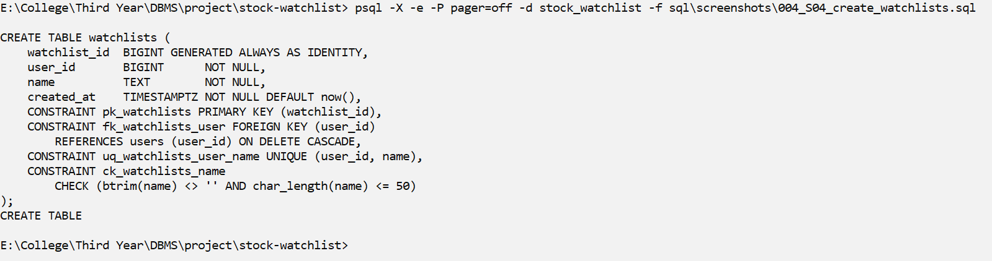
Screenshot S04: CREATE TABLE watchlists
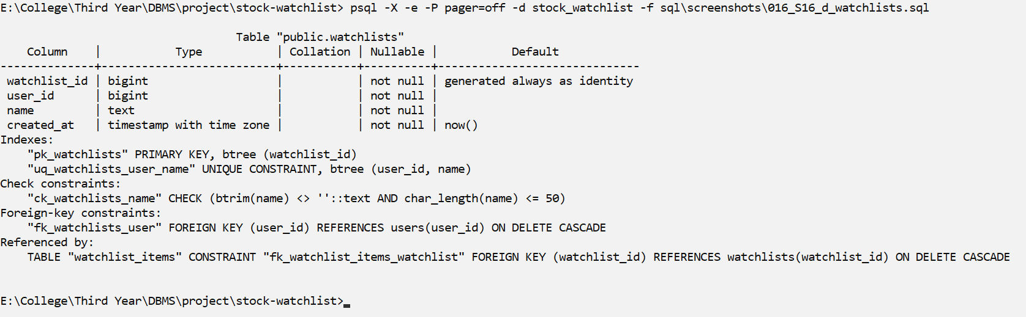
Screenshot S16: structure of watchlists (\d watchlists)

Table Name : watchlist_items
Description: This is the junction table between watchlists and instruments. A watchlist can contain many instruments and an instrument can be in many watchlists, so each row stores one (watchlist, instrument) pair.
Attribute | Data Type | Constraint
watchlist_id | BIGINT | PK / FK → watchlists (ON DELETE CASCADE)
instrument_id | BIGINT | PK / FK → instruments (ON DELETE RESTRICT)
added_at | TIMESTAMPTZ | NOT NULL, default current timestamp
Composite Primary Key: (watchlist_id, instrument_id) – pk_watchlist_items
Relationships: Resolves the many-to-many relationship watchlists (M) ↔ instruments (N). Deleting a watchlist deletes its items, but never the instrument or its prices.
Normal form: BCNF. The only key is (watchlist_id, instrument_id), and added_at needs both columns. We did not store user_id or symbol here, because they depend on only part of the key (that would break 2NF).
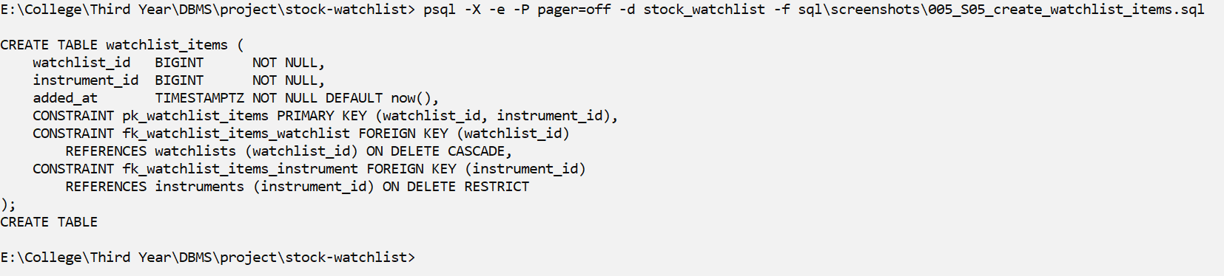
Screenshot S05: CREATE TABLE watchlist_items
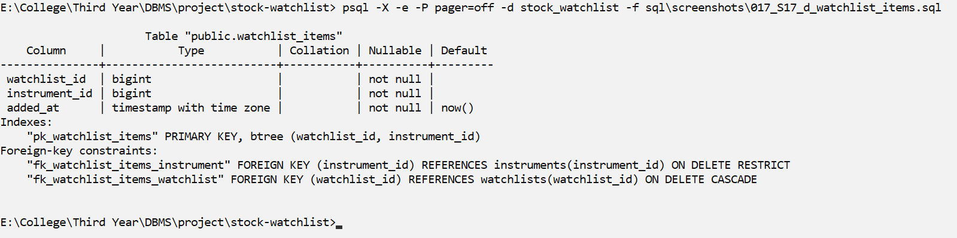
Screenshot S17: structure of watchlist_items (\d watchlist_items)

Table Name : price_ticks
Description: This table stores the price history. Each row is one price of one instrument at one moment (a tick), with the volume and the source it came from (REPLAY, BINANCE or MANUAL). The table is append-only: ticks are added through ingest_tick() and are never edited.
Attribute | Data Type | Constraint
tick_id | BIGINT | PK (pk_price_ticks), generated identity
instrument_id | BIGINT | NOT NULL, FK → instruments (ON DELETE RESTRICT)
observed_at | TIMESTAMPTZ | NOT NULL (market time of the price)
price | NUMERIC(18,8) | NOT NULL, CHECK price > 0
volume | NUMERIC(24,8) | NULL allowed (unknown), CHECK volume IS NULL OR volume >= 0
source | TEXT | NOT NULL, CHECK IN ('REPLAY', 'BINANCE', 'MANUAL')
source_event_id | TEXT | NOT NULL, CHECK not blank
ingested_at | TIMESTAMPTZ | NOT NULL, default current timestamp (time it was stored)
UNIQUE (source, instrument_id, source_event_id) – uq_price_ticks_source_event
Relationships: Many ticks belong to one instrument. One tick can trigger many alert_events (ON DELETE RESTRICT, so alert history cannot lose its tick).
Normal form: BCNF. Candidate keys: tick_id and (source, instrument_id, source_event_id). (instrument_id, observed_at) is not a key, because two real trades can happen at the same time.
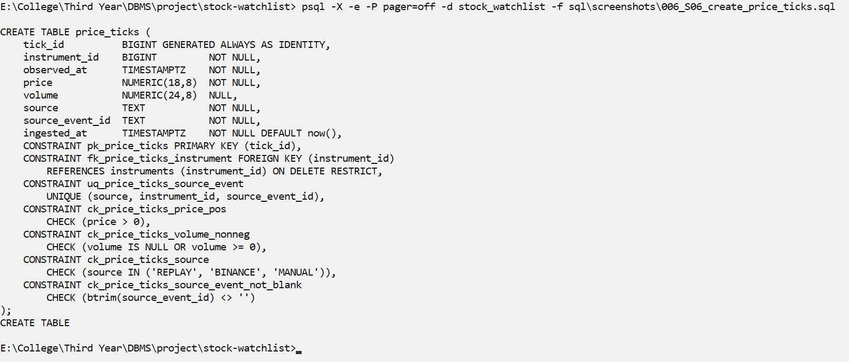
Screenshot S06: CREATE TABLE price_ticks
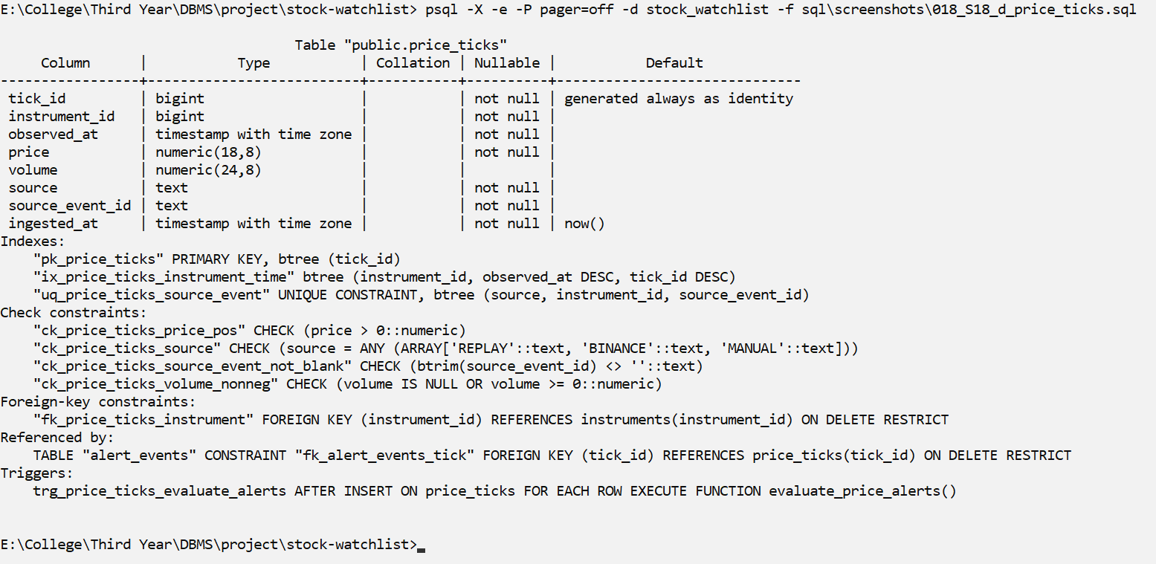
Screenshot S18: structure of price_ticks (\d price_ticks)

Table Name : alert_rules
Description: This table stores the alert rules that users create, for example 'tell me when RELIANCE goes ABOVE 3000'. A rule has a direction, a threshold and a cooldown (minimum seconds between two alerts). Rules are turned on or off with is_active instead of being deleted.
Attribute | Data Type | Constraint
rule_id | BIGINT | PK (pk_alert_rules), generated identity
user_id | BIGINT | NOT NULL, FK → users (ON DELETE CASCADE)
instrument_id | BIGINT | NOT NULL, FK → instruments (ON DELETE RESTRICT)
direction | TEXT | NOT NULL, CHECK IN ('ABOVE', 'BELOW')
threshold | NUMERIC(18,8) | NOT NULL, CHECK threshold > 0
cooldown_seconds | INTEGER | NOT NULL, default 300, CHECK >= 0
is_active | BOOLEAN | NOT NULL, default TRUE
created_at | TIMESTAMPTZ | NOT NULL, default current timestamp
UNIQUE (user_id, instrument_id, direction, threshold) – uq_alert_rules_definition
Relationships: Many rules belong to one user and to one instrument. One rule generates many alert_events (ON DELETE CASCADE).
Normal form: BCNF. Candidate keys: rule_id and (user_id, instrument_id, direction, threshold). All four columns are needed: dropping any one of them allows legal duplicates.
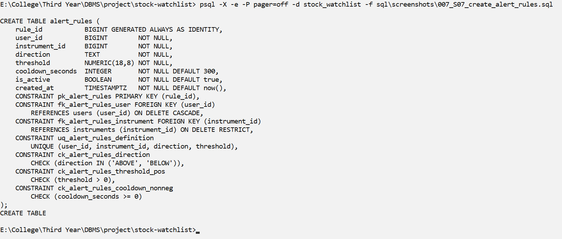
Screenshot S07: CREATE TABLE alert_rules
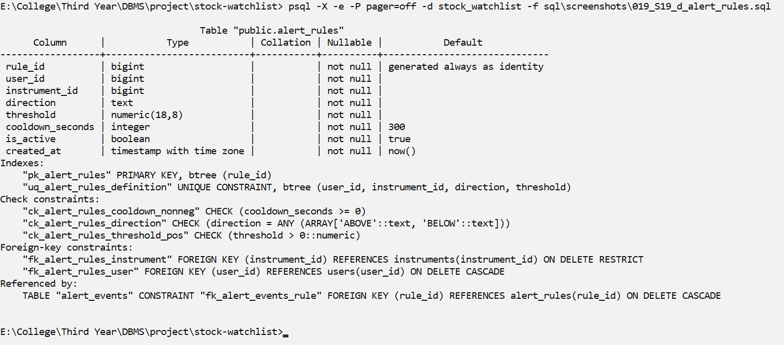
Screenshot S19: structure of alert_rules (\d alert_rules)

Table Name : alert_events
Description: This table is the history of fired alerts. Each row says which rule fired on which price tick. It is written only by the alert trigger.
Attribute | Data Type | Constraint
event_id | BIGINT | PK (pk_alert_events), generated identity
rule_id | BIGINT | NOT NULL, FK → alert_rules (ON DELETE CASCADE)
tick_id | BIGINT | NOT NULL, FK → price_ticks (ON DELETE RESTRICT)
fired_at | TIMESTAMPTZ | NOT NULL, default current timestamp
UNIQUE (rule_id, tick_id) – uq_alert_events_rule_tick (one rule cannot fire twice on the same tick)
Relationships: Many events belong to one rule and to one tick. A BEFORE INSERT trigger checks that the rule and the tick are for the same instrument.
Normal form: BCNF. Candidate keys: event_id and (rule_id, tick_id). We do not copy price, observed_at or instrument_id into this table, because tick_id → price would be a transitive dependency (breaks 3NF); they are found through price_ticks.
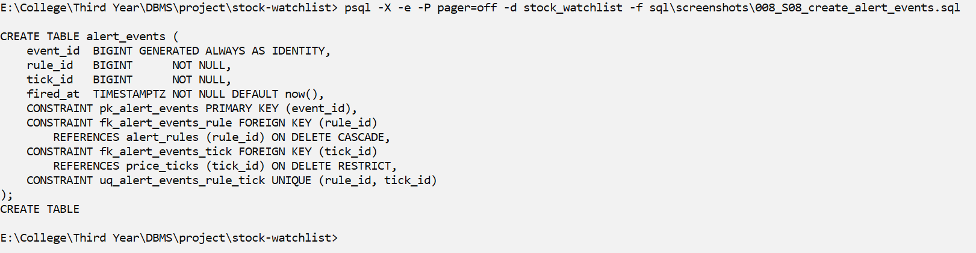
Screenshot S08: CREATE TABLE alert_events
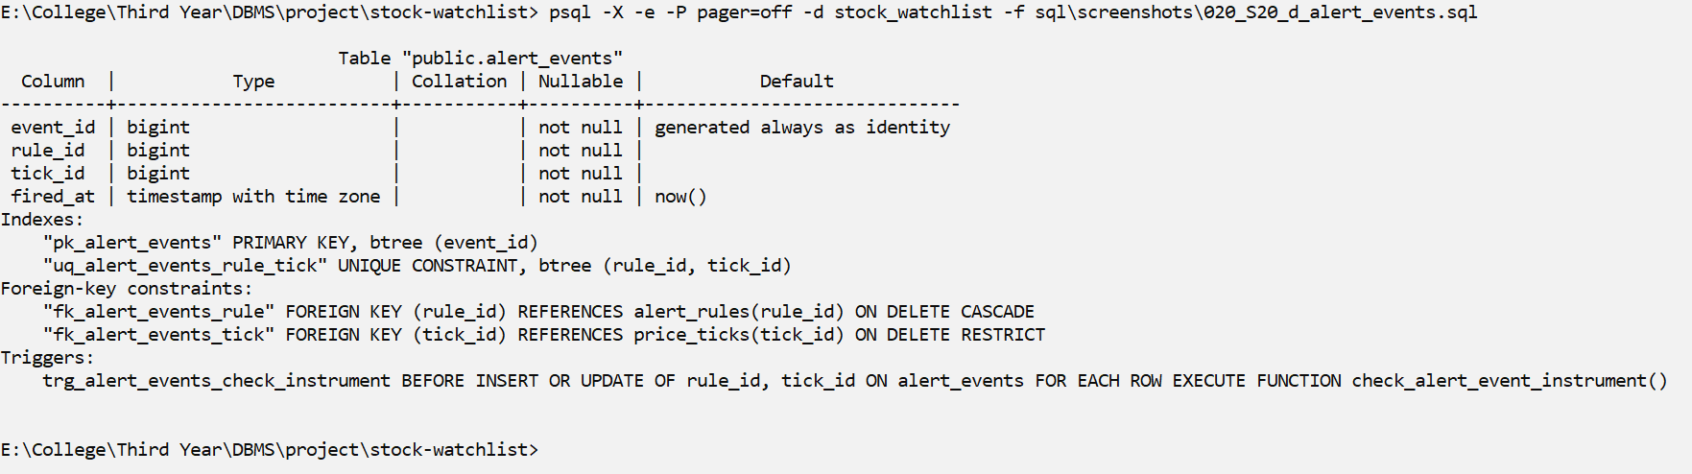
Screenshot S20: structure of alert_events (\d alert_events)

All Constraints and Relationships
The ON DELETE rule of each foreign key is chosen on purpose. User-owned data uses CASCADE: deleting a user removes their watchlists, items, rules and alerts. Shared market data uses RESTRICT: an instrument or a price tick cannot be deleted while something still uses it. Deleting a watchlist never deletes price history.
Parent → Child | Foreign key | ON DELETE
users → watchlists | fk_watchlists_user | CASCADE
users → alert_rules | fk_alert_rules_user | CASCADE
watchlists → watchlist_items | fk_watchlist_items_watchlist | CASCADE
alert_rules → alert_events | fk_alert_events_rule | CASCADE
instruments → watchlist_items | fk_watchlist_items_instrument | RESTRICT
instruments → price_ticks | fk_price_ticks_instrument | RESTRICT
instruments → alert_rules | fk_alert_rules_instrument | RESTRICT
price_ticks → alert_events | fk_alert_events_tick | RESTRICT
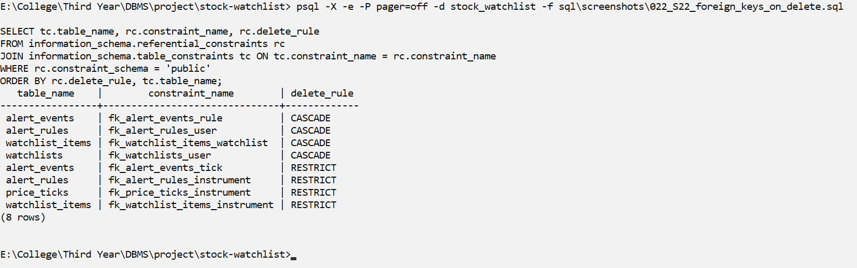
Screenshot S22: The 8 foreign keys with their ON DELETE rule.
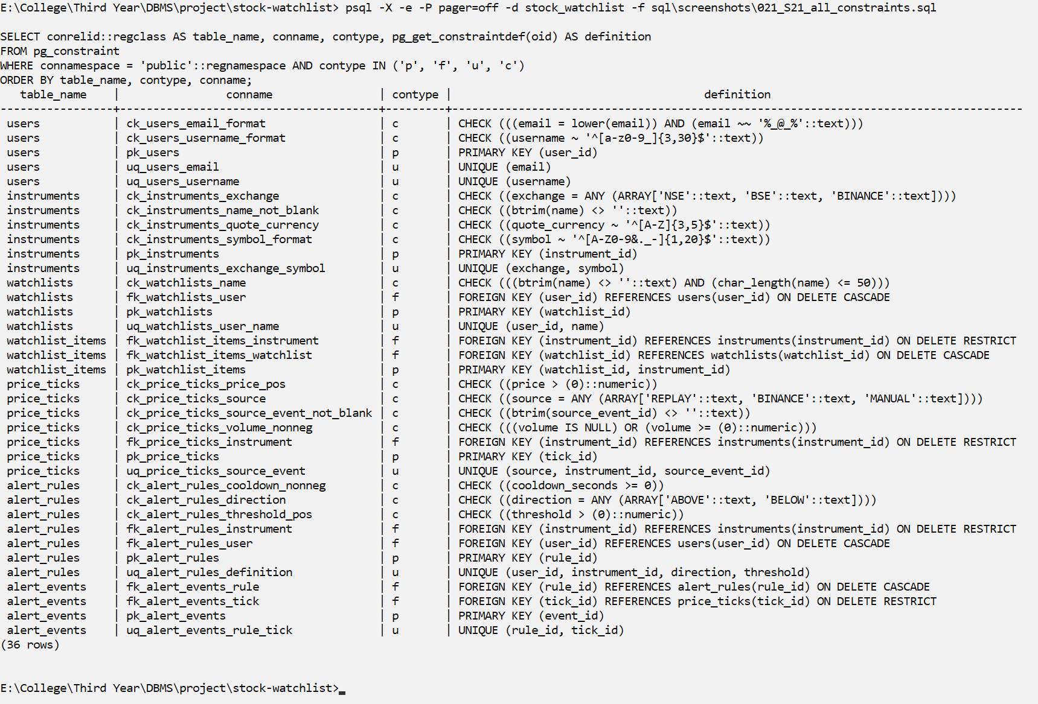
Screenshot S21: All 36 named constraints: 7 PRIMARY KEY, 8 FOREIGN KEY, 7 UNIQUE and 14 CHECK.

Normal Forms
To check the normal form of each table, we listed its functional dependencies (FDs) and its candidate keys. A table is in BCNF when the left side of every FD is a candidate key. BCNF also means the table is in 3NF, 2NF and 1NF.
- 1NF: every column holds one value. There are no lists in a cell – for example, the symbols of a watchlist are separate rows in watchlist_items, not a comma-separated text.
- 2NF: no column depends on only part of a composite key. For example, user_id is not stored in watchlist_items, because it depends only on watchlist_id.
- 3NF: no column depends on another non-key column. For example, alert_events does not store the price, because the price depends on tick_id.
- BCNF: in every table, the only determinants are candidate keys.
Table | Primary key | Other candidate keys | Normal form
users | user_id | username; email | BCNF
instruments | instrument_id | (exchange, symbol) | BCNF
watchlists | watchlist_id | (user_id, name) | BCNF
watchlist_items | (watchlist_id, instrument_id) | – | BCNF
price_ticks | tick_id | (source, instrument_id, source_event_id) | BCNF
alert_rules | rule_id | (user_id, instrument_id, direction, threshold) | BCNF
alert_events | event_id | (rule_id, tick_id) | BCNF

N02 – Normalization: primary key and candidate keys of every table
What it shows: (every determinant is a key -> each table is in BCNF)
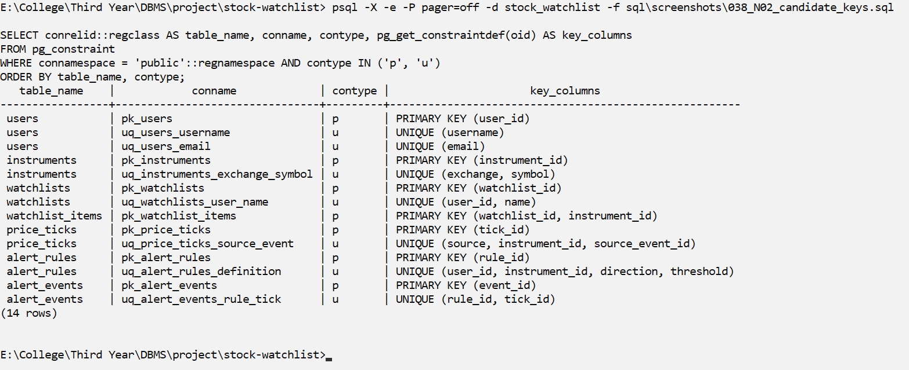
Screenshot N02
Explanation: Shows the primary key and the other candidate keys (UNIQUE constraints) of every table.
N01 – Normalization: the rejected functional dependencies are false
What it shows: symbol is NOT a key; exchange does NOT determine quote_currency (inside a transaction that is rolled back)
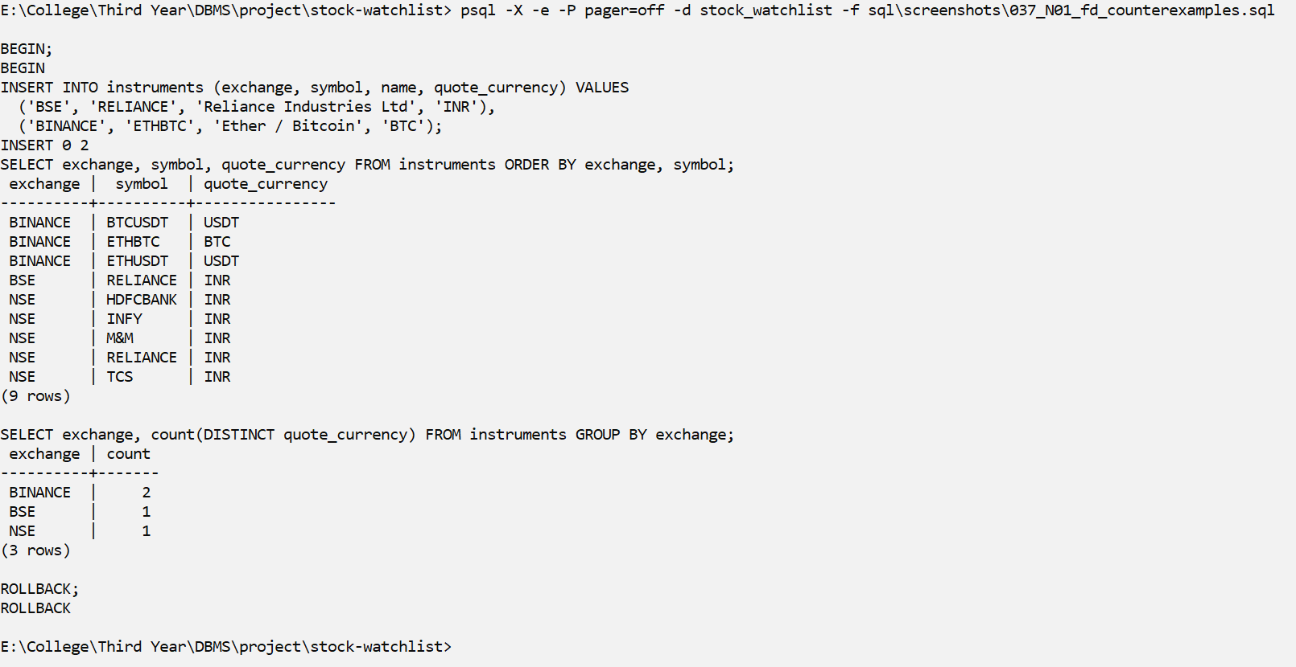
Screenshot N01
Explanation: Inside a rolled-back transaction we add BSE RELIANCE and BINANCE ETHBTC. The same symbol now exists on two exchanges, so symbol alone is not a key, and BINANCE now has two currencies, so exchange does not decide quote_currency.

SQL Implementation
This section shows the actual implementation. Every query is in its own file in sql/screenshots/, and every screenshot shows the command, the SQL and the real output from PostgreSQL. The data is the seed data (3 users, 7 instruments, 5 watchlists, 11 watchlist items and 6 alert rules) plus one replay run of 30 price ticks, which fired 8 alerts.
The table below shows the required query categories. We wrote 38 queries for them (A1–G3), which is more than the minimum of 35.
Category | Required coverage | Min queries
A. Basic | SELECT, WHERE, ORDER BY, DISTINCT, BETWEEN, IN, LIKE, IS NULL | 6
B. Aggregate | COUNT, SUM, AVG, MIN, MAX, GROUP BY, HAVING (must contrast WHERE vs HAVING in one query) | 5
C. Joins | INNER, LEFT, RIGHT, FULL OUTER (or emulation), SELF, CROSS (meaningful use) | 6
D. Subqueries | Scalar, single-row, multi-row (IN/ANY/ALL), correlated, EXISTS, NOT EXISTS, NOT IN (with a note on the NULL pitfall) | 6
E. Set operations | UNION, UNION ALL, INTERSECT, EXCEPT/MINUS (or equivalents) | 4
F. Advanced functions | CASE, COALESCE, NULLIF, date/time, string, numeric functions | 6
G. Window/analytic (recommended for higher band) | RANK, ROW_NUMBER, running total, LAG/LEAD | 2

Database Setup and DDL
S01 – Database server and session
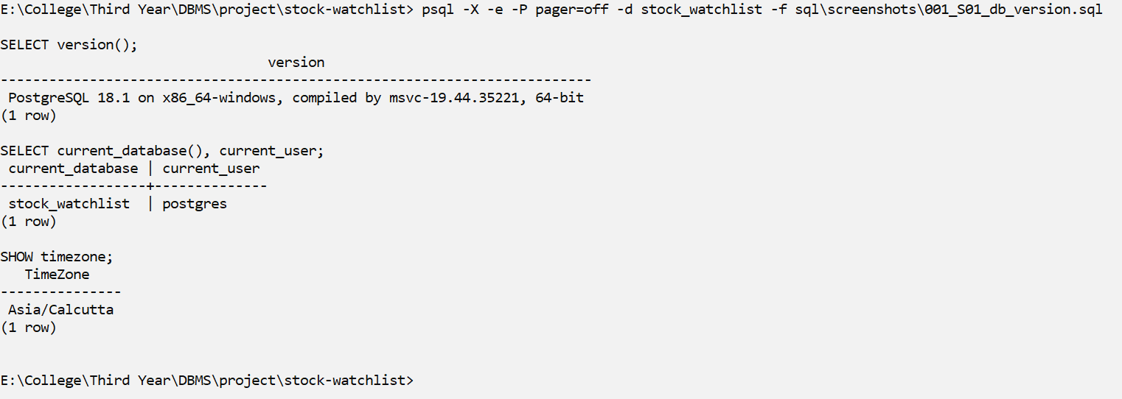
Screenshot S01
Explanation: We use PostgreSQL 18. The database is called stock_watchlist.
S09 – DML INSERT: loading the seed data (sql/01_seed.sql)
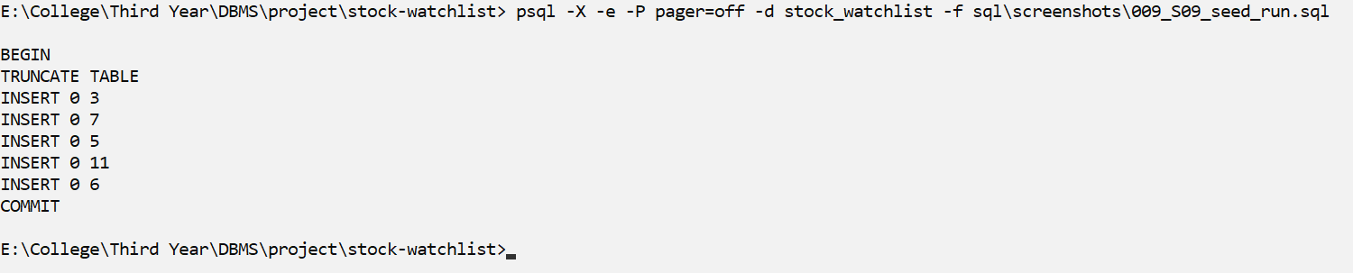
Screenshot S09
Explanation: Runs sql/01_seed.sql, which inserts the starting data: 3 users, 7 instruments, 5 watchlists, 11 watchlist items and 6 alert rules.
S10 – Creating ingest_tick() and the 2 triggers (sql/03_functions_triggers.sql)
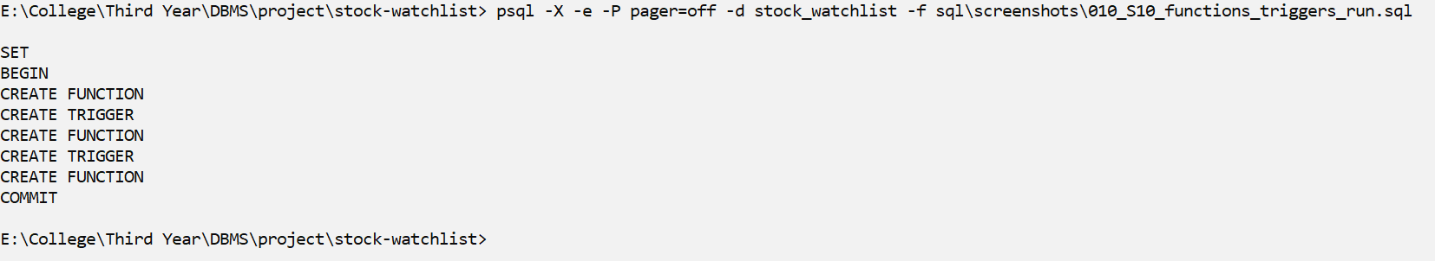
Screenshot S10
Explanation: Creates the ingest_tick() function and the 2 triggers. Every new price enters the database through ingest_tick().
S12 – Creating views, procedures, functions, cursors, roles and grants
What it shows: (sql/09_review2_objects.sql, schema reporting)
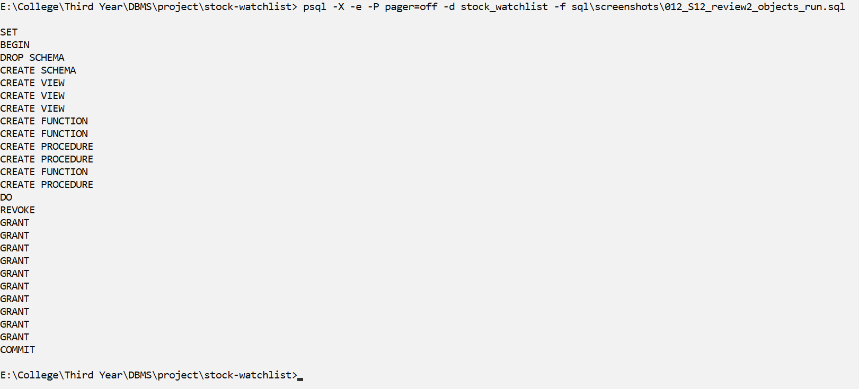
Screenshot S12
Explanation: Creates the Review 2 objects in a separate schema called reporting: 3 views, stored procedures, functions, cursors, roles and grants. The 7 main tables are not changed.
S13 – The 7 tables (schema public) and 3 views (schema reporting)
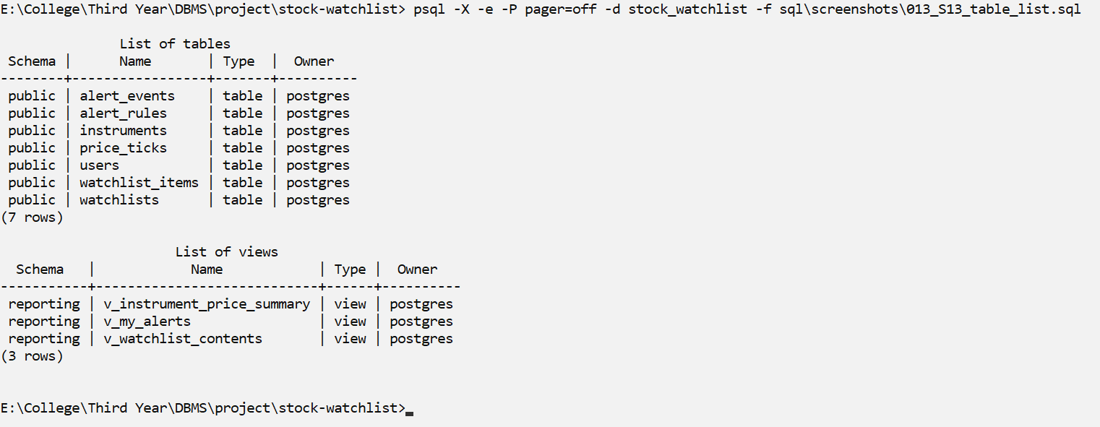
Screenshot S13
Explanation: Lists the 7 tables in the public schema and the 3 views in the reporting schema.

DML: INSERT, UPDATE and DELETE
S23 – Row counts after loading the seed data
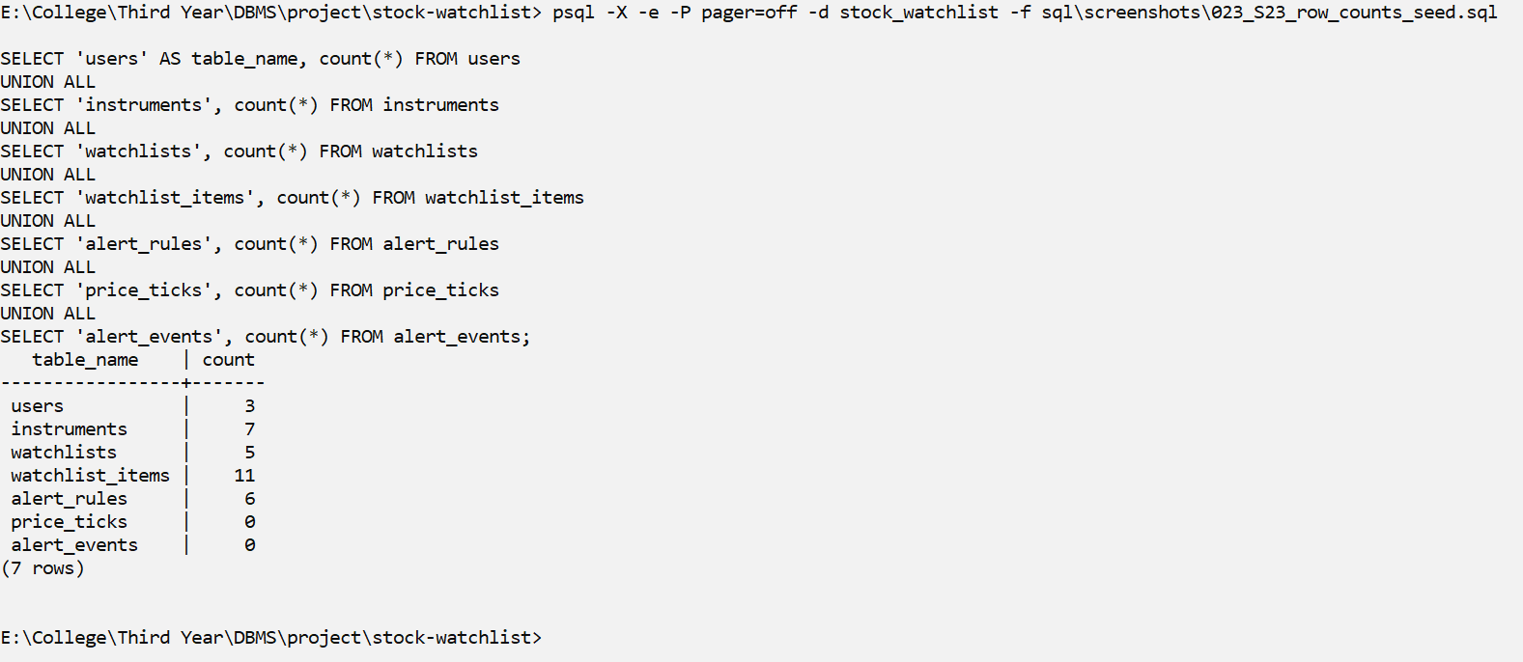
Screenshot S23
Explanation: Row counts right after the seed data is loaded. price_ticks and alert_events are still empty because no prices have arrived yet.
R01 – Replay feed run
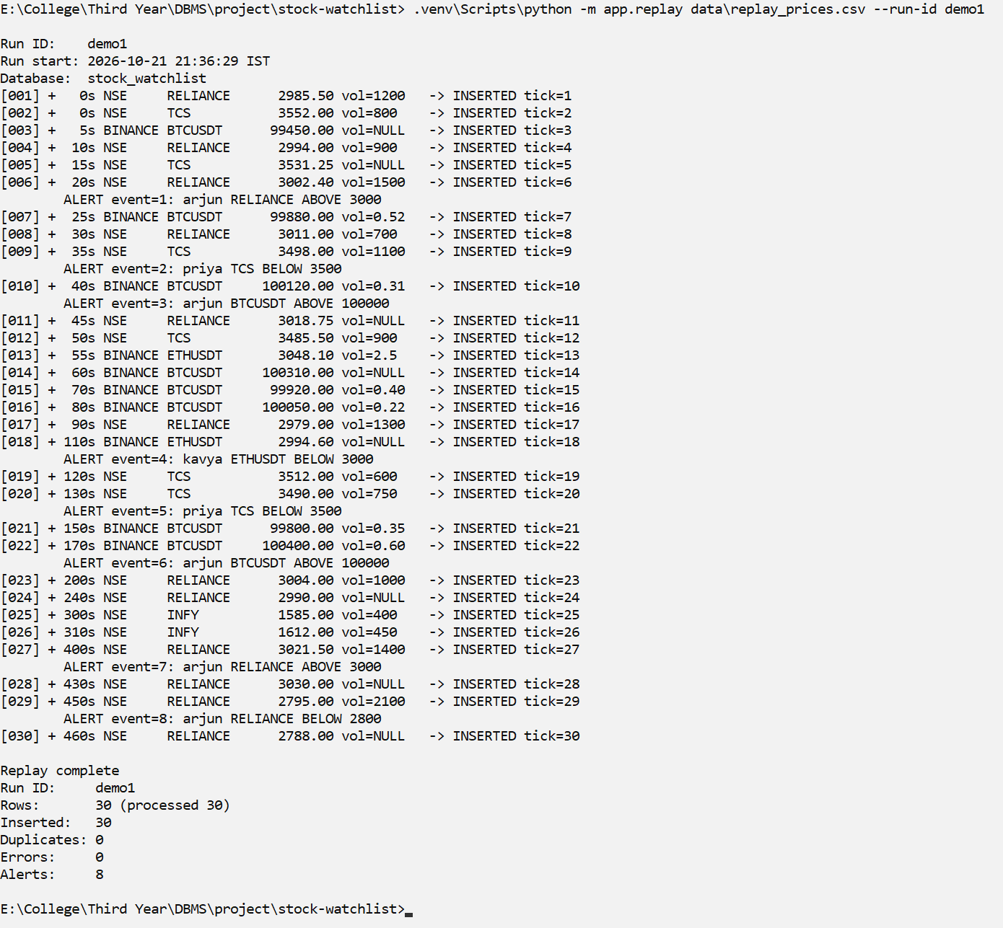
Screenshot R01
Explanation: The replay feed reads data/replay_prices.csv and sends every row to ingest_tick(). 30 ticks were inserted with 0 duplicates and 0 errors, and the trigger fired 8 alerts while the data was loading.
M01 – DML INSERT (autocommit: each statement is committed)
What it shows: arjun creates a new watchlist and adds 2 instruments
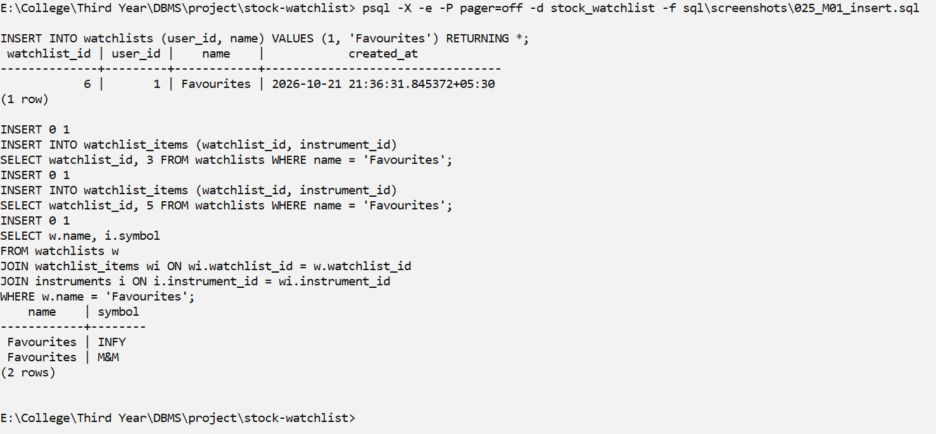
Screenshot M01
Explanation: INSERT: user arjun creates a new watchlist called 'Review 2 Demo' and adds INFY and M&M to it. RETURNING shows the new rows.
M02 – DML UPDATE: rename the watchlist; change a rule's cooldown, then
What it shows: set it back (a rule's definition is never edited, only is_active/cooldown)
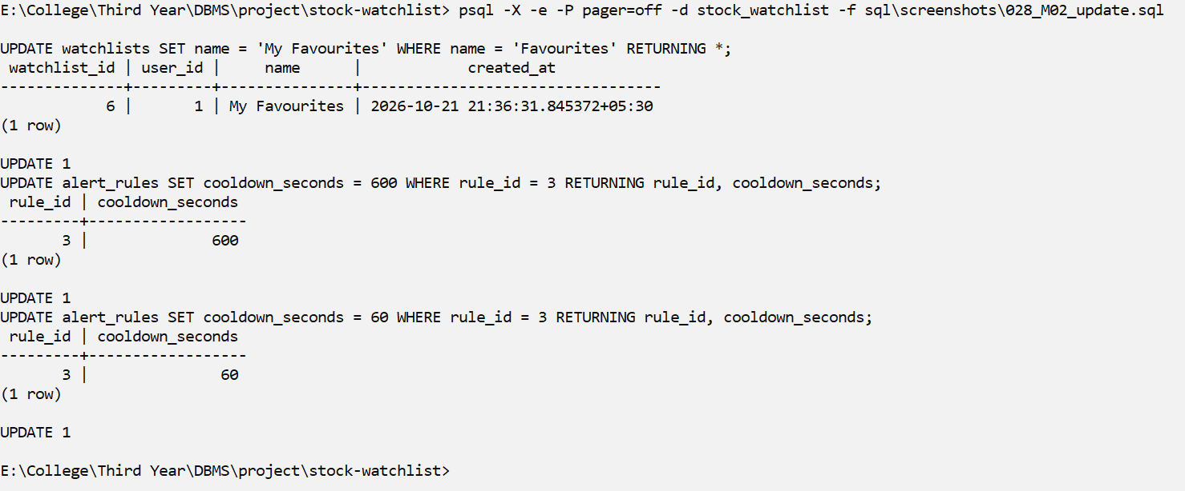
Screenshot M02
Explanation: UPDATE: the watchlist is renamed, and the cooldown of rule 3 is changed and then set back. In our design only the cooldown or is_active of a rule is changed; the rule's definition is never edited.
M03 – DML DELETE: removing the watchlist also removes its items
What it shows: (ON DELETE CASCADE) but never instruments or price history
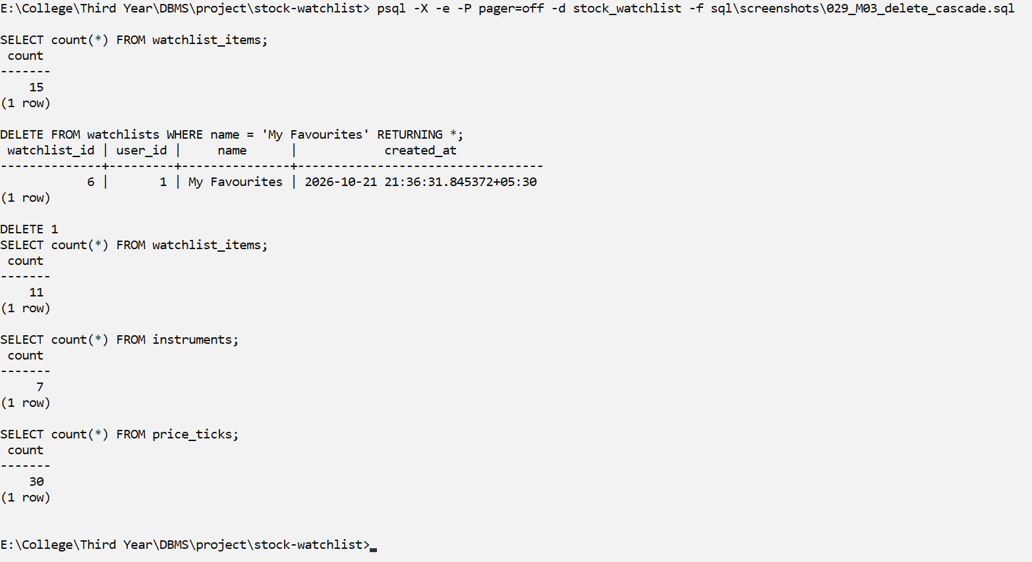
Screenshot M03
Explanation: DELETE: deleting the watchlist also deletes its items because of ON DELETE CASCADE. Instruments and price history are not touched.
M04 – Row-count table after the replay feed and the DML steps
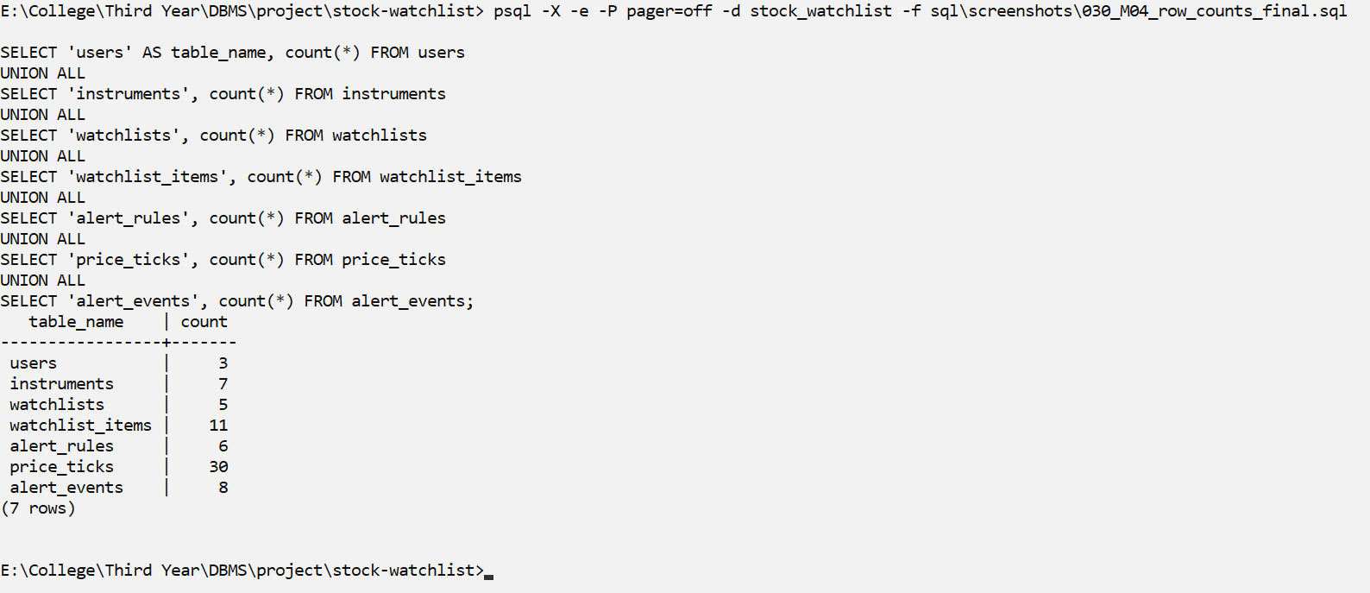
Screenshot M04
Explanation: Final row counts after the replay feed and the DML steps: 3 users, 7 instruments, 5 watchlists, 11 watchlist items, 6 alert rules, 30 price ticks and 8 alert events.

Constraints Rejecting Bad Data
CN01 – UNIQUE constraints reject duplicates
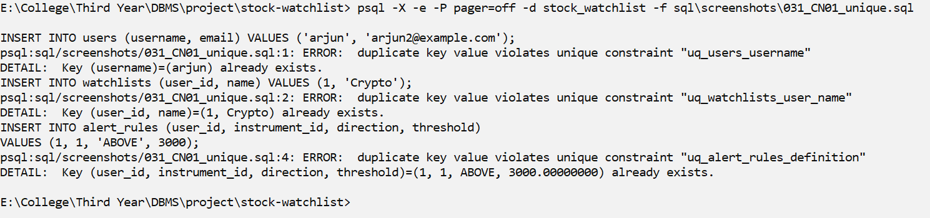
Screenshot CN01
Explanation: A second user called arjun, a second 'Crypto' watchlist for the same user and a duplicate alert rule are all rejected by UNIQUE constraints.
CN02 – CHECK constraints reject invalid values
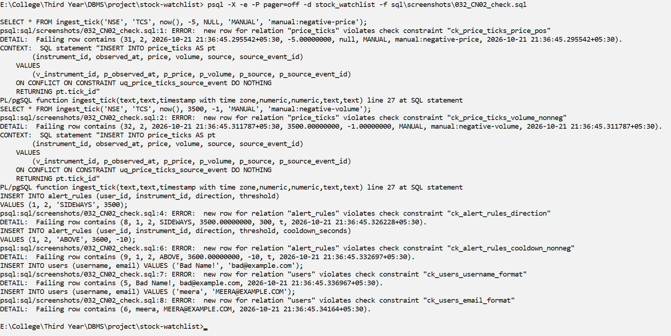
Screenshot CN02
Explanation: A negative price, a negative volume, a direction other than ABOVE/BELOW, a negative cooldown, an invalid username and an upper-case email are all rejected by CHECK constraints.
CN03 – FOREIGN KEY constraints reject references to missing rows
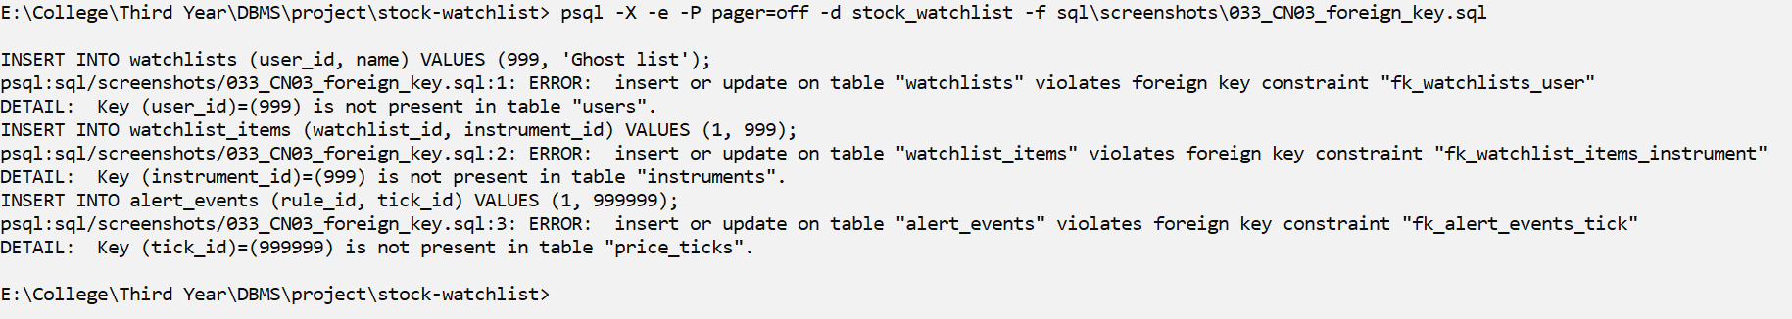
Screenshot CN03
Explanation: A watchlist for a user that does not exist, an item with an instrument that does not exist and an alert for a tick that does not exist are all rejected by FOREIGN KEY constraints.
CN04 – ON DELETE RESTRICT: shared market data cannot be deleted
What it shows: while watchlists, rules or alert history still reference it
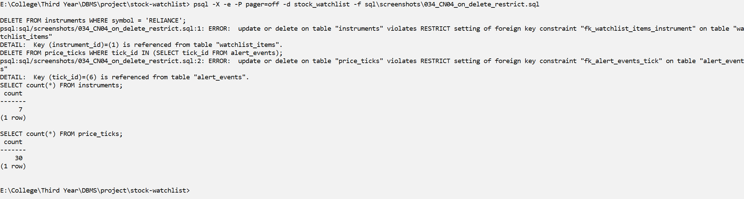
Screenshot CN04
Explanation: RELIANCE cannot be deleted because watchlists still use it, and a price tick cannot be deleted because the alert history points to it. The counts stay at 7 instruments and 30 ticks.
CN05 – ON DELETE CASCADE: deleting a user removes only user-owned data
What it shows: (watchlists, items, rules, alert history). Rolled back afterwards.
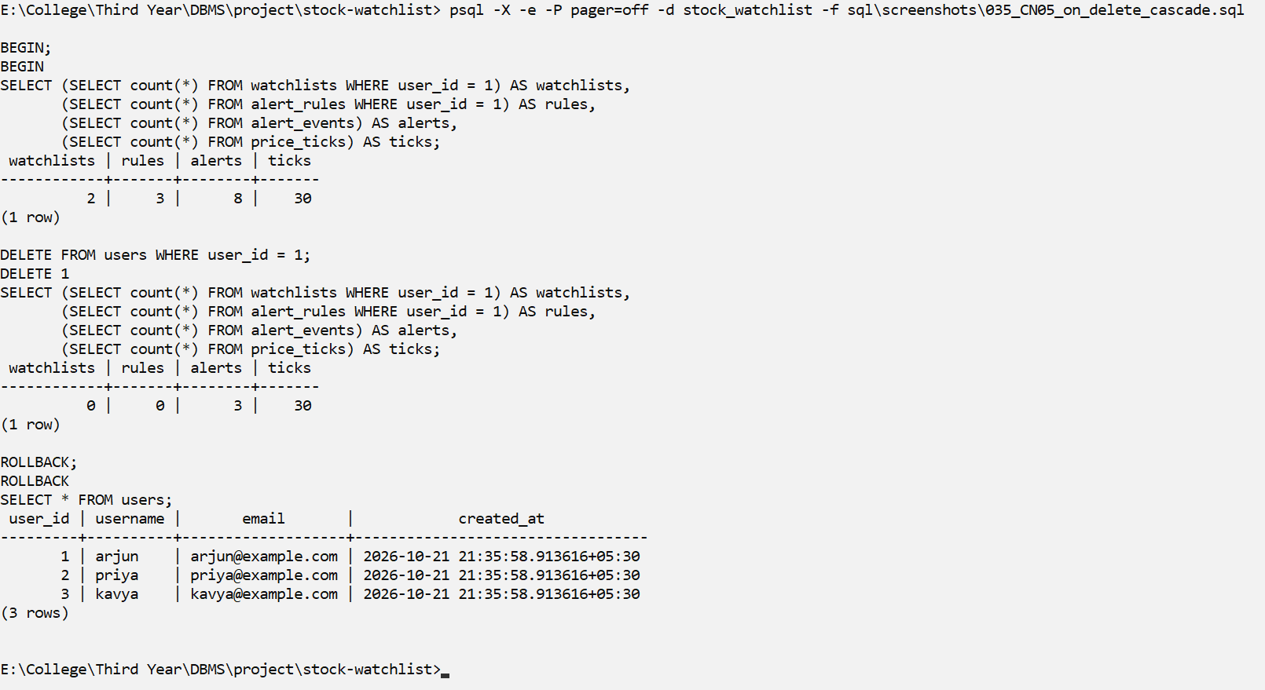
Screenshot CN05
Explanation: Deleting user arjun (inside a transaction) also removes arjun's watchlists, rules and alerts, but all price ticks stay. ROLLBACK then brings arjun back.
CN06 – Duplicate market event: UNIQUE (source, instrument_id, source_event_id)
What it shows: + ON CONFLICT DO NOTHING inside ingest_tick() -> stored only once
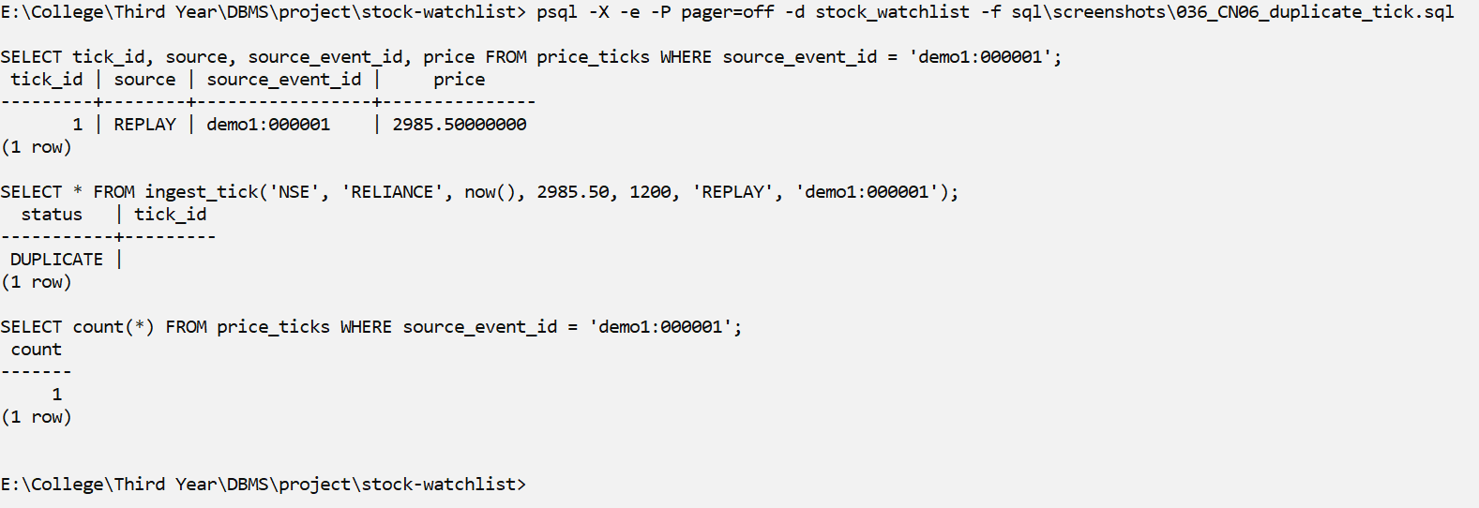
Screenshot CN06
Explanation: The same market event is sent again. Because of UNIQUE (source, instrument_id, source_event_id) and ON CONFLICT DO NOTHING inside ingest_tick(), it is not stored a second time; the count stays 1. This makes it safe to retry a feed.

Transactions (COMMIT, ROLLBACK, SAVEPOINT)
X01 – Transaction with SAVEPOINT, ROLLBACK TO SAVEPOINT and COMMIT
What it shows: a failed step is undone without losing the earlier work
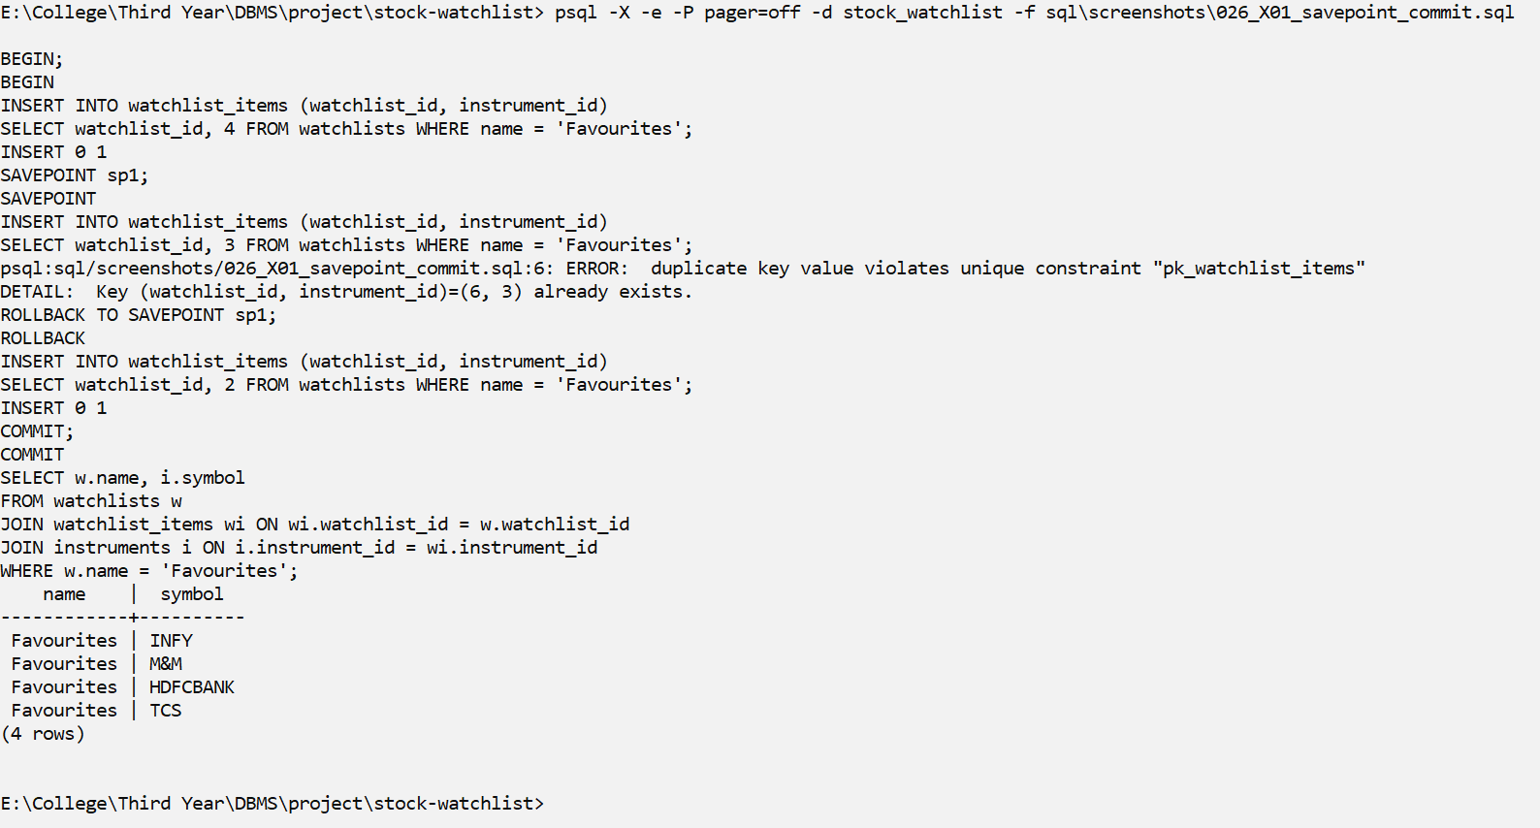
Screenshot X01
Explanation: Inside one transaction we add HDFCBANK, create a SAVEPOINT, then try to add INFY again, which fails. ROLLBACK TO SAVEPOINT undoes only the failed step, so TCS can still be added, and COMMIT saves HDFCBANK and TCS.
X02 – Transaction ROLLBACK: a mistaken DELETE is completely undone
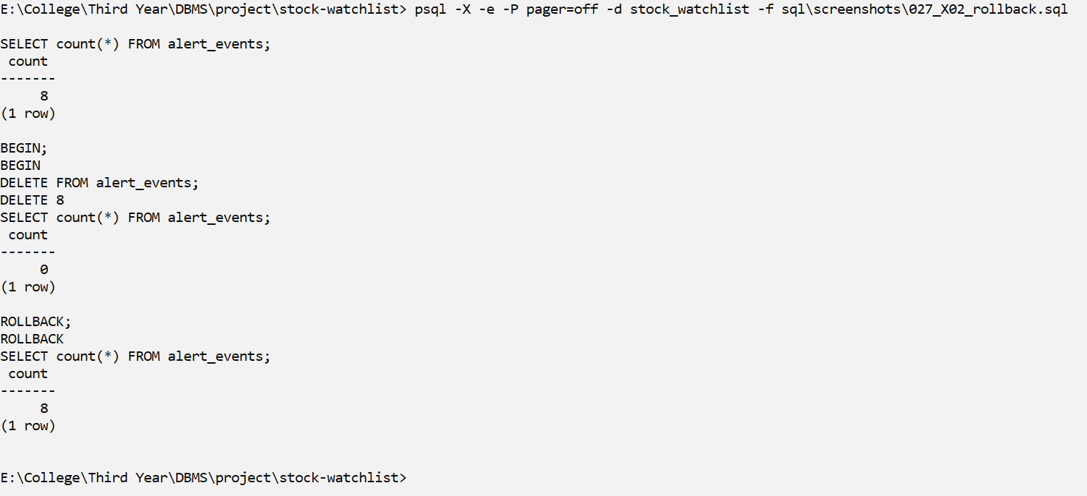
Screenshot X02
Explanation: All alert events are deleted inside a transaction. The count is 0 inside the transaction, and after ROLLBACK all the events are back.

A. Basic Queries
A1 – Basic: SELECT, WHERE, ORDER BY
Question: Which active NSE instruments do we track, alphabetically?
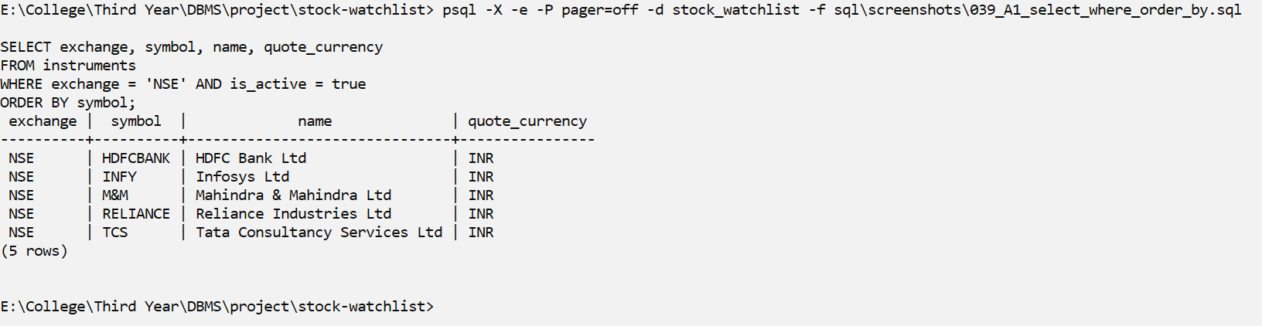
Screenshot A1
Explanation: WHERE keeps only the active NSE instruments and ORDER BY sorts them by symbol.
A2 – Basic: DISTINCT
Question: Which exchange / currency combinations and which data sources exist?
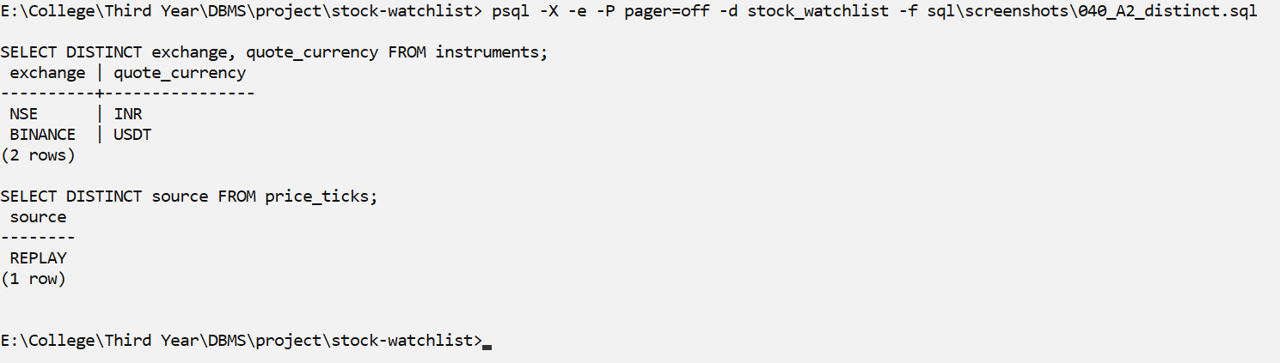
Screenshot A2
Explanation: DISTINCT removes repeated rows, so each exchange/currency pair and each data source is shown only once.
A3 – Basic: BETWEEN
Question: Which ticks were priced between 3,000 and 3,600 (inclusive)?
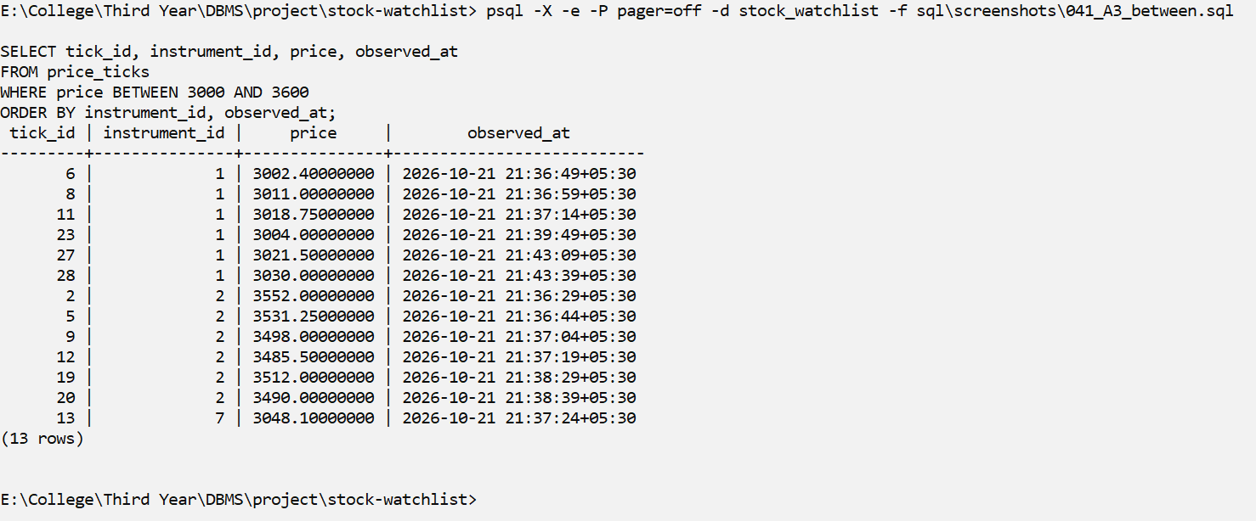
Screenshot A3
Explanation: BETWEEN includes both end values (3000 and 3600).
A4 – Basic: IN
Question: Show the alert rules of users 1 and 3 (arjun and kavya).
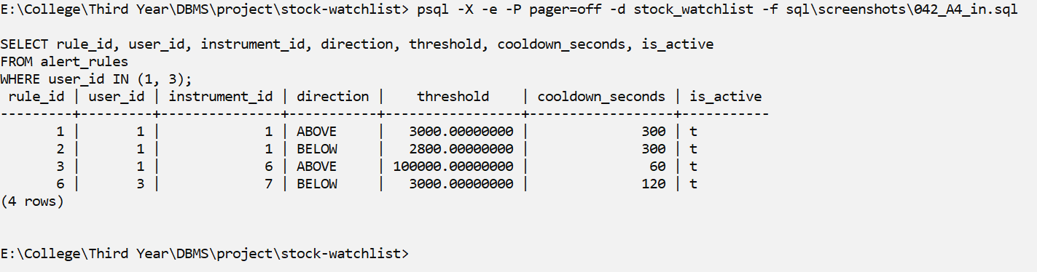
Screenshot A4
Explanation: IN (1, 3) is a short way of writing user_id = 1 OR user_id = 3.
A5 – Basic: LIKE / ILIKE pattern matching
Question: Which instruments are 'Ltd' companies, USDT pairs, or banks?
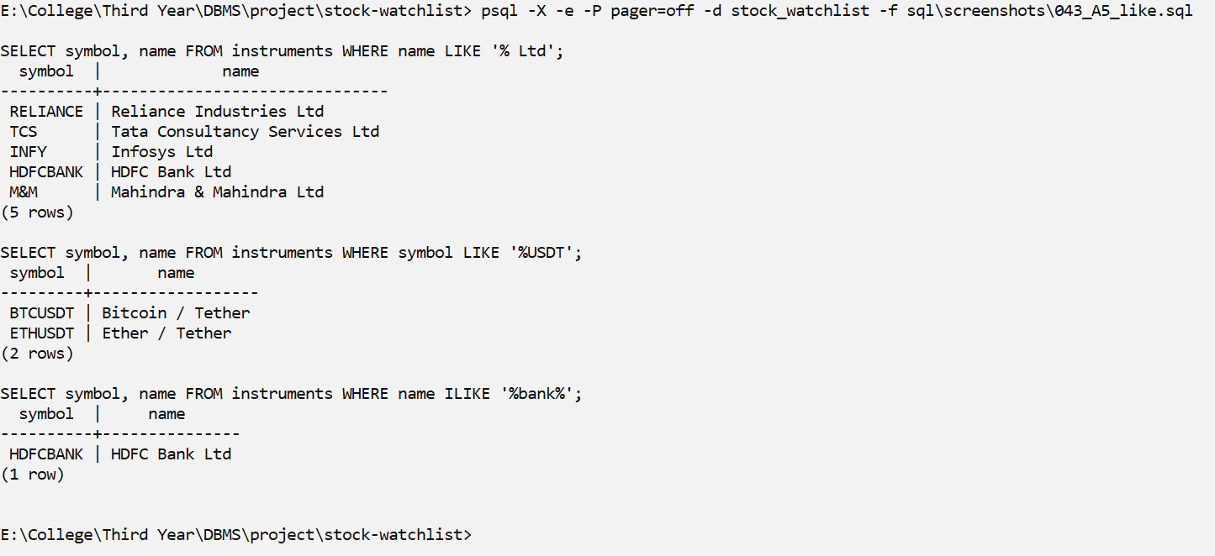
Screenshot A5
Explanation: LIKE matches a pattern, where % means 'any text'. ILIKE does the same but ignores upper and lower case.
A6 – Basic: IS NULL / IS NOT NULL
Question: Which ticks arrived with an UNKNOWN volume (NULL, not zero)?
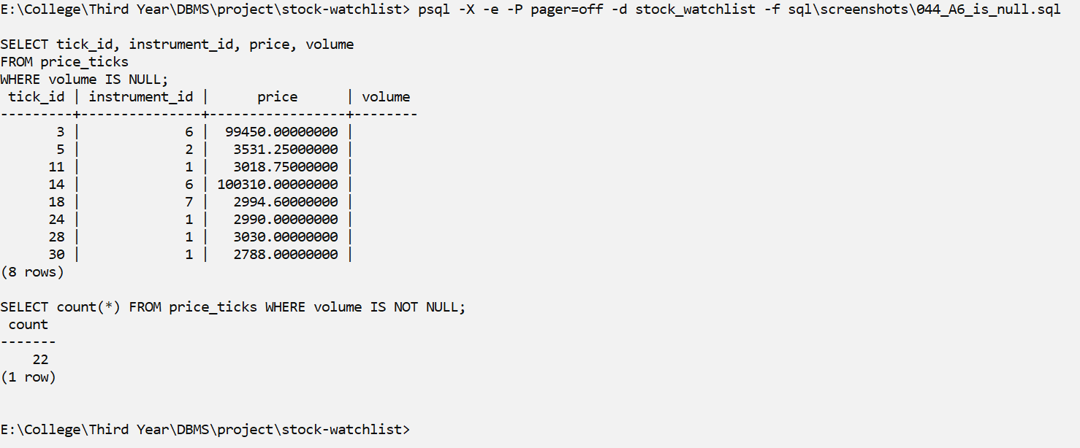
Screenshot A6
Explanation: A NULL volume means the volume is unknown (not zero). NULL cannot be found with = NULL, so IS NULL is used.

B. Aggregate Queries
B1 – Aggregate: COUNT, MIN, MAX, AVG with GROUP BY
Question: For each instrument, how many ticks and what price range?
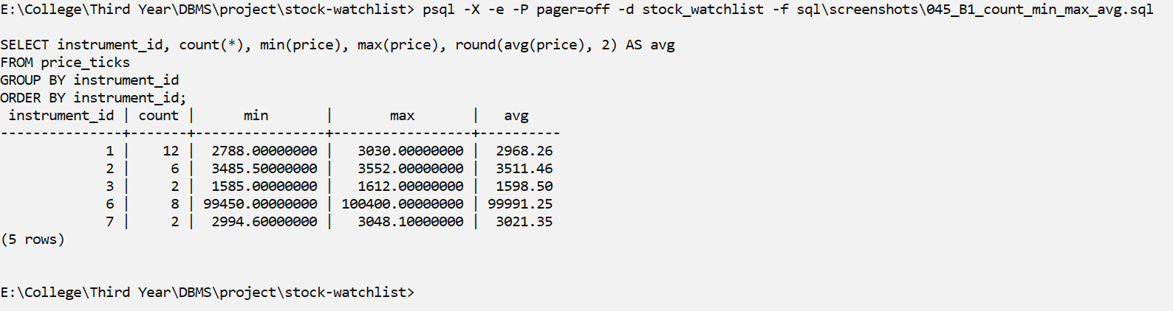
Screenshot B1
Explanation: GROUP BY makes one group per instrument, and COUNT, MIN, MAX and AVG are calculated for each group.
B2 – Aggregate: SUM and COUNT(*) vs COUNT(column)
Question: Total traded volume per instrument? (SUM and COUNT(col) skip NULLs)
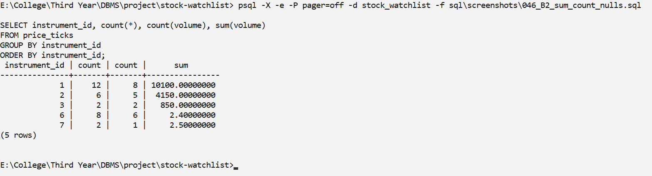
Screenshot B2
Explanation: COUNT(*) counts all rows, while COUNT(volume) and SUM(volume) skip the NULL values.
B3 – Aggregate: GROUP BY on two columns
Question: How many alerts fired per user and direction (ABOVE / BELOW)?
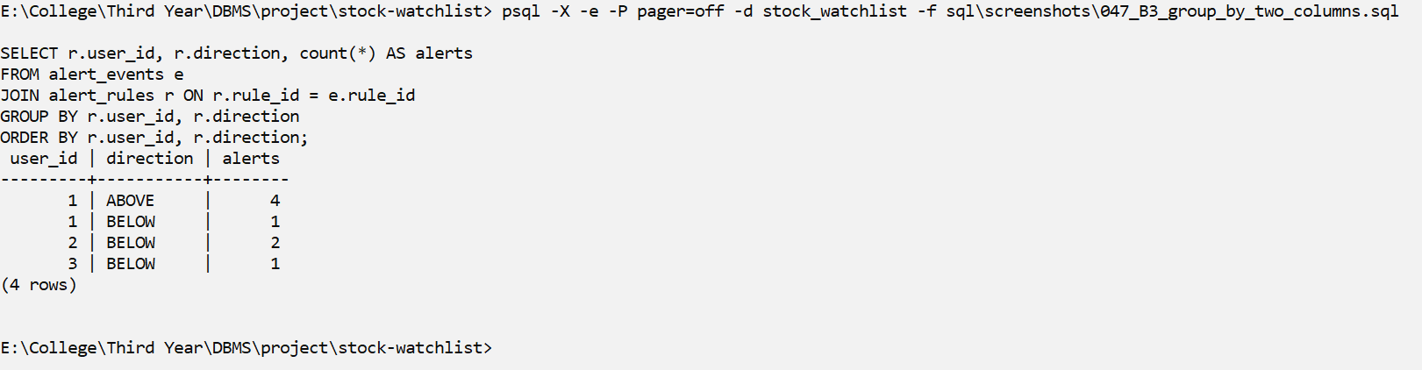
Screenshot B3
Explanation: Grouping by two columns gives one row for each user and direction.
B4 – Aggregate: WHERE vs HAVING in ONE query
What it shows: WHERE filters ROWS before grouping; HAVING filters GROUPS after. Q: Among ticks with a known volume, which instruments have >= 3 of them?
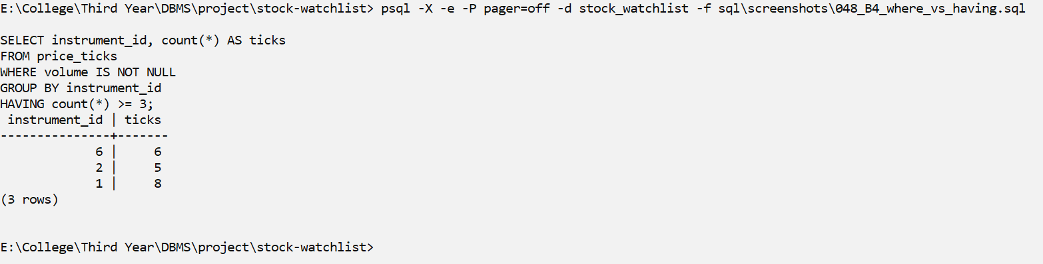
Screenshot B4
Explanation: WHERE removes the rows with unknown volume before grouping; HAVING removes the groups with fewer than 3 rows after grouping.
B5 – Aggregate: GROUP BY + HAVING
Question: Which watchlists contain at least 3 instruments?
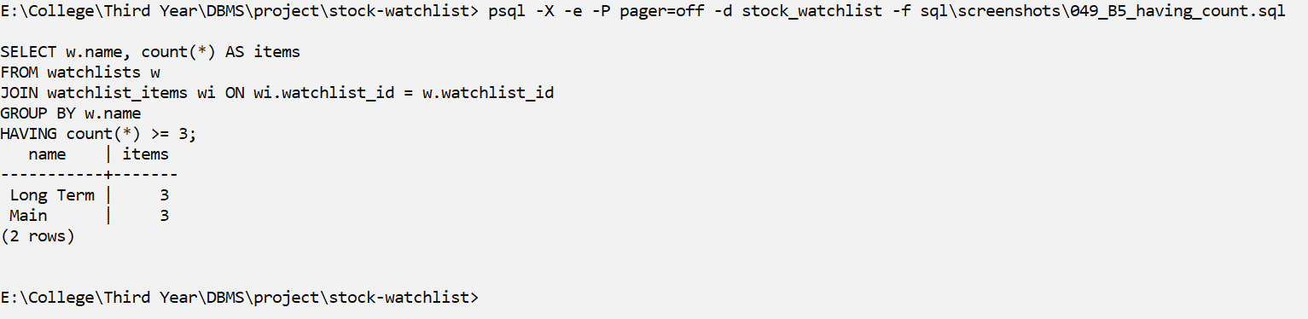
Screenshot B5
Explanation: HAVING keeps only the watchlists with 3 or more instruments.

C. Joins
C1 – Join: INNER JOIN across 4 tables (M:N through watchlist_items)
Question: Which instruments are in each user's watchlists?
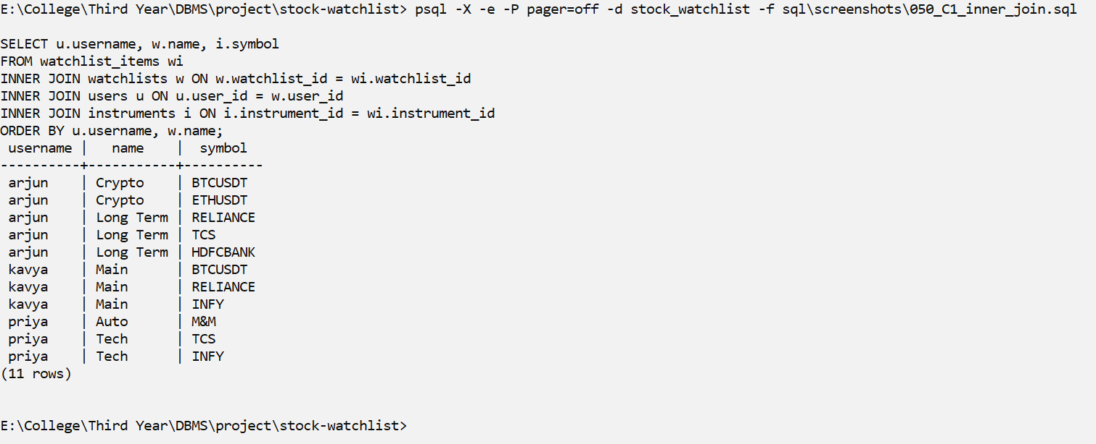
Screenshot C1
Explanation: INNER JOIN keeps only matching rows. watchlist_items connects watchlists and instruments (the many-to-many relationship).
C2 – Join: LEFT OUTER JOIN
Question: Tick count for EVERY instrument, including those with no data yet
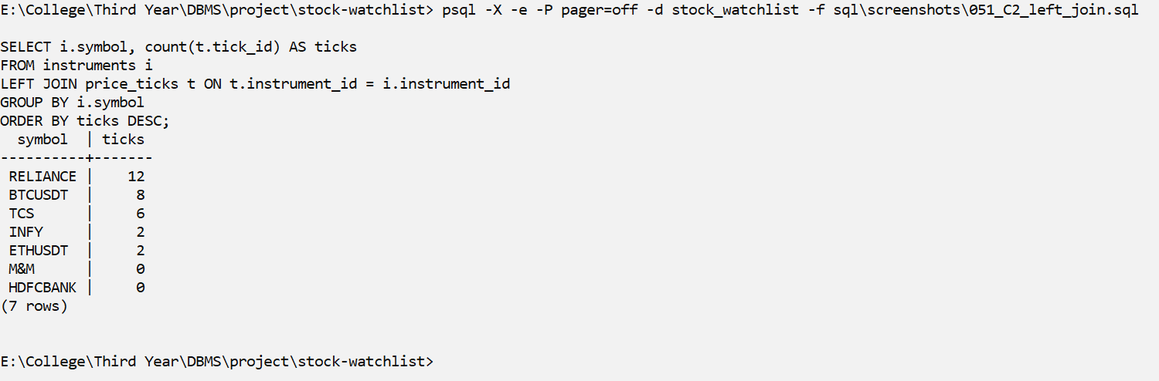
Screenshot C2
Explanation: LEFT JOIN keeps every instrument, even those with no ticks, which show a count of 0.
C3 – Join: RIGHT OUTER JOIN
Question: Every instrument with its alert rules (NULL = nobody has a rule on it)
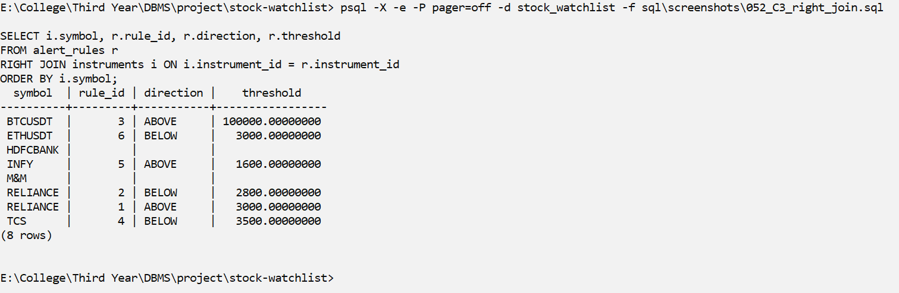
Screenshot C3
Explanation: RIGHT JOIN keeps every instrument from the right side; instruments with no rule show NULL in the rule columns.
C4 – Join: FULL OUTER JOIN
Question: Per user, which instruments are watched, which have rules, which both? (a rule on an unwatched instrument appears only from the right side)
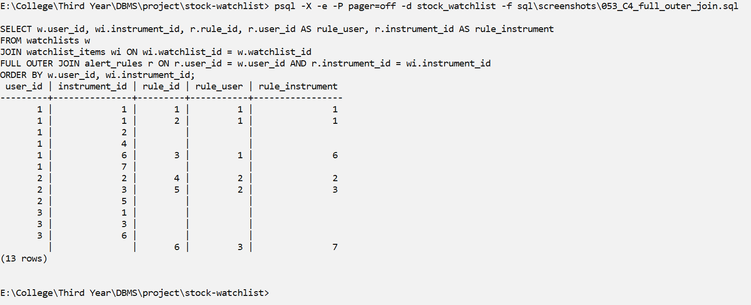
Screenshot C4
Explanation: FULL OUTER JOIN keeps rows from both sides: pairs that are only watched, pairs that only have a rule, and pairs that have both.
C5 – Join: SELF JOIN (watchlist_items joined to itself)
Question: Which pairs of different users watch the same instrument?
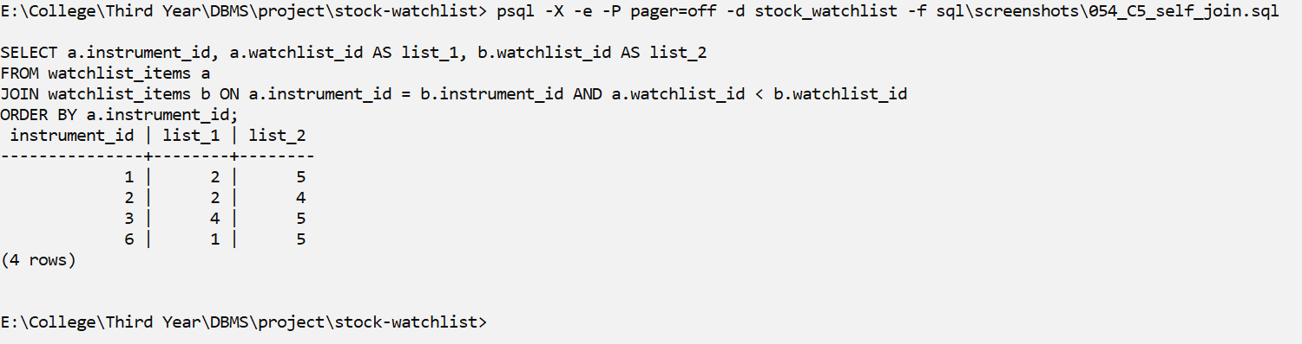
Screenshot C5
Explanation: watchlist_items is joined to itself to find two different users who watch the same instrument. wa.user_id < wb.user_id stops each pair from appearing twice.
C6 – Join: CROSS JOIN (every user x every instrument = 3 x 7 = 21 rows)
Question: Rule-coverage matrix: how many rules does each user have per instrument?
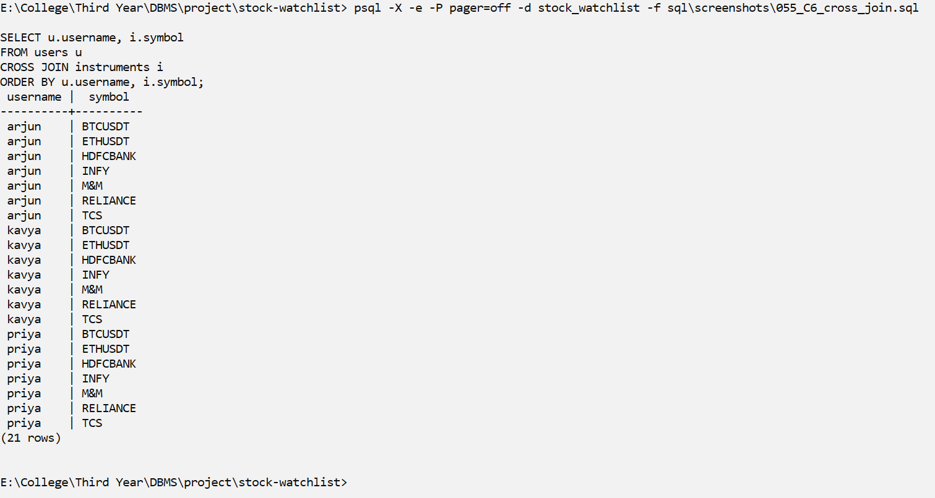
Screenshot C6
Explanation: CROSS JOIN pairs every user with every instrument (3 × 7 = 21 rows) to build a rule coverage matrix.

D. Subqueries
D1 – Subquery: scalar (returns exactly one value)
Question: What is the most recent tick, and how far is each TCS tick from the TCS average?
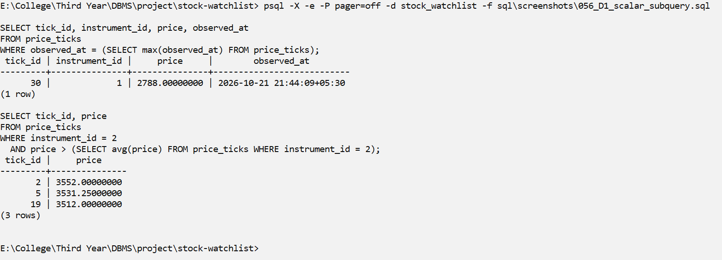
Screenshot D1
Explanation: The inner query returns one value (the latest time, or the average price), which the outer query then uses.
D2 – Subquery: single-row (compared with =)
Question: Which other instruments use the same currency as BTCUSDT? At what moment was BTCUSDT at its highest price?
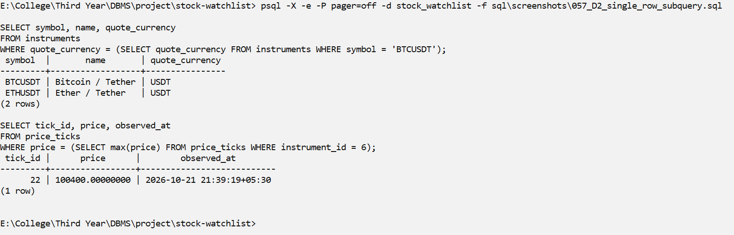
Screenshot D2
Explanation: The inner query returns exactly one row, so it can be compared with =.
D3 – Subquery: multi-row with IN
Question: Which instruments have produced at least one alert?
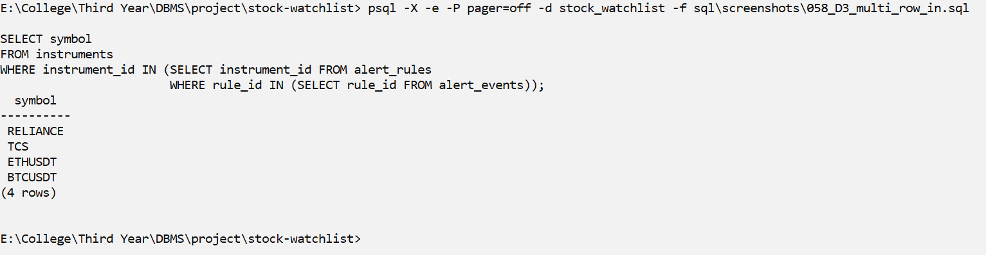
Screenshot D3
Explanation: The inner query returns many instrument_ids, and IN checks whether the instrument is one of them.
D4 – Subquery: multi-row with ALL and ANY
Question: Q1 (ALL): RELIANCE ticks priced above EVERY RELIANCE rule threshold Q2 (ANY): TCS ticks priced below AT LEAST ONE TCS rule threshold
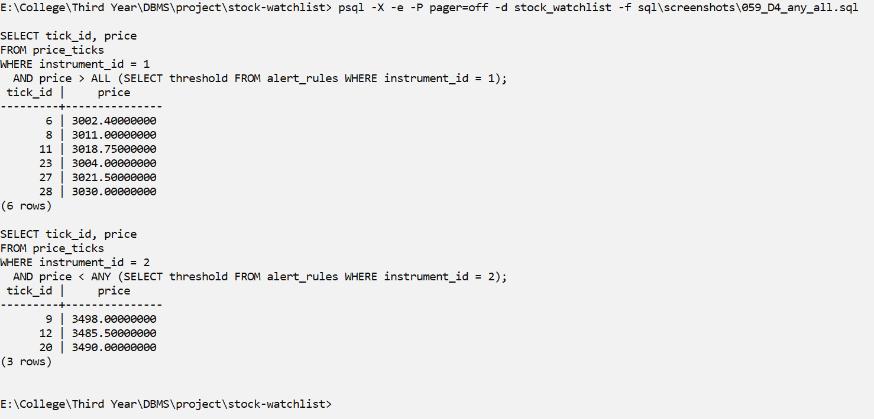
Screenshot D4
Explanation: > ALL means 'greater than every value in the list'; < ANY means 'less than at least one value'.
D5 – Subquery: correlated (inner query uses the outer row t.instrument_id)
Question: Which ticks were priced above their OWN instrument's average?
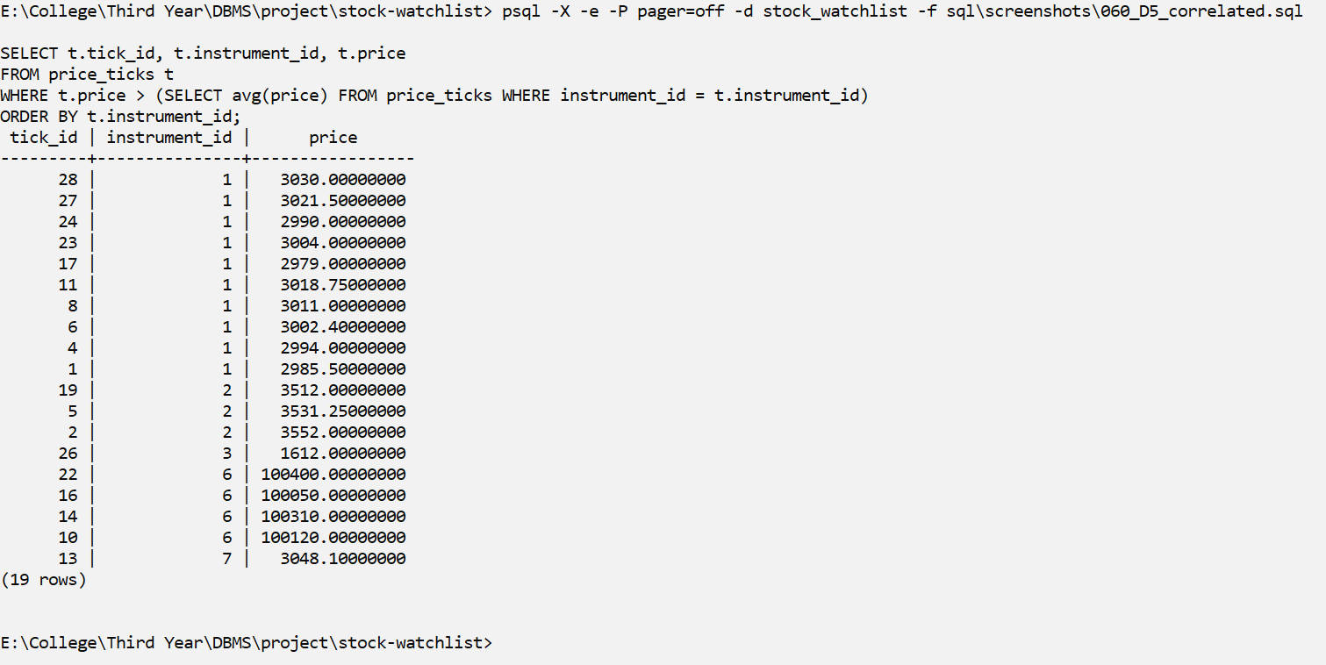
Screenshot D5
Explanation: The inner query runs again for every outer row, because it uses t.instrument_id from the outer query.
D6 – Subquery: EXISTS
Question: Which alert rules have fired at least once?
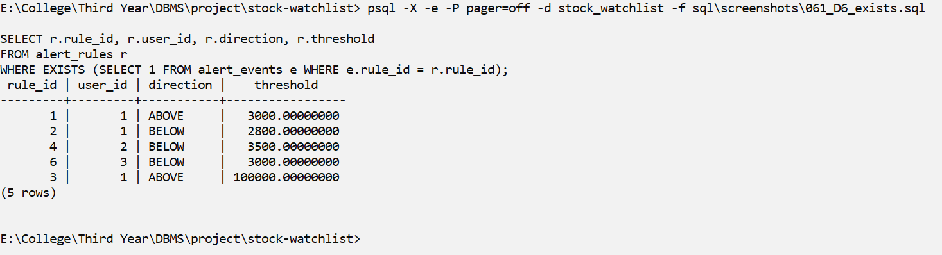
Screenshot D6
Explanation: EXISTS is true when the inner query finds at least one row.
D7 – Subquery: NOT EXISTS
Question: Which instruments have no price data yet? Which rules never fired?
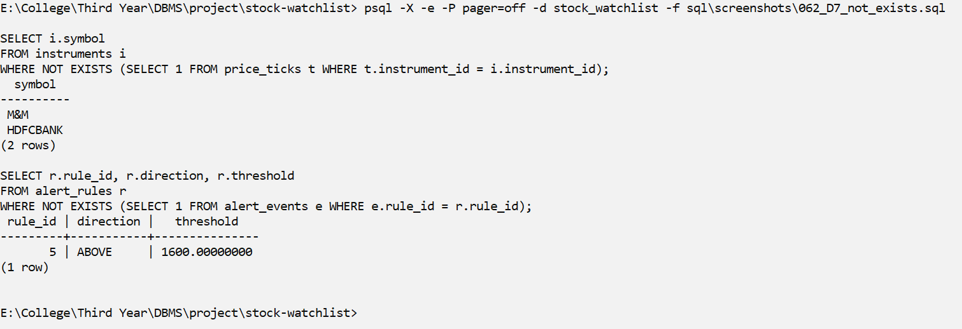
Screenshot D7
Explanation: NOT EXISTS finds rows with no match: instruments with no ticks, and rules that never fired.
D8 – Subquery: NOT IN and the NULL pitfall
Question: Which TCS trade sizes (volume) never occurred on RELIANCE? RELIANCE has NULL volumes, so x NOT IN (..., NULL) is never TRUE -> 0 rows.
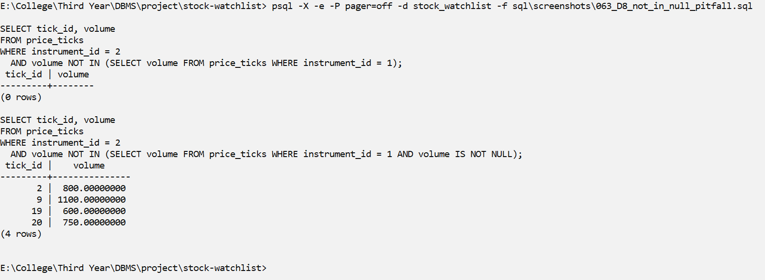
Screenshot D8
Explanation: If the NOT IN list contains a NULL, the condition is never TRUE, so the first query wrongly returns 0 rows. Removing the NULLs inside the subquery, or using NOT EXISTS, gives the correct answer.

E. Set Operations
E1 – Set operation: UNION (duplicates removed)
Question: Which instruments does arjun care about (watched OR has a rule)?
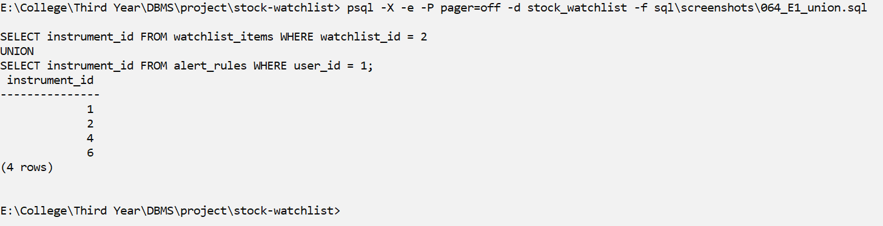
Screenshot E1
Explanation: UNION joins the two results and removes duplicates.
E2 – Set operation: UNION ALL (duplicates kept)
Question: How many times is each instrument referenced by watchlists + rules?
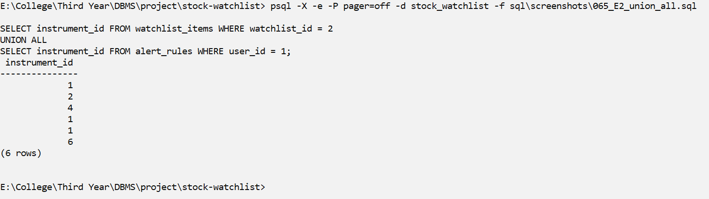
Screenshot E2
Explanation: UNION ALL keeps duplicates, so we can count how many times each instrument is used.
E3 – Set operation: INTERSECT
Question: Which (user, instrument) pairs are BOTH watched AND have an alert rule?
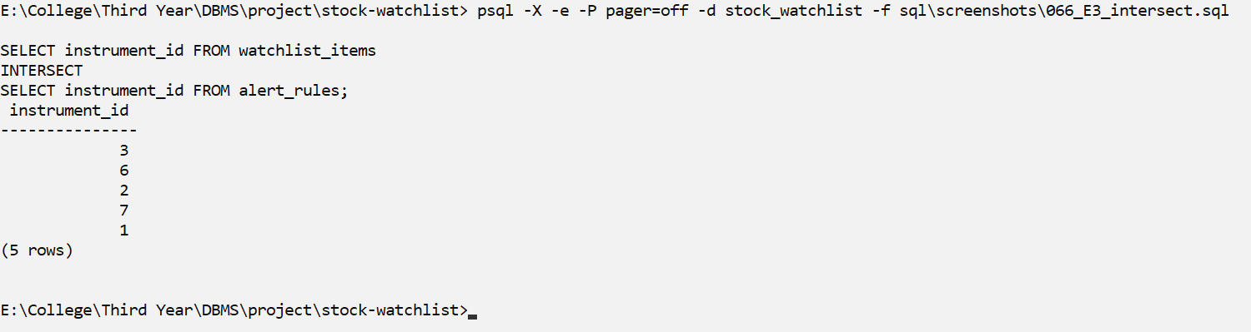
Screenshot E3
Explanation: INTERSECT returns only the pairs that appear in both queries.
E4 – Set operation: EXCEPT (PostgreSQL's MINUS)
Question: Which (user, instrument) pairs are watched but have NO alert rule?
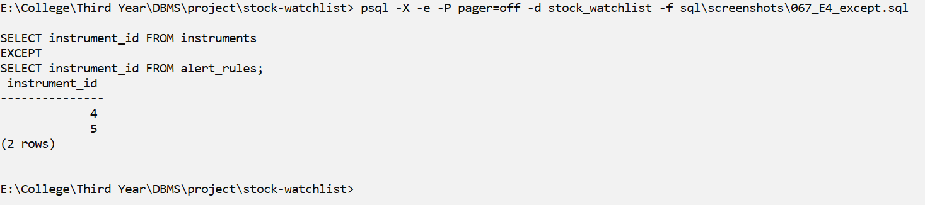
Screenshot E4
Explanation: EXCEPT returns the pairs from the first query that are not in the second one. PostgreSQL uses EXCEPT instead of MINUS.

F. Advanced Functions
F1 – Function: CASE
Question: Classify each RELIANCE tick by trade size and by price zone
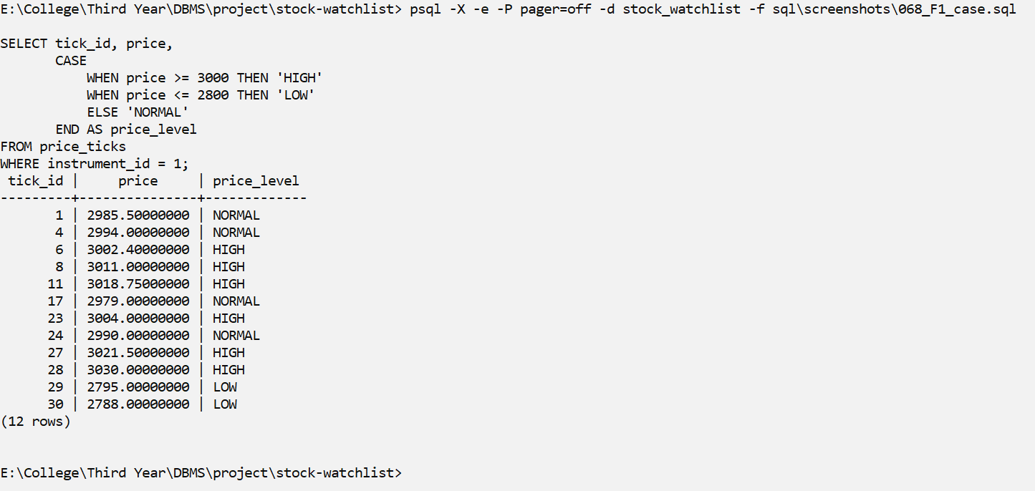
Screenshot F1
Explanation: CASE works like if/else inside a query and gives a label to each row.
F2 – Function: COALESCE (first non-NULL value)
Question: Latest price per instrument, with a readable text when there is none
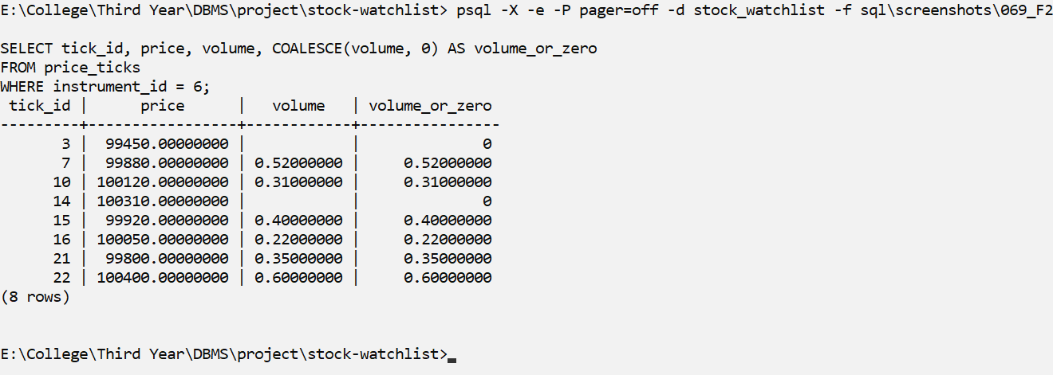
Screenshot F2
Explanation: COALESCE returns the first value that is not NULL, so missing data is shown as readable text.
F3 – Function: NULLIF (avoid division by zero)
Question: Ratio of ticks with a known volume to ticks with an unknown volume (INFY has 0 unknown-volume ticks: NULLIF turns 0 into NULL, no error)
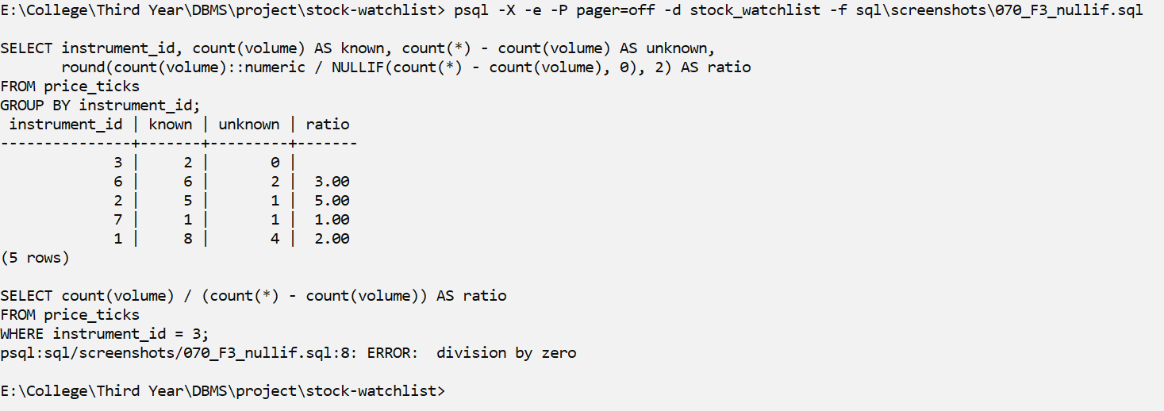
Screenshot F3
Explanation: NULLIF(x, 0) turns 0 into NULL, so the division gives NULL instead of an error. The last query shows the 'division by zero' error that happens without NULLIF.
F4 – Function: date / time
Question: Show RELIANCE ticks in IST and UTC, the minute bucket, and seconds since the first tick
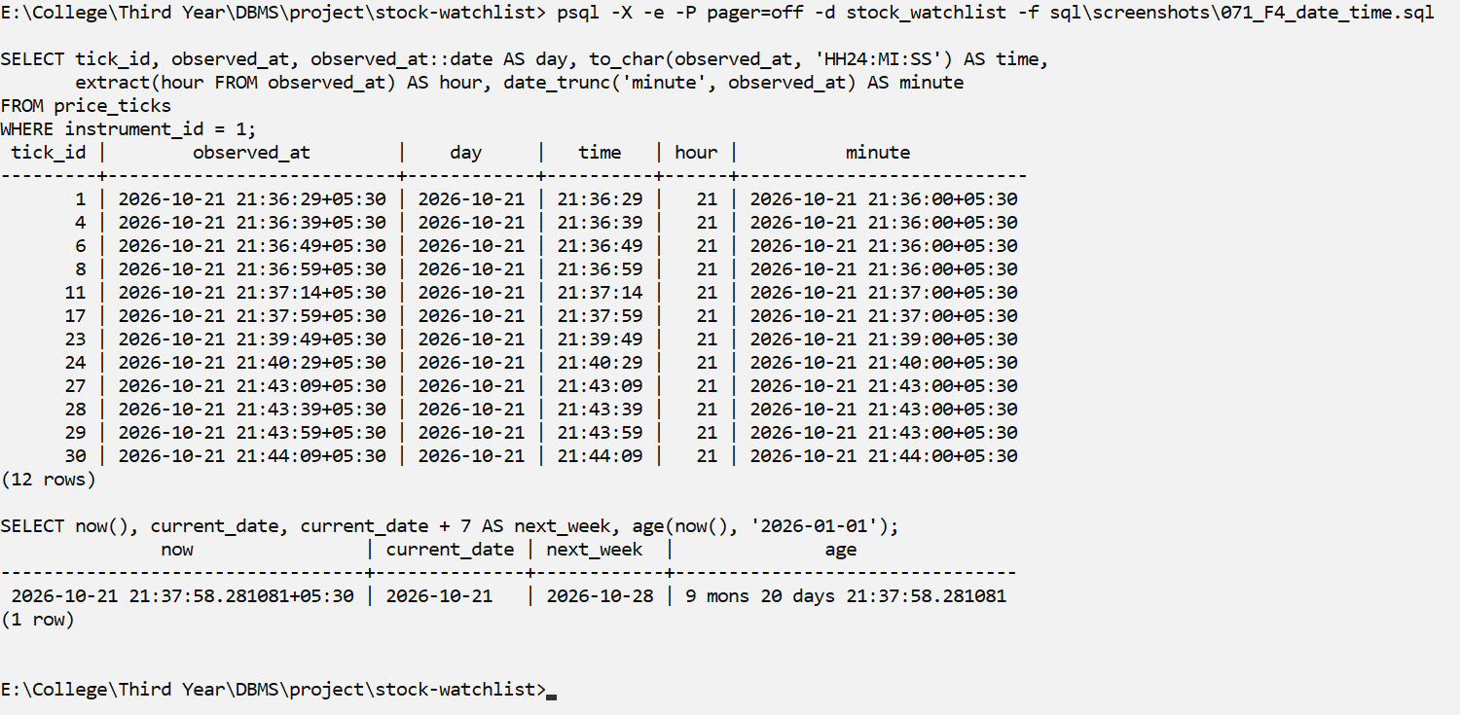
Screenshot F4
Explanation: to_char, AT TIME ZONE, date_trunc, extract and age work with dates and times. Times are stored as TIMESTAMPTZ and shown in IST.
F5 – Function: string functions
Question: Build display labels and split identifiers into parts
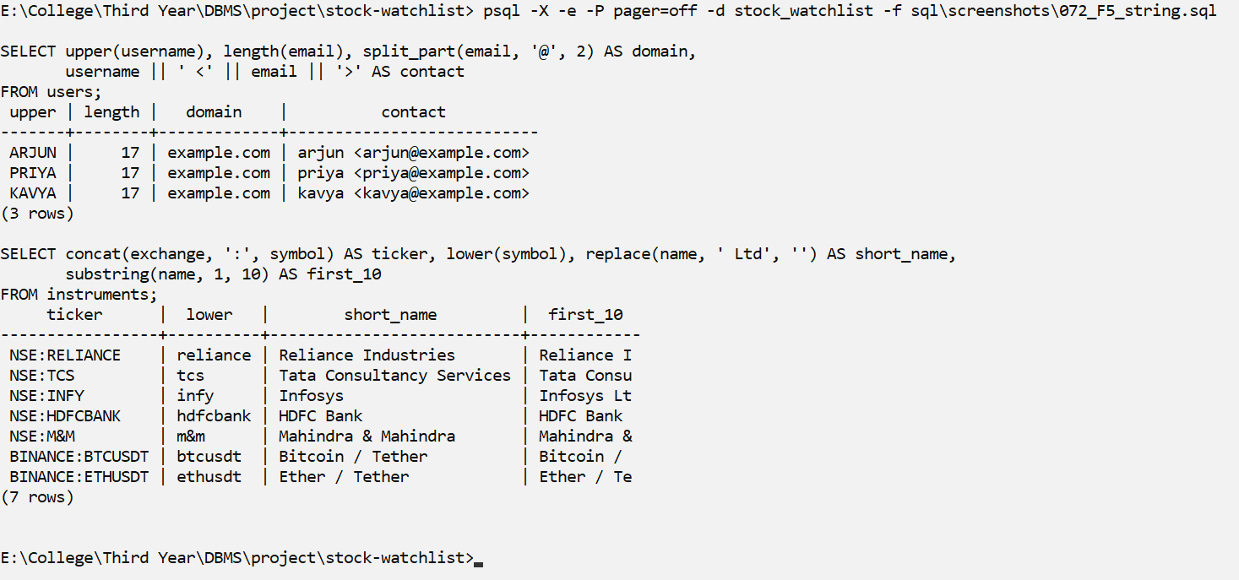
Screenshot F5
Explanation: upper, initcap, length, split_part, concat, replace, left and format change or split text.
F6 – Function: numeric functions
Question: BTCUSDT trade value, rounding, and distance from the 100,000 rule
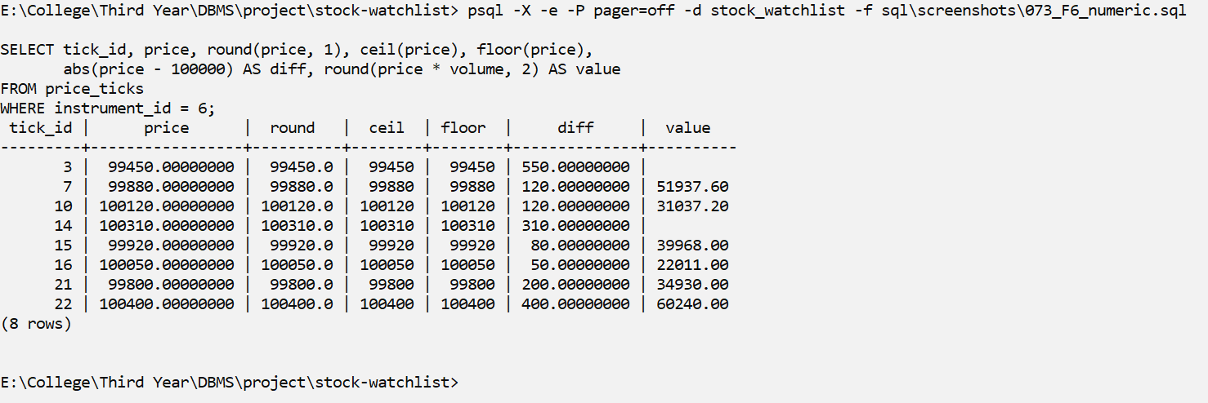
Screenshot F6
Explanation: round, ceil, floor, trunc, abs, sign and mod work with numbers.

G. Window / Analytic Functions
G1 – Window: ROW_NUMBER, RANK, DENSE_RANK (difference shown by the ties)
Question: Rank instruments by how many ticks they have
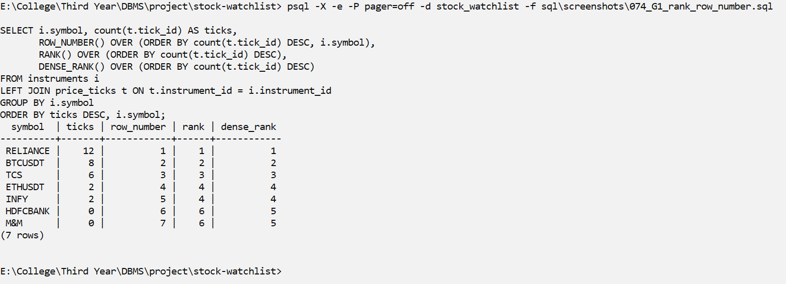
Screenshot G1
Explanation: ROW_NUMBER always gives different numbers; RANK skips numbers after a tie; DENSE_RANK does not skip.
G2 – Window: running total and running average (SUM / AVG OVER ORDER BY)
Question: Cumulative traded volume and moving price average for BTCUSDT
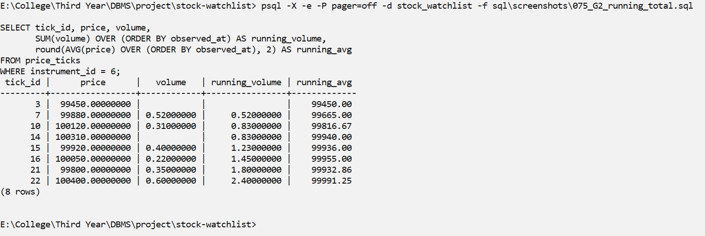
Screenshot G2
Explanation: SUM and AVG with OVER (ORDER BY ...) give a running total; ROWS BETWEEN 2 PRECEDING AND CURRENT ROW gives a moving average of 3 ticks.
G3 – Window: LAG and LEAD
Question: Previous / next RELIANCE price, the change, and where it crossed 3000 (the same previous-vs-new comparison the alert trigger makes)
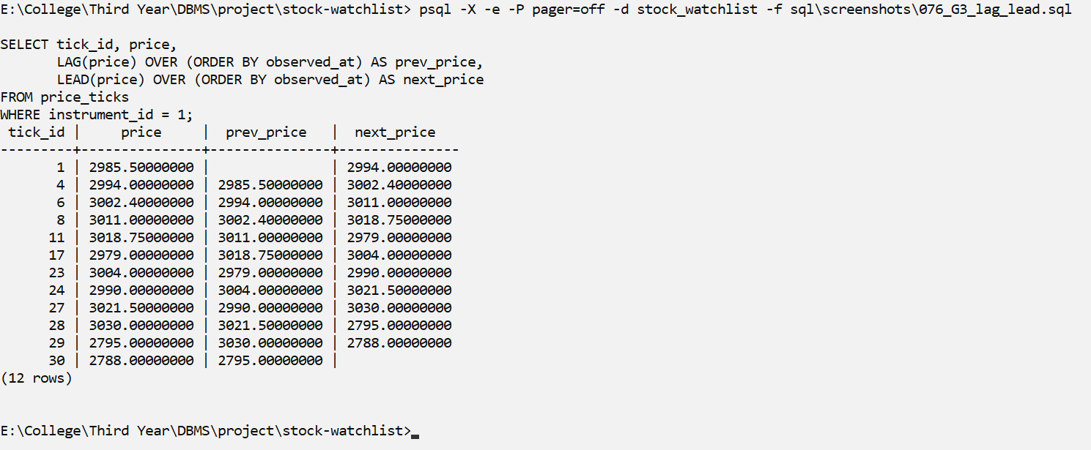
Screenshot G3
Explanation: LAG gives the previous price and LEAD gives the next price. Comparing the previous and the new price is the same check our alert trigger uses to find a crossing.

Indexes and EXPLAIN Comparison
Our most common query is 'the latest prices of one instrument'. For it we created one B-tree index on price_ticks (instrument_id, observed_at DESC, tick_id DESC). To see the difference clearly, we compared the query on a separate test database with 500,000 ticks, once without the index and once with it.
S11 – Creating the performance index (sql/06_indexes.sql)
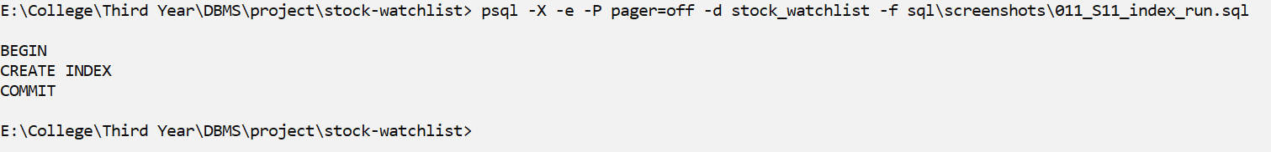
Screenshot S11
Explanation: Creates our performance index ix_price_ticks_instrument_time on (instrument_id, observed_at DESC, tick_id DESC).
IX1 – All indexes: 14 created by PK / UNIQUE constraints + 1 performance index
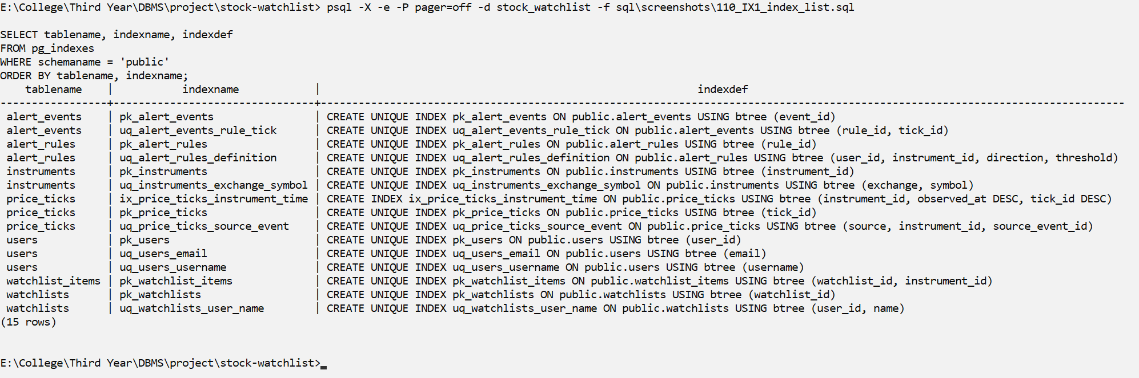
Screenshot IX1
Explanation: Lists all indexes. 14 are created automatically by PRIMARY KEY and UNIQUE constraints, and 1 is our performance index.
IX2 – EXPLAIN ANALYZE WITHOUT ix_price_ticks_instrument_time (500,000 rows)
What it shows: query: latest 50 RELIANCE ticks. Index dropped inside a transaction, then ROLLBACK restores it (DDL is transactional in PostgreSQL)
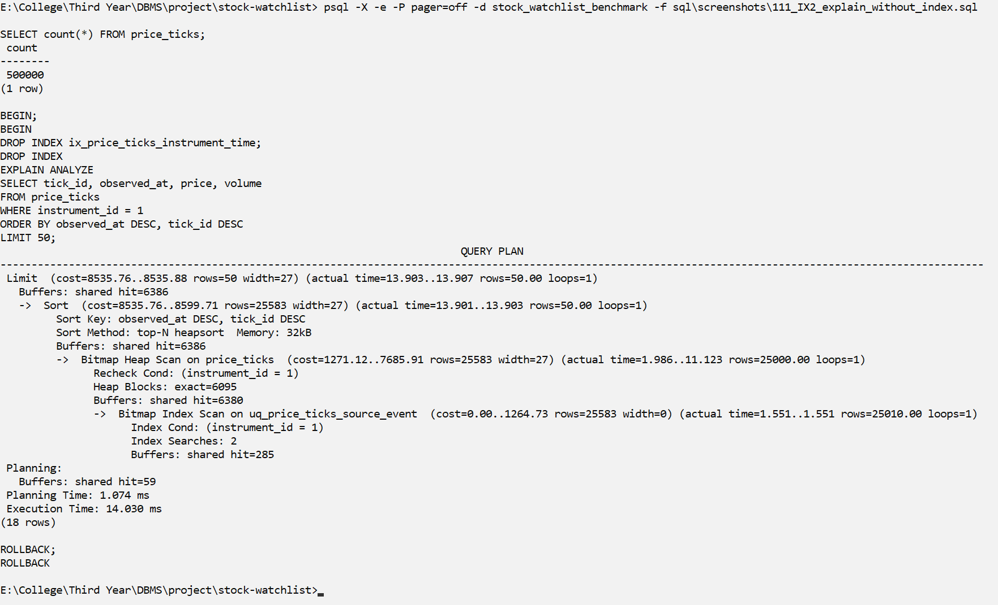
Screenshot IX2
Explanation: On a test database with 500,000 ticks, without our index PostgreSQL has to read all (about 25,000) RELIANCE rows and sort them to get the latest 50. Execution time: 19.966 ms.
IX3 – EXPLAIN ANALYZE WITH ix_price_ticks_instrument_time (same query, 500,000 rows)
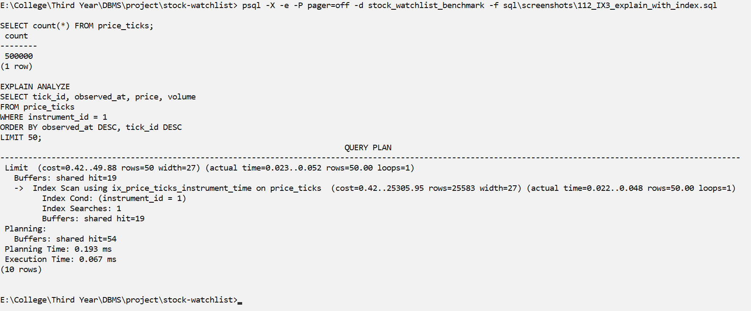
Screenshot IX3
Explanation: With the index, PostgreSQL reads the latest 50 rows directly in the right order (Index Scan, no Sort step). Execution time: 0.100 ms, using 19 buffers instead of 6,383.
IX4 – Size of the table and each of its indexes (benchmark database)
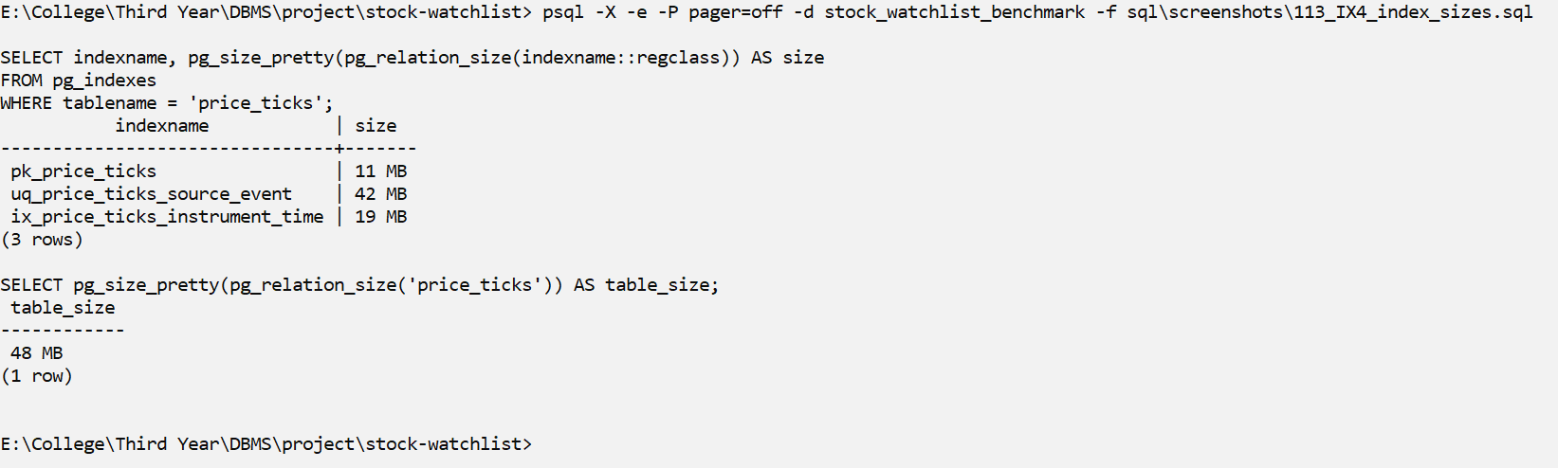
Screenshot IX4
Explanation: The index uses 19 MB on the 500,000-row table (table 48 MB, all indexes together 72 MB). This is the cost we pay for the faster reads.
 | Without index (IX2) | With index (IX3)
Plan | Bitmap Heap Scan + Sort | Index Scan (no Sort)
Rows read for RELIANCE | about 25,000 | 50
Buffers | 6,383 | 19
Execution time | 19.966 ms | 0.100 ms

Advanced SQL Implementation

Complex Business Queries
We wrote 10 complex queries. Each one uses at least 3 tables or a nested/analytic construct. The expected output was worked out from the seed and replay data before running the query.
CQ01 – Complex: 5 tables (users, alert_rules, alert_events, price_ticks, instruments)
Field | Content
ID | CQ01
Business question | For each user and instrument, how many alerts fired, and when / at what price was the most recent one?
SQL | SELECT u.username,  i.symbol,  count(*) AS alerts,  max(t.observed_at)::timestamp(0) AS last_alert_market_time,  ((array_agg(t.price ORDER BY t.observed_at DESC))[1])::numeric(12,2) AS last_alert_price  FROM alert_events e  JOIN alert_rules r ON r.rule_id = e.rule_id  JOIN users u ON u.user_id = r.user_id  JOIN price_ticks t ON t.tick_id = e.tick_id  JOIN instruments i ON i.instrument_id = r.instrument_id  GROUP BY u.username, i.symbol  ORDER BY u.username, alerts DESC, i.symbol;
Expected output | 4 rows: arjun–RELIANCE 3 alerts, arjun–BTCUSDT 2, kavya–ETHUSDT 1 and priya–TCS 2. Together this is 8 alerts, the same number the replay run printed.
Actual output screenshot | 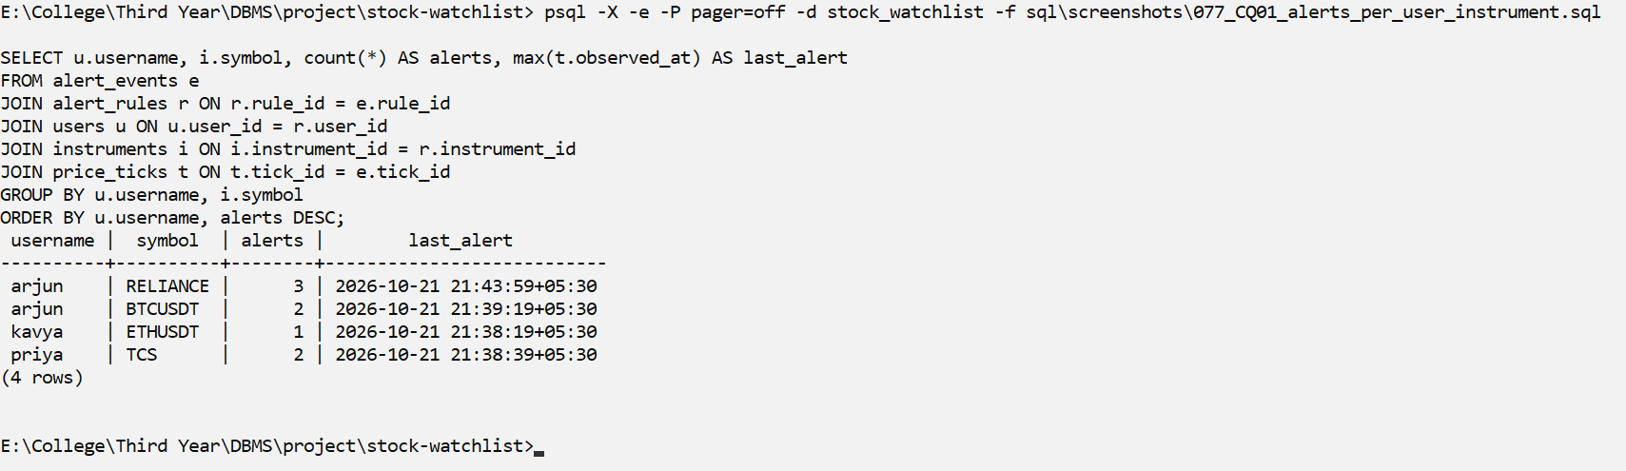
Explanation | alert_events is joined to alert_rules (owner and instrument), users (name), price_ticks (time and price of the tick that fired) and instruments (symbol). GROUP BY user and symbol counts the alerts, and array_agg ordered by time picks the price of the most recent alert. The result is correct because it matches the 8 alerts printed by the replay run (R01).
CQ02 – Complex: 4 tables + LATERAL subquery + UDF
Field | Content
ID | CQ02
Business question | Show every watchlist item with its latest price and % change since its first tick (what the website dashboard shows)
SQL | SELECT u.username, w.name AS watchlist, i.symbol,  lp.price::numeric(12,2) AS latest_price,  i.quote_currency AS ccy,  reporting.fn_price_change_pct(i.instrument_id) AS change_pct,  lp.observed_at::time(0) AS as_of  FROM users u  JOIN watchlists w ON w.user_id = u.user_id  JOIN watchlist_items wi ON wi.watchlist_id = w.watchlist_id  JOIN instruments i ON i.instrument_id = wi.instrument_id  LEFT JOIN LATERAL (  SELECT t.price, t.observed_at FROM price_ticks t  WHERE t.instrument_id = i.instrument_id  ORDER BY t.observed_at DESC, t.tick_id DESC LIMIT 1) lp ON true  ORDER BY u.username, w.name, i.symbol;
Expected output | 11 rows, one for each watchlist item. HDFCBANK and M&M have no ticks, so their price is empty. RELIANCE ends at 2788.00, which is about 6.6% below its first tick (2985.50).
Actual output screenshot | 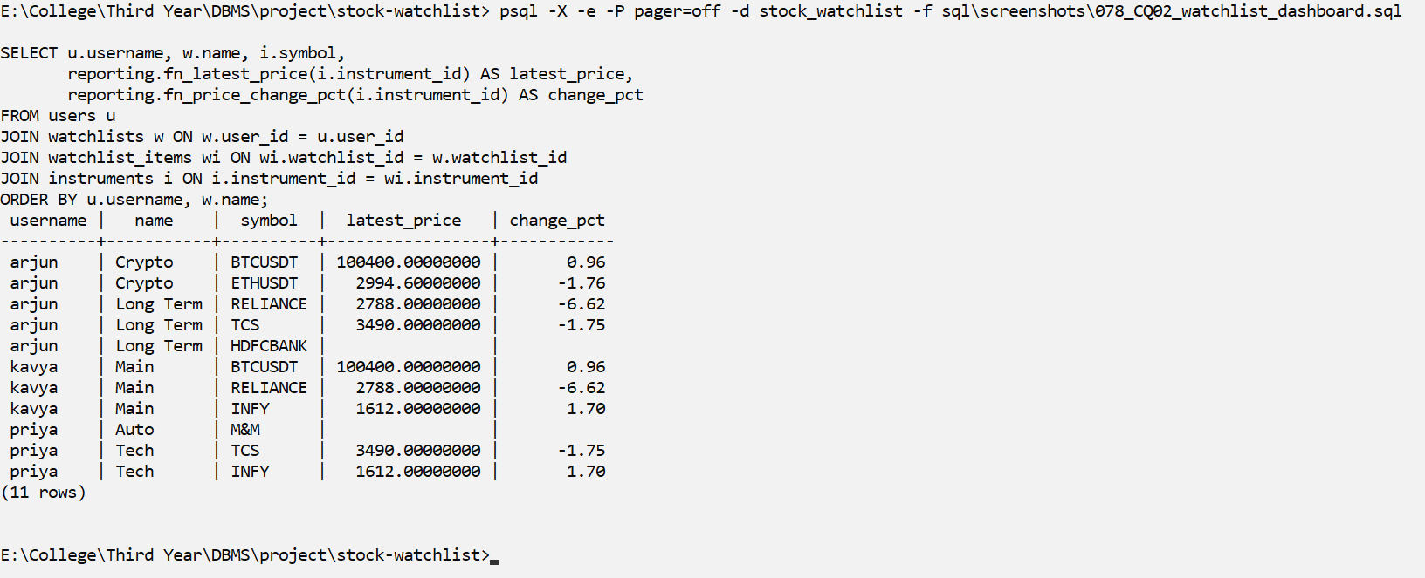
Explanation | 4 tables are joined through the many-to-many link. LEFT JOIN LATERAL picks the newest tick of each instrument (ORDER BY observed_at DESC, tick_id DESC LIMIT 1) and keeps instruments that have no ticks. fn_price_change_pct() is our user-defined function. This is the same data the web dashboard shows.
CQ03 – Complex: 4 tables + LATERAL + CASE
Field | Content
ID | CQ03
Business question | For every ACTIVE rule, how far (%) is the latest price from the threshold, and is the rule's condition currently met?
SQL | SELECT r.rule_id, u.username, i.symbol, r.direction,  r.threshold::numeric(12,2) AS threshold,  lp.price::numeric(12,2) AS latest_price,  round((lp.price - r.threshold) / r.threshold * 100, 2) AS distance_pct,  CASE WHEN lp.price IS NULL THEN 'no data'  WHEN (r.direction = 'ABOVE' AND lp.price >= r.threshold)  OR (r.direction = 'BELOW' AND lp.price <= r.threshold) THEN 'condition met'  ELSE 'waiting' END AS state  FROM alert_rules r  JOIN users u ON u.user_id = r.user_id  JOIN instruments i ON i.instrument_id = r.instrument_id  LEFT JOIN LATERAL (  SELECT t.price FROM price_ticks t WHERE t.instrument_id = r.instrument_id  ORDER BY t.observed_at DESC, t.tick_id DESC LIMIT 1) lp ON true  WHERE r.is_active  ORDER BY abs(lp.price - r.threshold) / r.threshold NULLS LAST;
Expected output | 5 rows (rule 5 is disabled, so it is not shown). Rules 2, 3, 4 and 6 have their condition met; rule 1 (RELIANCE ABOVE 3000) is waiting, because the latest RELIANCE price is 2788.
Actual output screenshot | 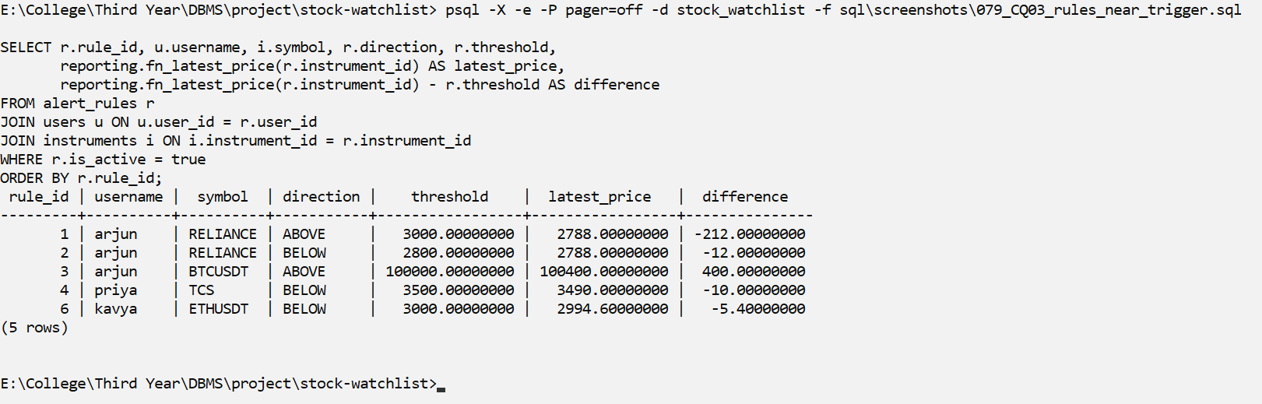
Explanation | WHERE r.is_active removes the disabled rule. LATERAL gets the latest price of each rule's instrument, and CASE decides the state. The rows are sorted by distance from the threshold, so the closest rule comes first.
CQ04 – Complex: 5 tables + NOT EXISTS (nested)
Field | Content
ID | CQ04
Business question | Which alerts fired on an instrument that the rule's owner does NOT have in any of their watchlists?
SQL | SELECT e.event_id, u.username, i.symbol, r.direction,  r.threshold::numeric(12,2) AS threshold, t.price::numeric(12,2) AS price  FROM alert_events e  JOIN alert_rules r ON r.rule_id = e.rule_id  JOIN users u ON u.user_id = r.user_id  JOIN instruments i ON i.instrument_id = r.instrument_id  JOIN price_ticks t ON t.tick_id = e.tick_id  WHERE NOT EXISTS (  SELECT 1 FROM watchlists w  JOIN watchlist_items wi ON wi.watchlist_id = w.watchlist_id  WHERE w.user_id = r.user_id AND wi.instrument_id = r.instrument_id)  ORDER BY e.event_id;
Expected output | 1 row: kavya's ETHUSDT BELOW 3000 alert. kavya's only watchlist (Main) has RELIANCE, INFY and BTCUSDT, but not ETHUSDT.
Actual output screenshot | 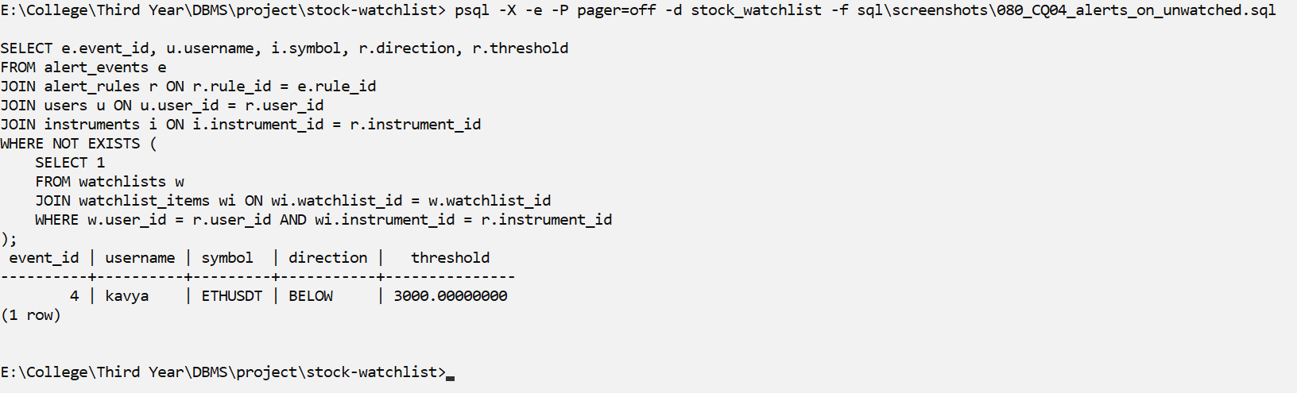
Explanation | For each alert, NOT EXISTS looks in all the owner's watchlists for the rule's instrument. If none is found, the alert is shown. All other alerts are on instruments that their owner watches.
CQ05 – Complex: aggregate + window (RANK)
Field | Content
ID | CQ05
Business question | Rank instruments by volatility: price range as % of average price (only instruments with at least 2 ticks)
SQL | SELECT i.symbol,  count(*) AS ticks,  min(t.price)::numeric(12,2) AS low,  max(t.price)::numeric(12,2) AS high,  round((max(t.price) - min(t.price)) / avg(t.price) * 100, 3) AS range_pct,  round(stddev_samp(t.price), 2) AS std_dev,  RANK() OVER (ORDER BY (max(t.price) - min(t.price)) / avg(t.price) DESC) AS volatility_rank  FROM price_ticks t  JOIN instruments i ON i.instrument_id = t.instrument_id  GROUP BY i.symbol  HAVING count(*) >= 2  ORDER BY volatility_rank;
Expected output | 5 rows (HDFCBANK and M&M have no ticks). RELIANCE should be the most volatile, because it moved between 2788 and 3030, about 8% of its average.
Actual output screenshot | 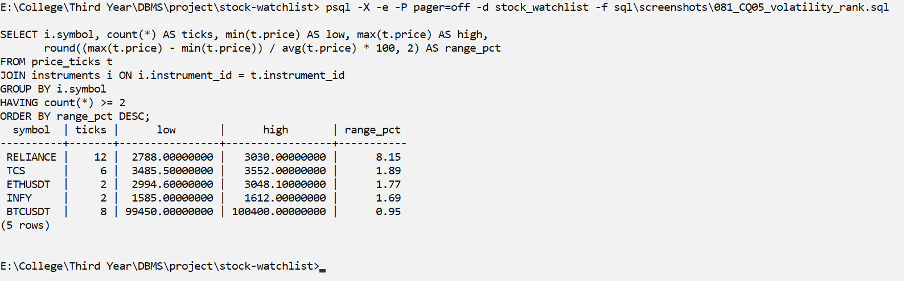
Explanation | GROUP BY makes one group per instrument and HAVING count(*) >= 2 keeps instruments with enough data. The range is divided by the average to compare instruments with very different prices (INR stocks and USDT crypto). RANK() is applied to the grouped result.
CQ06 – Complex: 4 tables + window (LAG) in a subquery
Field | Content
ID | CQ06
Business question | Which DISABLED rules would have fired? (crossings they missed)
SQL | SELECT r.rule_id, u.username, i.symbol, r.direction,  r.threshold::numeric(12,2) AS threshold,  x.prev_price::numeric(12,2) AS prev_price,  x.price::numeric(12,2) AS price,  x.observed_at::time(0) AS at  FROM alert_rules r  JOIN users u ON u.user_id = r.user_id  JOIN instruments i ON i.instrument_id = r.instrument_id  JOIN (SELECT t.instrument_id, t.price, t.observed_at,  LAG(t.price) OVER (PARTITION BY t.instrument_id  ORDER BY t.observed_at, t.tick_id) AS prev_price  FROM price_ticks t) x ON x.instrument_id = r.instrument_id  WHERE NOT r.is_active  AND ( (r.direction = 'ABOVE' AND x.prev_price < r.threshold AND x.price >= r.threshold)  OR (r.direction = 'BELOW' AND x.prev_price > r.threshold AND x.price <= r.threshold))  ORDER BY r.rule_id, x.observed_at;
Expected output | 1 row: rule 5 (priya, INFY ABOVE 1600) is disabled, and INFY moved from 1585 to 1612, which crosses 1600.
Actual output screenshot | 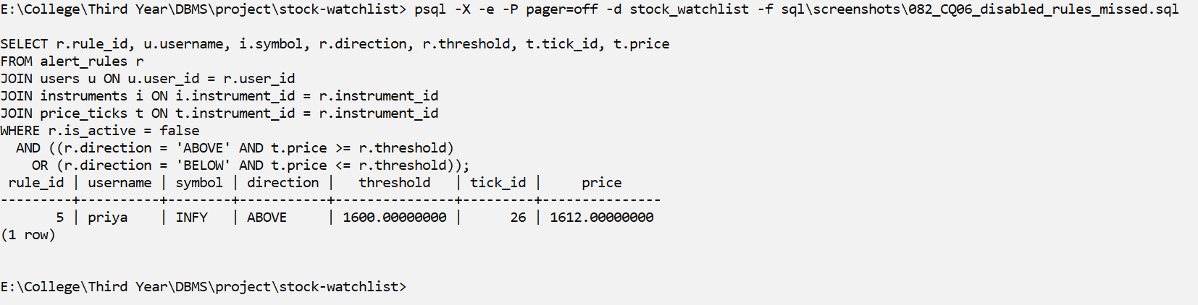
Explanation | The inner query uses LAG partitioned by instrument to get each tick's previous price. The outer query keeps only disabled rules and uses the same crossing condition as the trigger (previous < threshold and new >= threshold for ABOVE).
CQ07 – Complex: correlated scalar subqueries over 5 tables + RANK
Field | Content
ID | CQ07
Business question | How engaged is each user (lists, items, active rules, alerts)?
SQL | SELECT username, watchlists, items, active_rules, alerts,  RANK() OVER (ORDER BY alerts DESC, active_rules DESC) AS engagement_rank  FROM (  SELECT u.username,  (SELECT count(*) FROM watchlists w WHERE w.user_id = u.user_id) AS watchlists,  (SELECT count(*) FROM watchlists w  JOIN watchlist_items wi ON wi.watchlist_id = w.watchlist_id  WHERE w.user_id = u.user_id) AS items,  (SELECT count(*) FROM alert_rules r  WHERE r.user_id = u.user_id AND r.is_active) AS active_rules,  (SELECT count(*) FROM alert_events e  JOIN alert_rules r ON r.rule_id = e.rule_id  WHERE r.user_id = u.user_id) AS alerts  FROM users u) s  ORDER BY engagement_rank, username;
Expected output | arjun is ranked first (2 lists, 5 items, 3 active rules, 5 alerts), then priya (2 alerts), then kavya (1 alert).
Actual output screenshot | 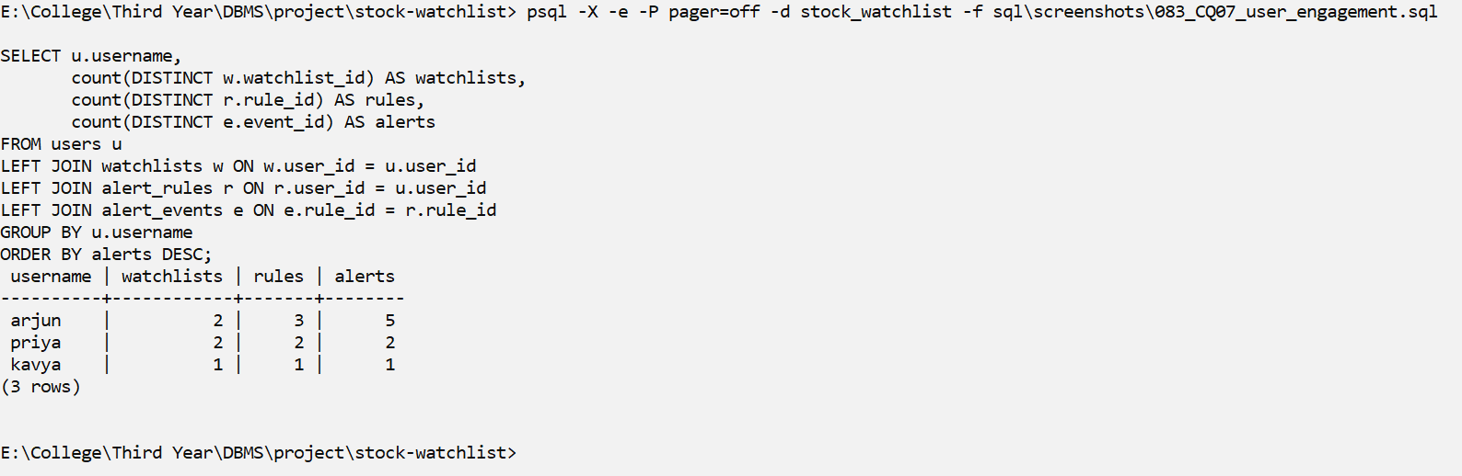
Explanation | Each column is a correlated scalar subquery that counts rows for the current user from a different table. RANK() then orders users by alerts and active rules.
CQ08 – Complex: 4 tables + interval arithmetic
Field | Content
ID | CQ08
Business question | How quickly was each alert recorded after its tick was stored? (the trigger runs inside the same INSERT -> fractions of a millisecond)
SQL | SELECT e.event_id, i.symbol, r.direction,  t.price::numeric(12,2) AS price,  t.ingested_at::time(3) AS tick_stored_at,  e.fired_at::time(3) AS alert_recorded_at,  round(extract(epoch FROM e.fired_at - t.ingested_at) * 1000, 3) AS delay_ms  FROM alert_events e  JOIN price_ticks t ON t.tick_id = e.tick_id  JOIN alert_rules r ON r.rule_id = e.rule_id  JOIN instruments i ON i.instrument_id = r.instrument_id  ORDER BY e.event_id;
Expected output | 8 rows, one for each alert, each with a delay of 0 ms.
Actual output screenshot | 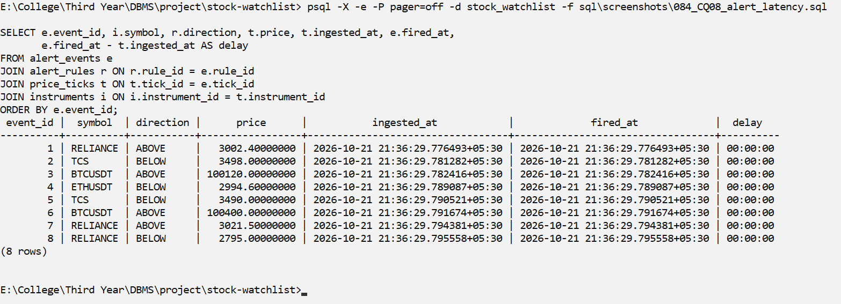
Explanation | fired_at and ingested_at both default to now(), and now() stays the same for the whole transaction. A delay of exactly 0 shows that the alert was written inside the same transaction as the tick, by the trigger.
CQ09 – Complex: window functions + 4 tables
Field | Content
ID | CQ09
Business question | For every fired alert, prove it was a real crossing: show the previous price, the new price and the tick's position in history
SQL | WITH ordered AS (  SELECT t.tick_id, t.instrument_id, t.price, t.observed_at,  LAG(t.price) OVER w AS prev_price,  ROW_NUMBER() OVER w AS tick_no  FROM price_ticks t  WINDOW w AS (PARTITION BY t.instrument_id ORDER BY t.observed_at, t.tick_id))  SELECT e.event_id, u.username, i.symbol, r.direction,  r.threshold::numeric(12,2) AS threshold,  o.prev_price::numeric(12,2) AS prev_price,  o.price::numeric(12,2) AS new_price,  o.tick_no AS nth_tick,  CASE WHEN r.direction = 'ABOVE' THEN o.prev_price < r.threshold AND o.price >= r.threshold  ELSE o.prev_price > r.threshold AND o.price <= r.threshold END AS is_crossing  FROM alert_events e  JOIN ordered o ON o.tick_id = e.tick_id  JOIN alert_rules r ON r.rule_id = e.rule_id  JOIN users u ON u.user_id = r.user_id  JOIN instruments i ON i.instrument_id = r.instrument_id  ORDER BY e.event_id;
Expected output | 8 rows, and is_crossing is true for every row, because the trigger only fires on a real crossing.
Actual output screenshot | 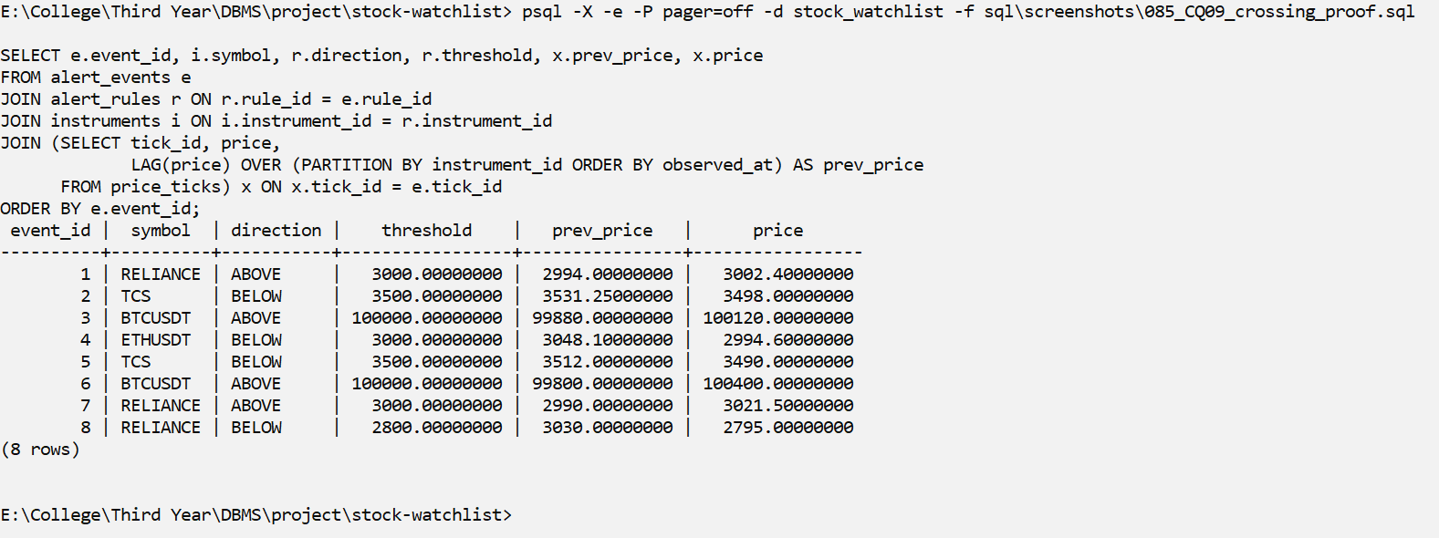
Explanation | The CTE numbers each instrument's ticks in time order and uses LAG for the previous price. For every alert we check the crossing again: ABOVE needs previous < threshold and new >= threshold, BELOW needs previous > threshold and new <= threshold. All 8 rows are true, so no false alert was stored.
CQ10 – Complex: 5 tables + conditional aggregation (FILTER)
Field | Content
ID | CQ10
Business question | For every watched instrument, does its owner have an ABOVE rule, a BELOW rule, both, or none?
SQL | SELECT u.username, i.symbol,  count(r.rule_id) FILTER (WHERE r.direction = 'ABOVE') AS above_rules,  count(r.rule_id) FILTER (WHERE r.direction = 'BELOW') AS below_rules,  CASE WHEN count(r.rule_id) = 0 THEN 'no protection'  WHEN count(DISTINCT r.direction) = 2 THEN 'both sides'  ELSE 'one side only' END AS coverage  FROM users u  JOIN watchlists w ON w.user_id = u.user_id  JOIN watchlist_items wi ON wi.watchlist_id = w.watchlist_id  JOIN instruments i ON i.instrument_id = wi.instrument_id  LEFT JOIN alert_rules r ON r.user_id = u.user_id  AND r.instrument_id = i.instrument_id  AND r.is_active  GROUP BY u.username, i.symbol  ORDER BY u.username, i.symbol;
Expected output | 11 rows, one for each watchlist item. Only arjun's RELIANCE has both sides; arjun's BTCUSDT and priya's TCS have one side; the rest have no protection (priya's INFY rule is disabled, so it is not counted).
Actual output screenshot | 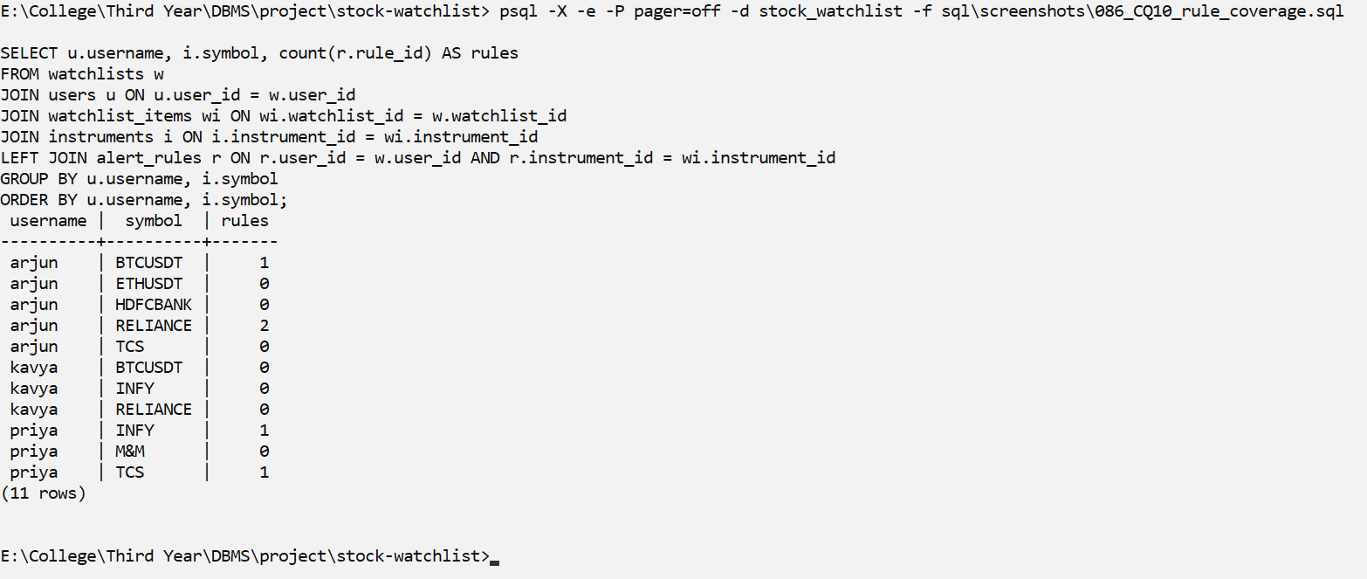
Explanation | The 4-table join lists every watched instrument. The LEFT JOIN to alert_rules has is_active inside ON, so items without an active rule are kept. count(...) FILTER counts the ABOVE and BELOW rules separately, and CASE gives the label.

Views
We created 3 views in the reporting schema: one that joins 4 tables, one aggregated view and one security view that restricts rows.
V1 – reporting.v_watchlist_contents
Field | Content
Purpose | One simple name for 'who watches what'. It joins 4 tables: users, watchlists, watchlist_items and instruments.
CREATE VIEW statement | CREATE VIEW reporting.v_watchlist_contents AS  SELECT u.user_id, u.username,  w.watchlist_id, w.name AS watchlist_name,  i.instrument_id, i.exchange, i.symbol, i.quote_currency,  wi.added_at  FROM users u  JOIN watchlists w ON w.user_id = u.user_id  JOIN watchlist_items wi ON wi.watchlist_id = w.watchlist_id  JOIN instruments i ON i.instrument_id = wi.instrument_id;
Query using the view | SELECT username, watchlist_name, exchange, symbol  FROM reporting.v_watchlist_contents  WHERE username = 'priya'  ORDER BY watchlist_name, symbol;
Screenshot | 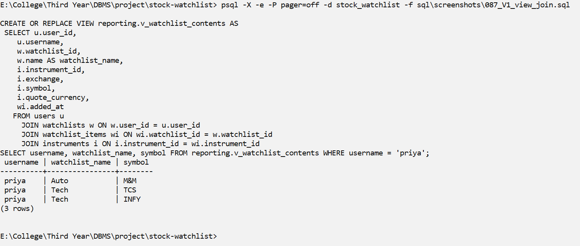
Why useful | It hides the joins, so other queries can just read the view (M01, X01 and the cursor procedure use it). It is not updatable, because it reads from more than one table (see V4).
V2 – reporting.v_instrument_price_summary
Field | Content
Purpose | Aggregated view: price statistics for each instrument (number of ticks, minimum, maximum and average price, first and last tick time).
CREATE VIEW statement | CREATE VIEW reporting.v_instrument_price_summary AS  SELECT i.instrument_id, i.exchange, i.symbol, i.quote_currency,  count(t.tick_id) AS tick_count,  min(t.price) AS min_price,  max(t.price) AS max_price,  round(avg(t.price), 2) AS avg_price,  min(t.observed_at) AS first_tick_at,  max(t.observed_at) AS last_tick_at  FROM instruments i  LEFT JOIN price_ticks t ON t.instrument_id = i.instrument_id  GROUP BY i.instrument_id, i.exchange, i.symbol, i.quote_currency;
Query using the view | SELECT symbol, tick_count, min_price::numeric(12,2) AS min, max_price::numeric(12,2) AS max,  avg_price, last_tick_at::time(0) AS last_tick  FROM reporting.v_instrument_price_summary  ORDER BY tick_count DESC, symbol;
Screenshot | 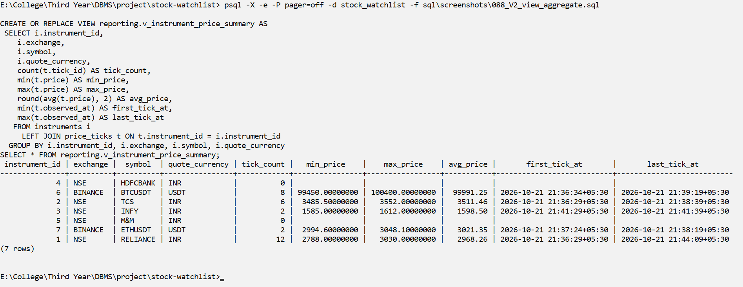
Why useful | The GROUP BY logic is written once and reused. The analyst role is allowed to read this view. It is not updatable, because it uses GROUP BY.
V3 – reporting.v_my_alerts
Field | Content
Purpose | Security (row-restricting) view: each database user sees only their own alerts, because of WHERE u.username = current_user.
CREATE VIEW statement | CREATE VIEW reporting.v_my_alerts WITH (security_barrier) AS  SELECT e.event_id, i.exchange, i.symbol, r.direction, r.threshold,  t.price, t.observed_at, e.fired_at  FROM alert_events e  JOIN alert_rules r ON r.rule_id = e.rule_id  JOIN users u ON u.user_id = r.user_id  JOIN price_ticks t ON t.tick_id = e.tick_id  JOIN instruments i ON i.instrument_id = r.instrument_id  WHERE u.username = current_user;
Query using the view | SET ROLE arjun;  SELECT current_user, event_id, symbol, direction, threshold::numeric(12,2), price::numeric(12,2)  FROM reporting.v_my_alerts ORDER BY event_id;  SET ROLE priya;  SELECT current_user, event_id, symbol, direction, threshold::numeric(12,2), price::numeric(12,2)  FROM reporting.v_my_alerts ORDER BY event_id;  RESET ROLE;
Screenshot | 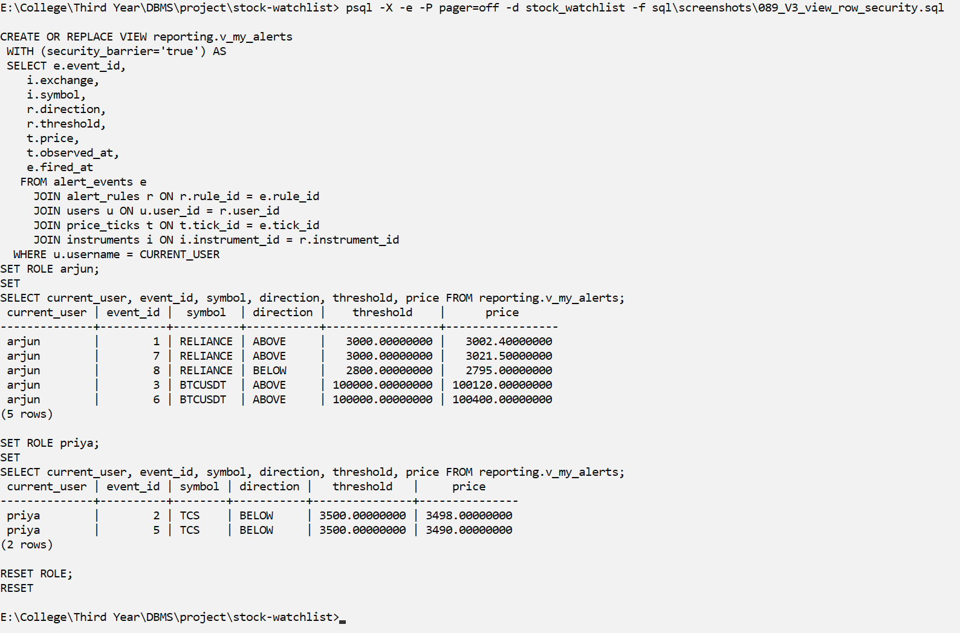
Why useful | End users have no privileges on the tables; this view is their only way to read data, and they see only their own rows. security_barrier stops tricks that could leak other users' rows. It is not updatable (joins).
V4 – Are the views updatable? (information_schema + attempts)
What it shows: Views with joins or GROUP BY are NOT automatically updatable
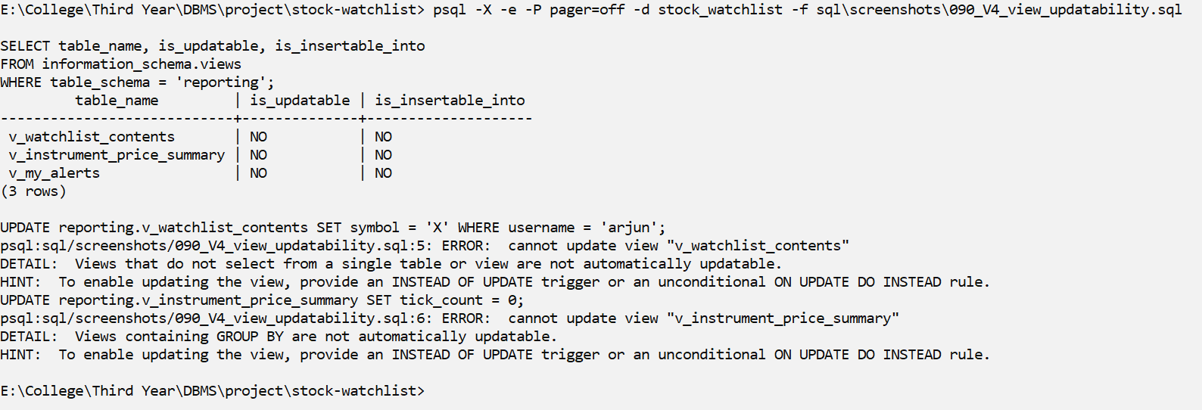
Screenshot V4
Explanation: information_schema shows that none of the 3 views is updatable. Trying to UPDATE them gives an error, because they use joins or GROUP BY.

Stored Procedures
Besides ingest_tick(), which every feed uses to insert prices, we wrote 2 stored procedures in the reporting schema. sp_create_watchlist() creates a watchlist and all its items in one call (all or nothing). sp_set_rule_active() turns an alert rule on or off; in our design rules are disabled instead of being edited or deleted.
P1 – Stored procedures and user-defined functions (psql command: df)
What it shows: public: ingest_tick + 2 trigger functions; reporting: Review 2 routines
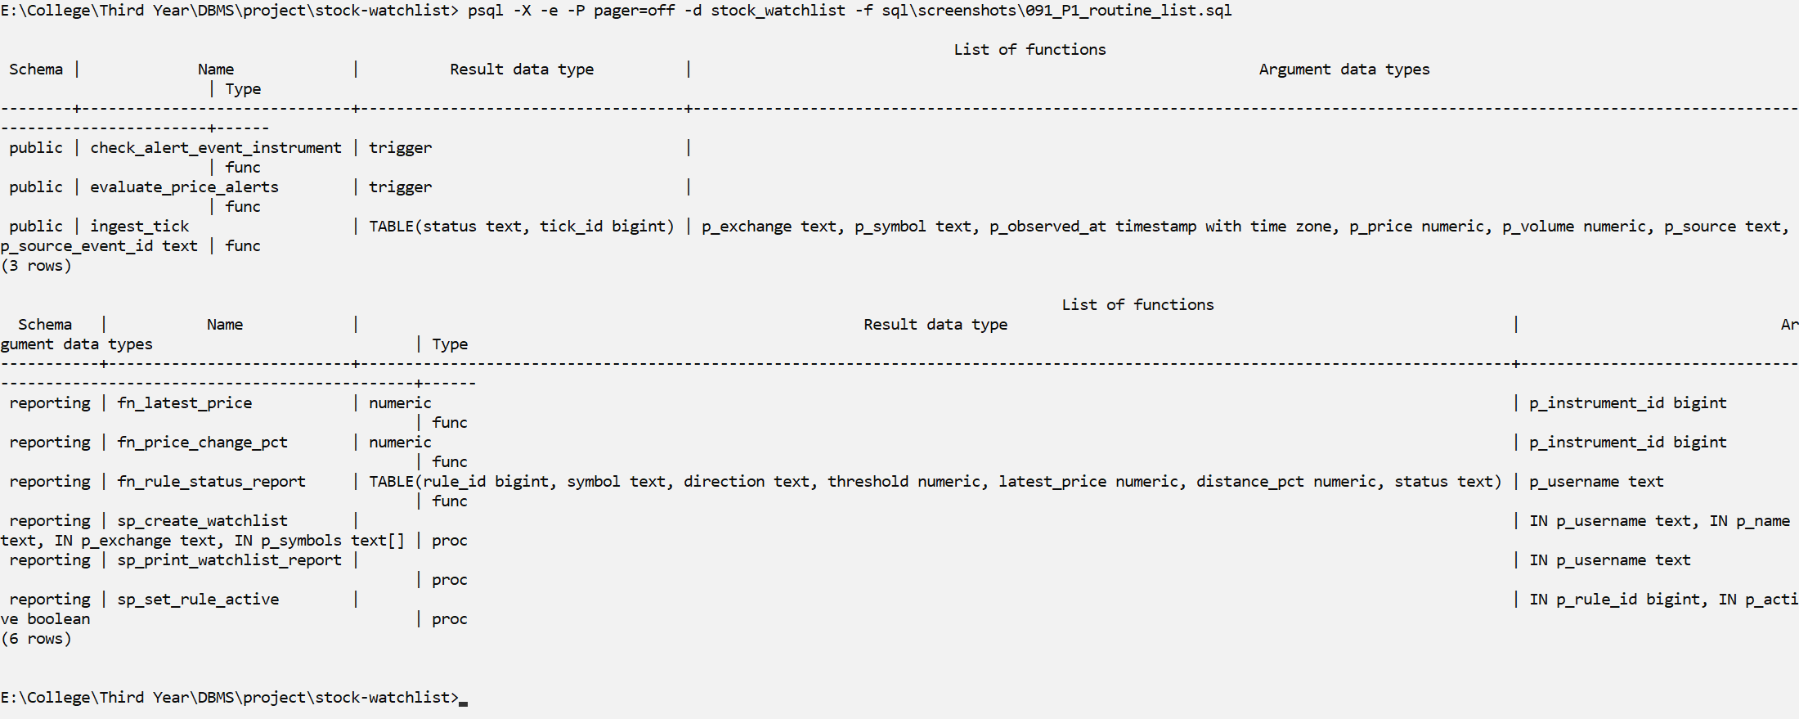
Screenshot P1
Explanation: \df lists ingest_tick() and the 2 trigger functions in public, and our Review 2 routines in the reporting schema.
P2 – Stored procedure reporting.sp_create_watchlist (atomic: all or nothing)
What it shows: 1) an unknown symbol -> exception -> nothing is created 2) a valid call inside a transaction (rolled back afterwards)
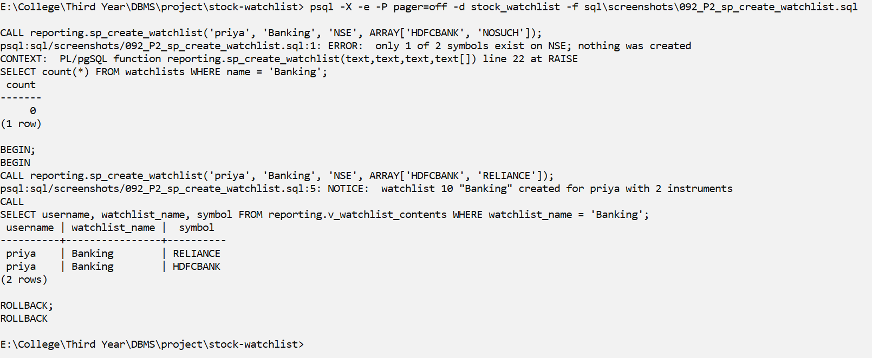
Screenshot P2
Explanation: First call: one symbol (NOSUCH) does not exist, so the procedure raises an exception and nothing is created (0 'Banking' lists). Second call: all symbols exist, so the watchlist and both items are created (then rolled back).
P3 – Stored procedure reporting.sp_set_rule_active (enable / disable a rule)
What it shows: inside a transaction that is rolled back
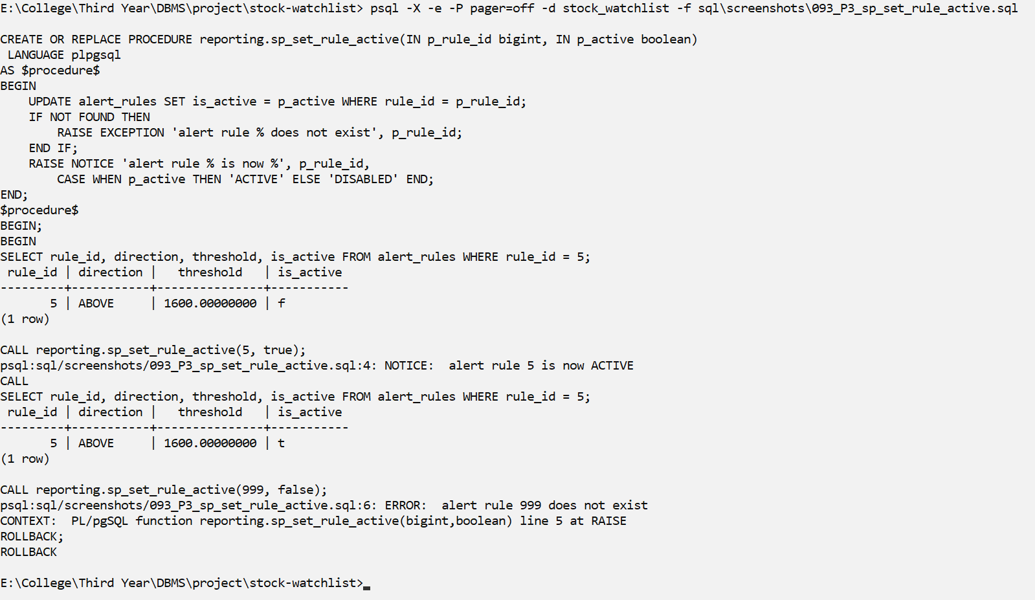
Screenshot P3
Explanation: Rule 5 is turned on with one CALL. Calling it with rule 999, which does not exist, raises an error.

User-Defined Functions
U1 – User-defined function reporting.fn_latest_price(instrument_id)
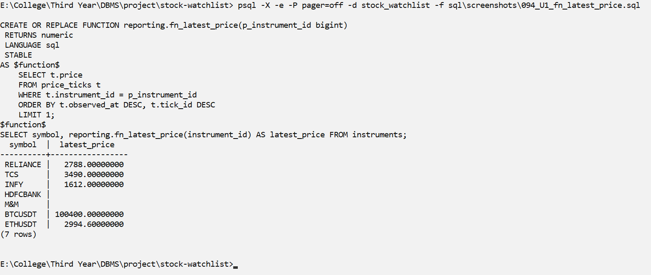
Screenshot U1
Explanation: Returns the latest price of an instrument, or NULL if it has no ticks yet (HDFCBANK, M&M). It uses the same ORDER BY as our index.
U2 – User-defined function reporting.fn_price_change_pct(instrument_id)
What it shows: % change from the first tick to the latest tick
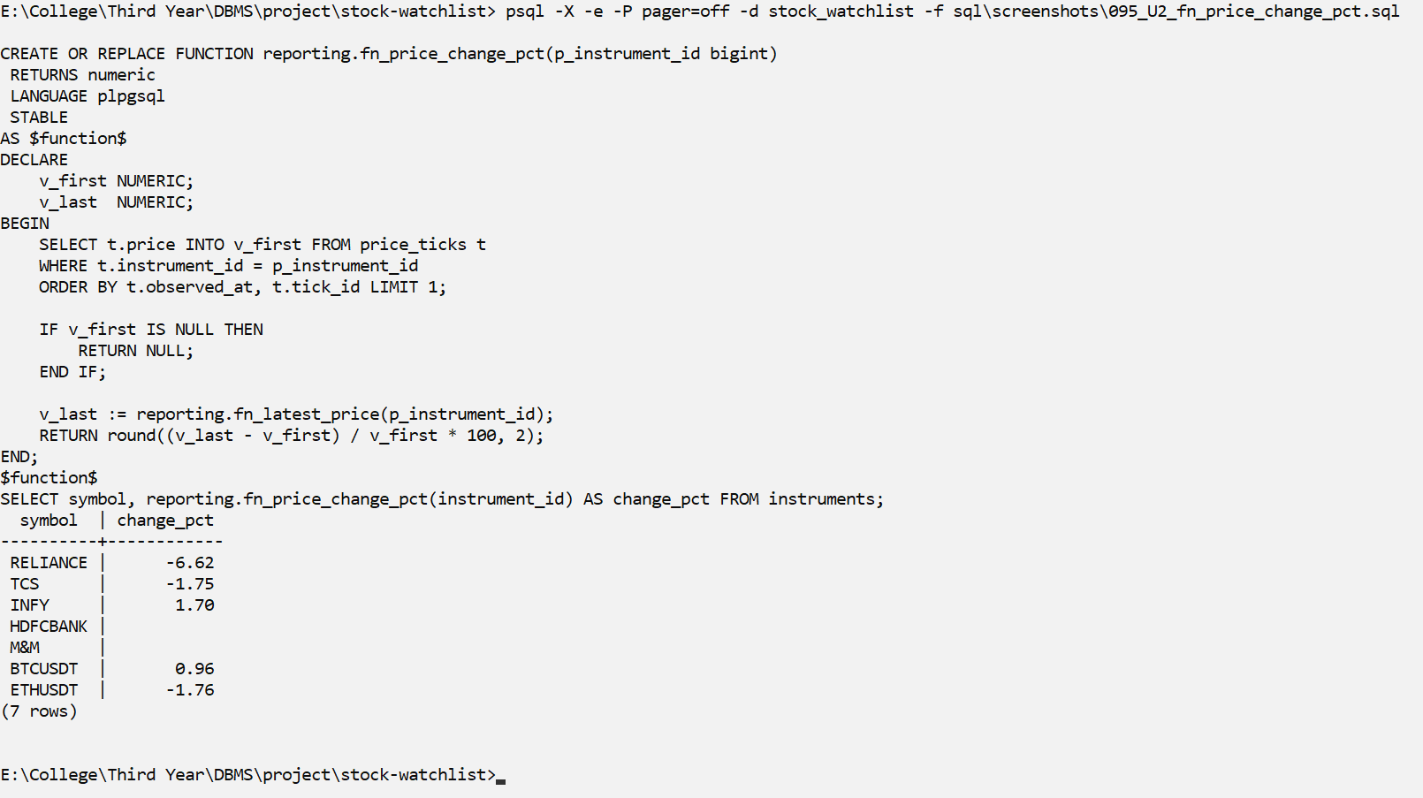
Screenshot U2
Explanation: Returns the % change from the first tick to the latest tick. It calls fn_latest_price() inside it.

Triggers
Our 2 triggers do the main work of the alert system. The AFTER INSERT trigger on price_ticks compares the previous price and the new price with each active rule of that instrument and writes an alert_events row only when the price crosses the threshold and the cooldown has passed. The BEFORE INSERT trigger on alert_events makes sure an alert never links a rule and a tick of different instruments.
S10 – Creating ingest_tick() and the 2 triggers (sql/03_functions_triggers.sql)
Screenshot S10
Explanation: Creates the ingest_tick() function and the 2 triggers. Every new price enters the database through ingest_tick().
T1 – The 2 triggers (information_schema.triggers)
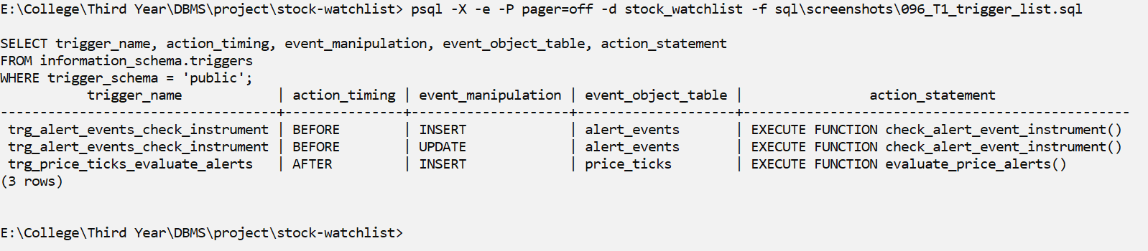
Screenshot T1
Explanation: Our 2 triggers: trg_price_ticks_evaluate_alerts (AFTER INSERT on price_ticks, FOR EACH ROW) checks the alert rules for each new tick, and trg_alert_events_check_instrument (BEFORE INSERT on alert_events) checks that the rule and the tick are for the same instrument.
T2 – AFTER INSERT trigger trg_price_ticks_evaluate_alerts fires an alert
What it shows: new rule: arjun HDFCBANK ABOVE 1700. Ticks 1690 -> 1710 -> 1720. Only the crossing (1690 -> 1710) creates an event (edge-triggered). Everything is rolled back.
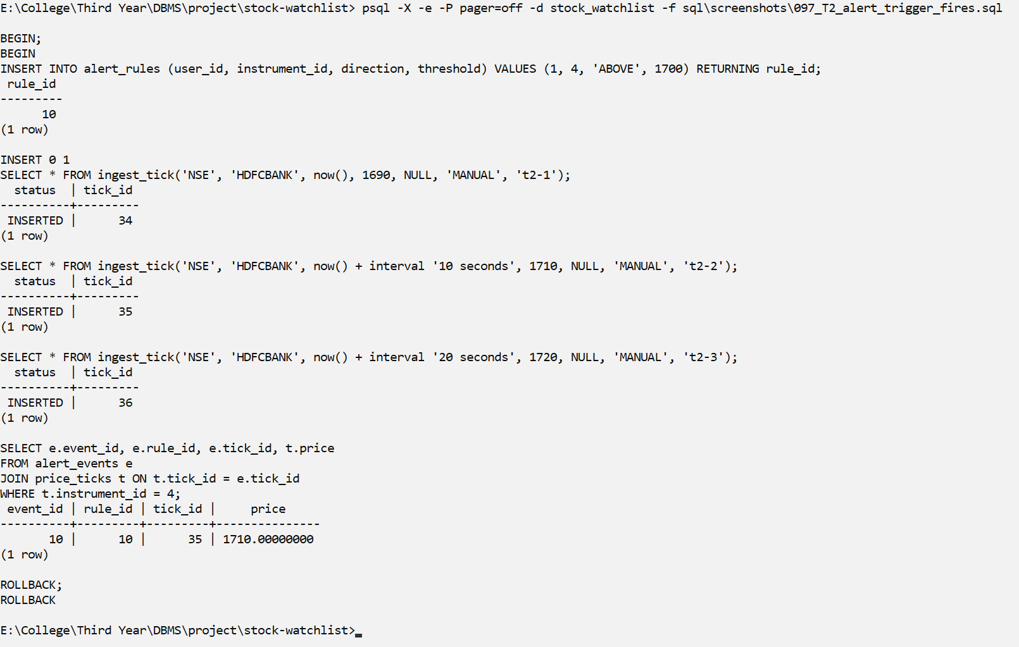
Screenshot T2
Explanation: New rule: HDFCBANK ABOVE 1700. Prices 1690 → 1710 → 1720. Only the move from 1690 to 1710 crosses 1700, so only one alert is created. 1720 is still above 1700 and does not fire again (edge-triggered).
T3 – Trigger logic: cooldown (300 s, measured in market time)
What it shows: crossing at +10s fires; re-cross at +30s is inside the cooldown (no alert); re-cross at +410s is after the cooldown (fires). Rolled back.
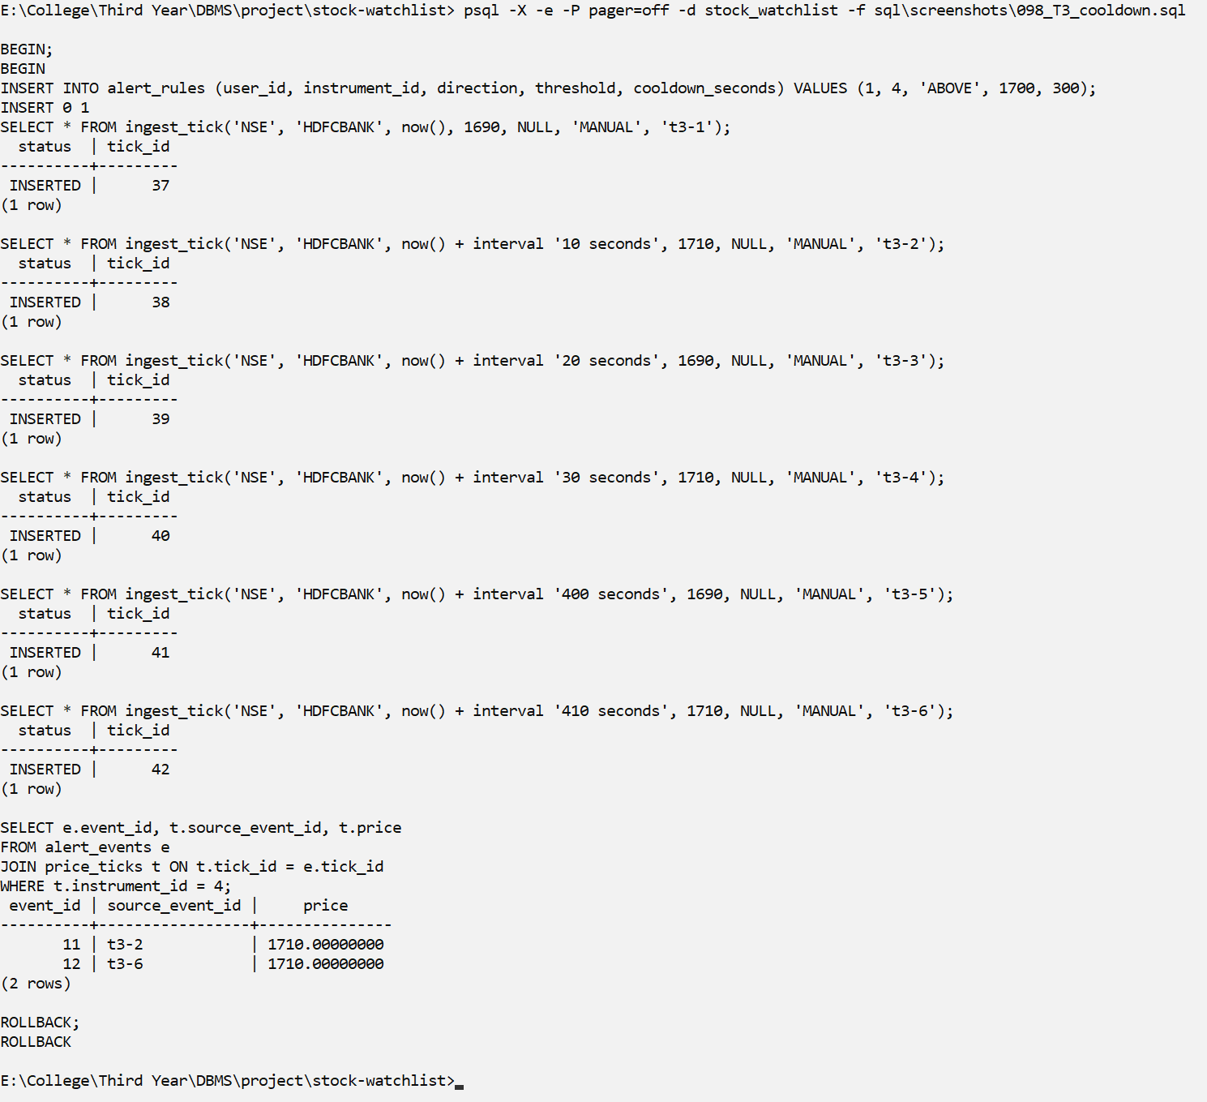
Screenshot T3
Explanation: With a 300 second cooldown: the crossing at +10 s fires; the crossing at +30 s is inside the cooldown and does not fire; the crossing at +410 s is after the cooldown and fires. 2 alerts in total.
T4 – Trigger logic: a LATE (out-of-order) tick is stored but not evaluated
What it shows: rule HDFCBANK BELOW 1600. Tick at +60s = 1650, then a tick stamped +30s (earlier!) at 1590 arrives late -> stored, but no BELOW alert. Rolled back.
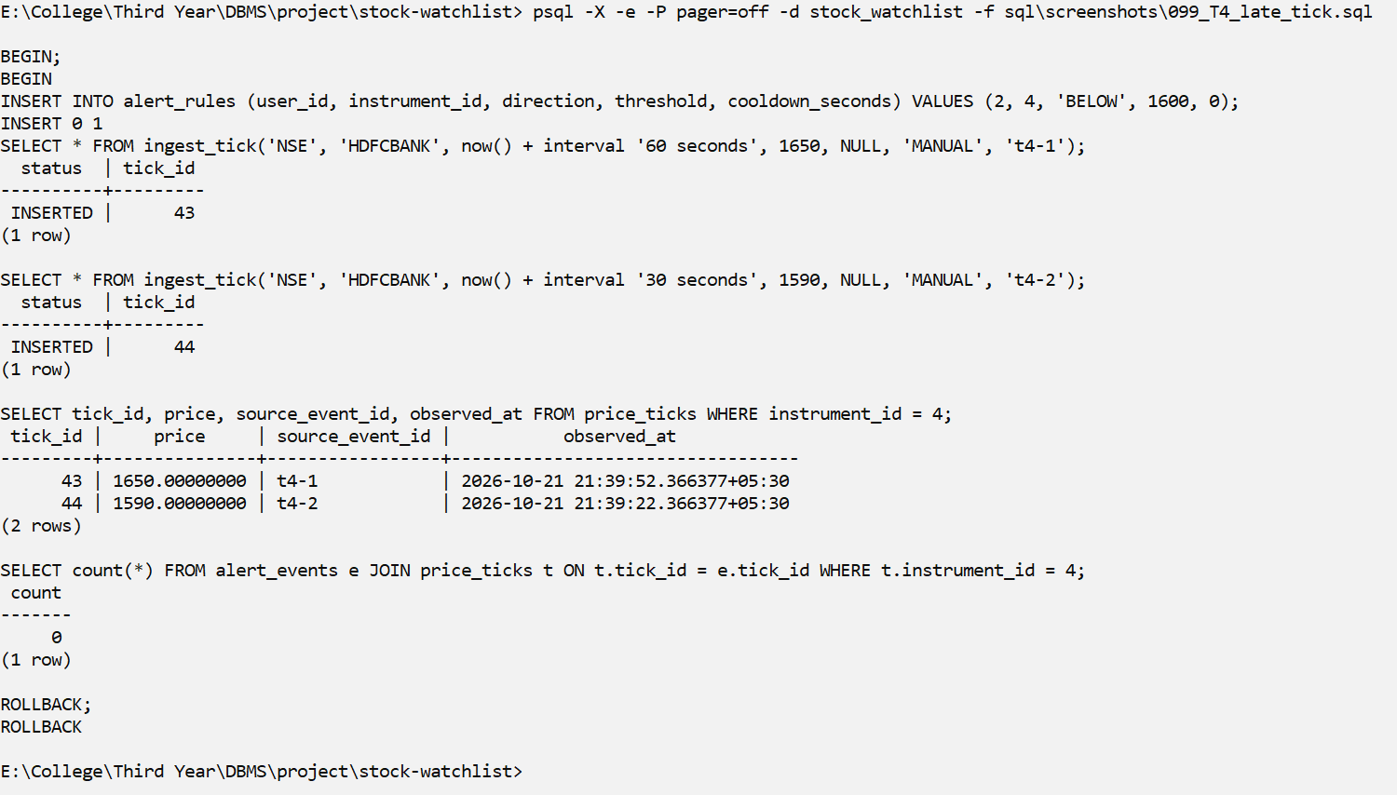
Screenshot T4
Explanation: A tick that arrives late (its time is older than the newest tick) is stored, but it is not checked against the rules, so no wrong alert is made.
T5 – BEFORE INSERT trigger trg_alert_events_check_instrument
What it shows: rejects an alert whose rule and tick belong to DIFFERENT instruments
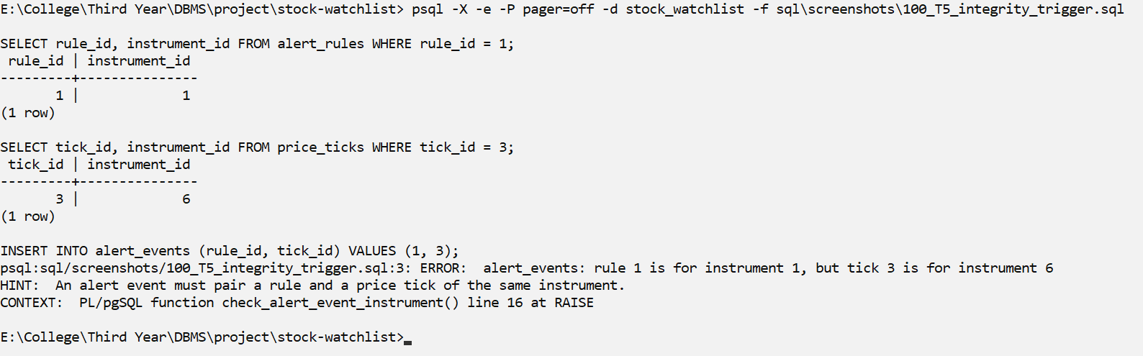
Screenshot T5
Explanation: Inserting an alert that links rule 1 (RELIANCE) with a BTCUSDT tick is rejected by the BEFORE INSERT trigger.

Cursors
CR1 – Cursor 1 (definition): explicit, parameterised cursor in PL/pgSQL
What it shows: DECLARE c_rules CURSOR (p_user) ... OPEN / FETCH loop / CLOSE
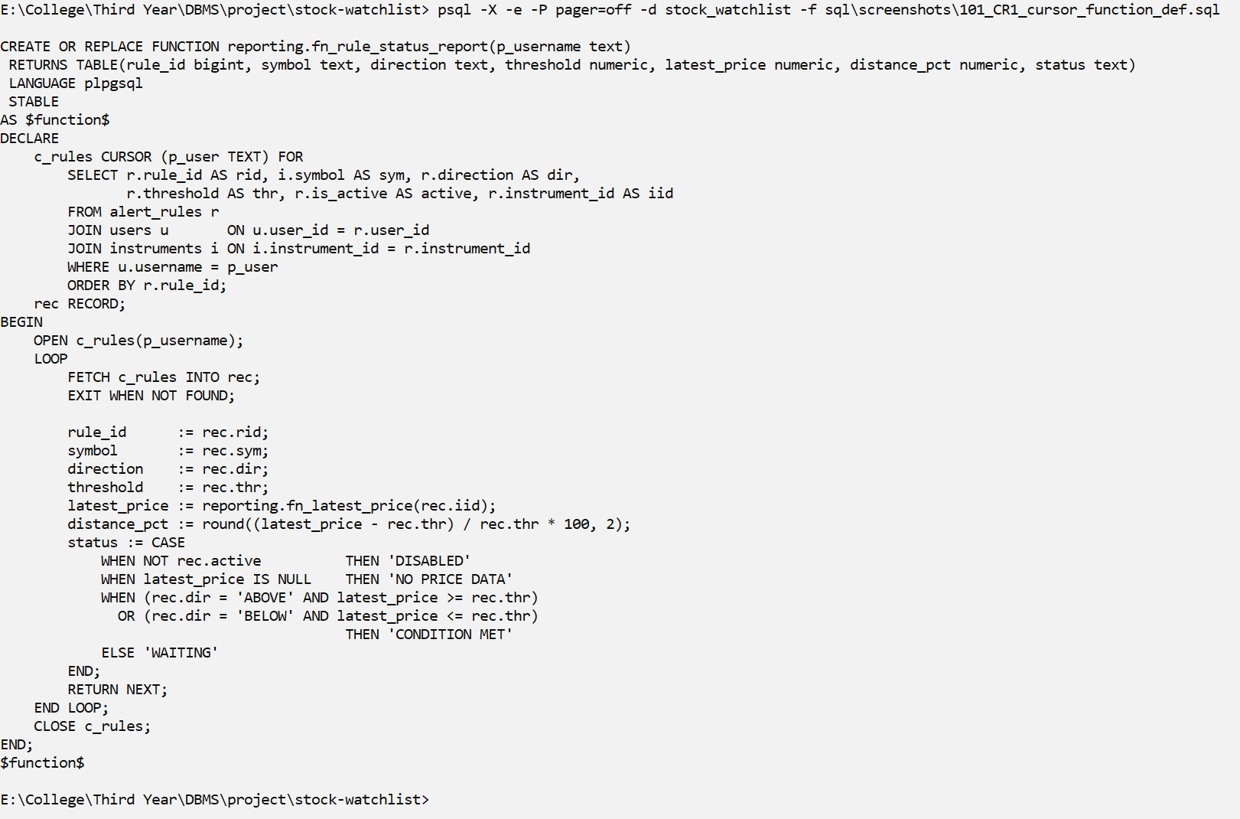
Screenshot CR1
Explanation: fn_rule_status_report() uses an explicit cursor with a parameter: DECLARE c_rules CURSOR (p_user), OPEN, FETCH in a loop, and CLOSE.
CR2 – Cursor 1 (run): the cursor walks each user's rules one row at a time
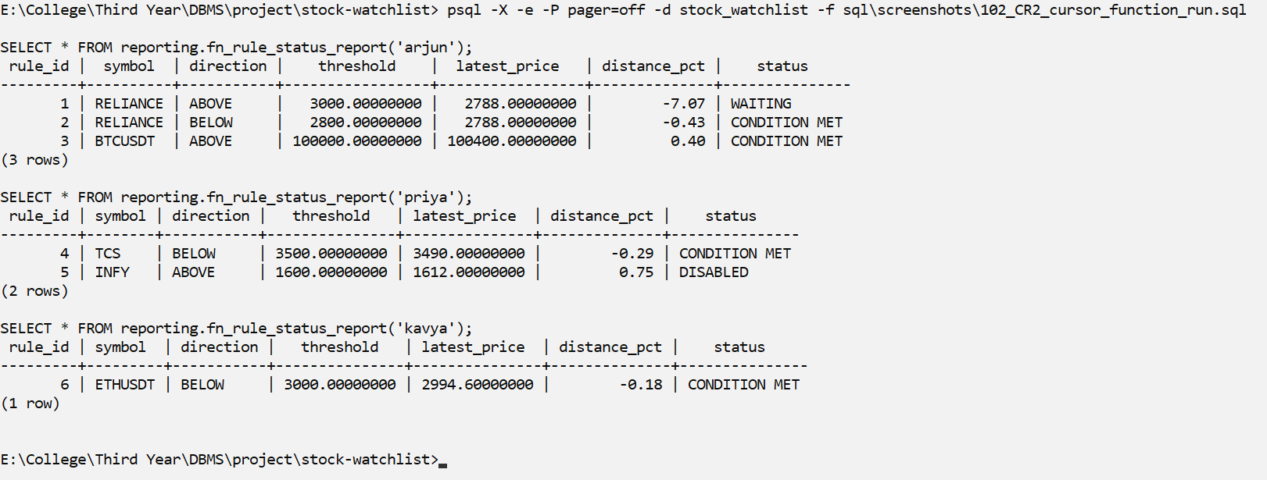
Screenshot CR2
Explanation: The cursor walks through each user's rules one row at a time and shows the latest price and the status of each rule.
CR3 – Cursor 2: REFCURSOR in a stored procedure (OPEN ... FOR / FETCH / CLOSE)
What it shows: prints a watchlist report line by line with RAISE NOTICE
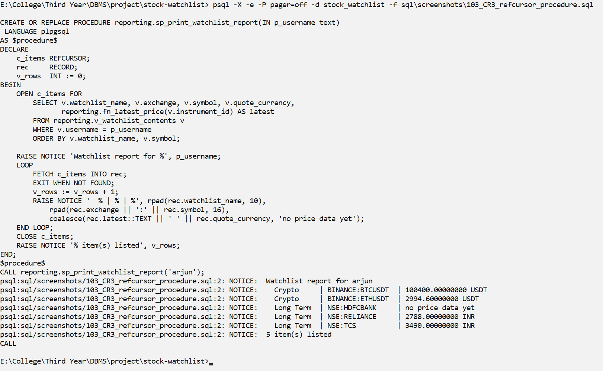
Screenshot CR3
Explanation: sp_print_watchlist_report() uses a REFCURSOR: OPEN ... FOR a query, FETCH each row in a loop, print it with RAISE NOTICE, then CLOSE.
CR4 – SQL-level SCROLL cursor: DECLARE, FETCH FIRST / FORWARD / LAST / ABSOLUTE, CLOSE
What it shows: walks BTCUSDT ticks without loading them all at once
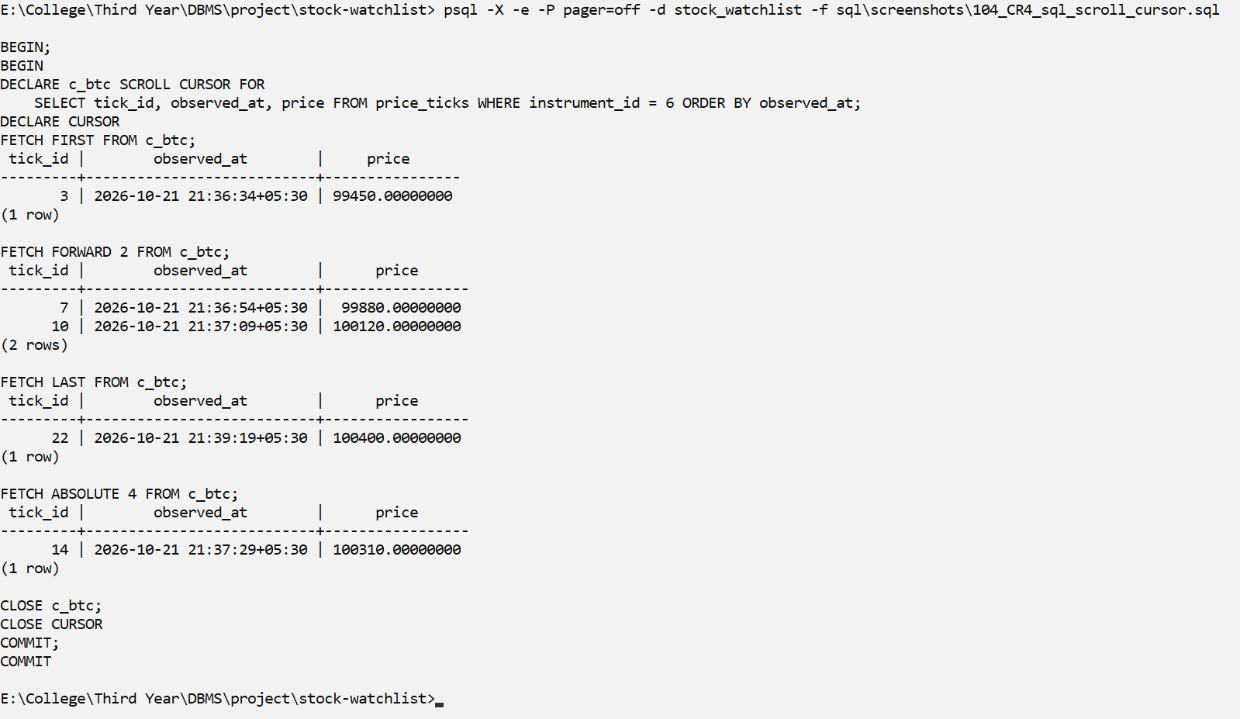
Screenshot CR4
Explanation: A SQL SCROLL cursor can move forward and jump to the first, the last or the 4th row (FETCH FIRST / FORWARD / LAST / ABSOLUTE) without loading all rows at once.

SQL Security Implementation
We follow the idea of least privilege: each role gets only the rights it needs. The roles are created by sql/09_review2_objects.sql. The demos use SET ROLE from the postgres session to act as the restricted role (the roles have no passwords).
Role | Type | Privileges
sw_admin | Group role (administrator) | SELECT, INSERT, UPDATE, DELETE on all tables; all reporting views and routines
sw_analyst | Group role (analyst) | SELECT on instruments and price_ticks; v_instrument_price_summary; fn_latest_price, fn_price_change_pct
sw_enduser | Group role (end users) | Only SELECT on reporting.v_my_alerts – no table privileges
arjun, priya | Login roles, members of sw_enduser | Same as sw_enduser; each sees only their own alerts

Task | Evidence
Create ≥ 3 users/roles | sql/09_review2_objects.sql creates sw_admin, sw_analyst, sw_enduser and the logins arjun and priya (S12, SEC1)
GRANT privileges per role matrix | GRANT statements in sql/09_review2_objects.sql; \dp output (SEC2) and privilege matrix (SEC3)
REVOKE demonstration | SEC4: sw_analyst can read price_ticks; after REVOKE the same SELECT gives 'permission denied'; ROLLBACK restores it
Least privilege proof | SEC5: sw_analyst cannot DELETE price_ticks or read users; arjun cannot read alert_rules or call sp_set_rule_active
Secure exposure | End users have no table privileges; reporting.v_my_alerts is their only access path (V3, SEC5)
SEC1 – Roles created by sql/09_review2_objects.sql
What it shows: 3 group roles (admin / analyst / end user) + 2 end-user logins
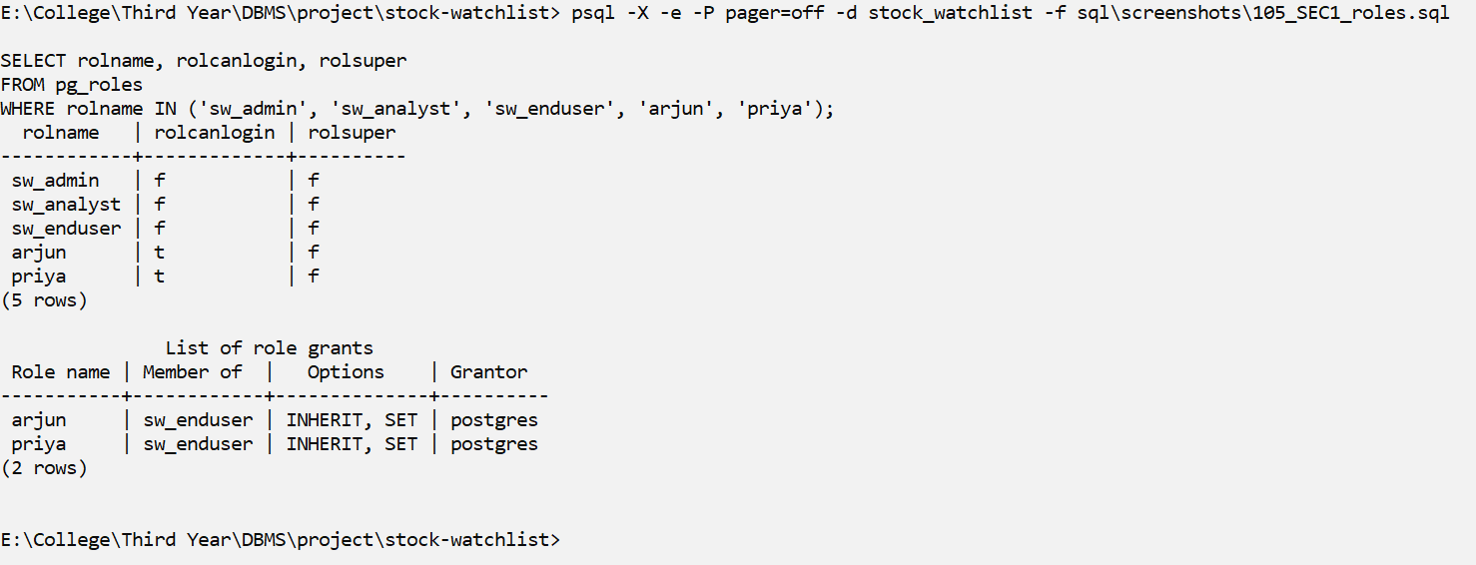
Screenshot SEC1
Explanation: 3 group roles (sw_admin, sw_analyst, sw_enduser) and 2 login roles (arjun, priya) that are members of sw_enduser.
SEC2 – Granted privileges (psql command: dp) on core tables and the reporting views
What it shows: r=SELECT a=INSERT w=UPDATE d=DELETE
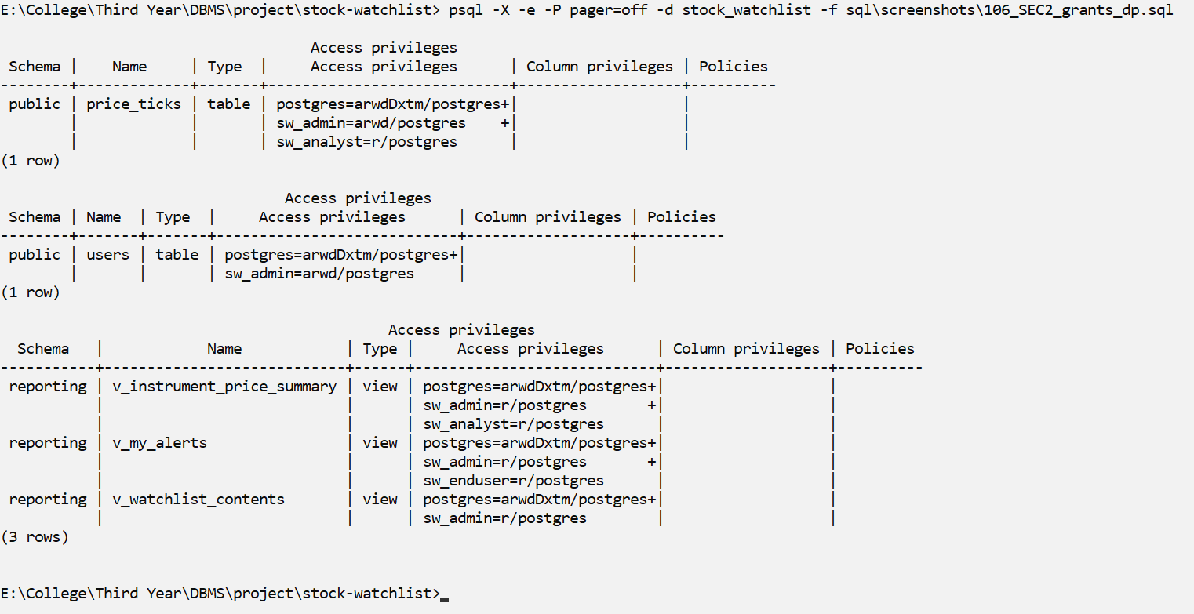
Screenshot SEC2
Explanation: \dp shows the privileges given to each role (r = SELECT, a = INSERT, w = UPDATE, d = DELETE).
SEC3 – Role / privilege matrix (has_table_privilege)
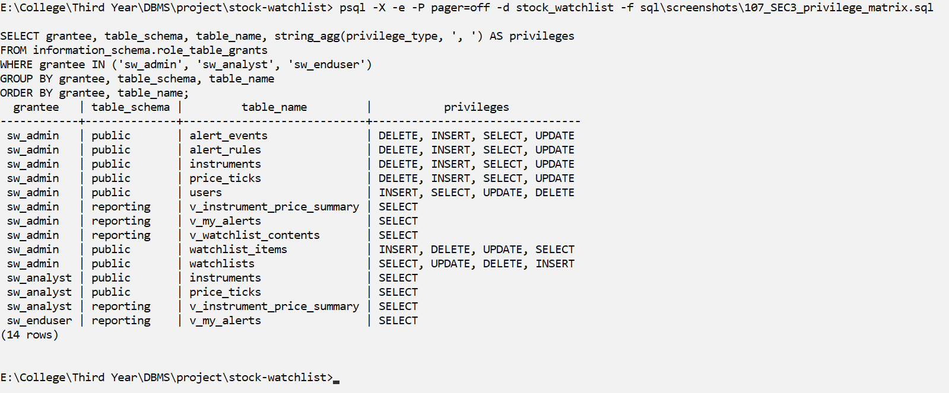
Screenshot SEC3
Explanation: has_table_privilege() shows the full role/privilege matrix.
SEC4 – REVOKE demonstration: before / after (inside a transaction, rolled back)
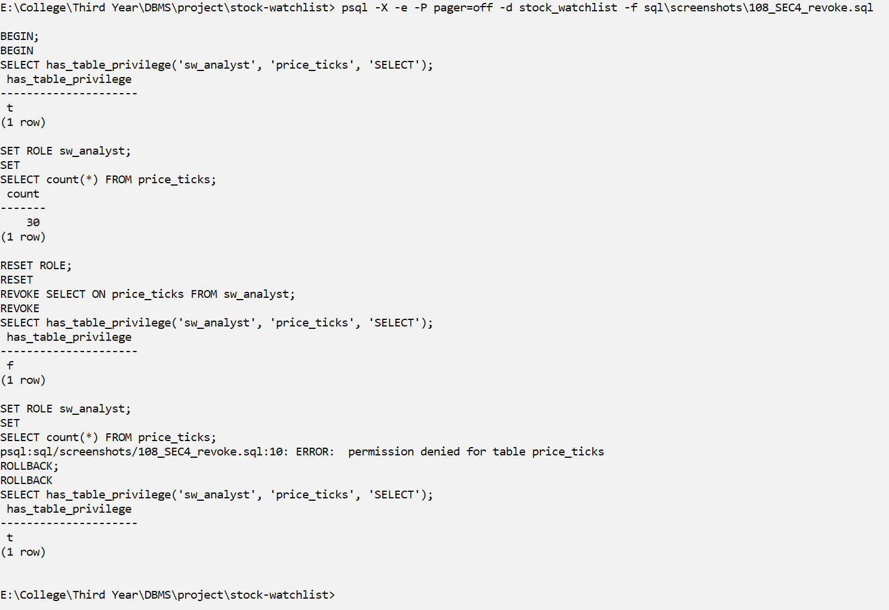
Screenshot SEC4
Explanation: Before REVOKE, sw_analyst can read price_ticks. After REVOKE SELECT, the same query gives 'permission denied'. ROLLBACK gives the privilege back.
SEC5 – Least privilege: restricted roles attempt forbidden operations
What it shows: (SET ROLE switches this session to the restricted role)
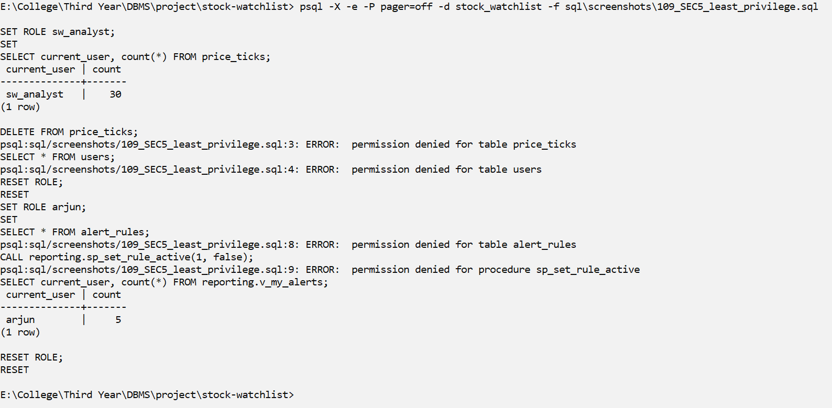
Screenshot SEC5
Explanation: sw_analyst can read price_ticks but cannot DELETE from it or read users. arjun cannot read alert_rules or call sp_set_rule_active, but can read his own 5 alerts through the view.

Review 2 Requirements (checklist)
# | Mandatory component | Evidence
1 | CREATE TABLE scripts + all constraints | sql/00_schema.sql: 7 tables, 36 named constraints, runs cleanly (S02–S08, S21)
2 | INSERT, UPDATE, DELETE | Seed INSERTs (S09), M01 INSERT, M02 UPDATE, M03 DELETE; row-count tables S23 and M04
3 | Basic, aggregate, join, subquery, set-operation queries | 38 queries A1–G3 (section 7) + 10 complex queries CQ01–CQ10
4 | Views | 3 views: V1 (4-table join), V2 (aggregated), V3 (security); V4 updatability
5 | Transactions (COMMIT/ROLLBACK/SAVEPOINT) | X01 (SAVEPOINT + COMMIT), X02 (ROLLBACK), CN05 (CASCADE inside a rolled-back transaction)
6 | Procedures/functions | 2 procedures (P2, P3), 2 functions (U1, U2), plus ingest_tick() and 2 cursor routines
7 | Triggers | 2 triggers working (T1–T5)
8 | Indexes + one EXPLAIN comparison | ix_price_ticks_instrument_time; EXPLAIN ANALYZE on 500,000 rows: 19.966 ms → 0.100 ms (IX2, IX3)
9 | Execution screenshots | Every screenshot shows the command, the SQL and the real output
10 | Design changes since Review 1 | Change log below

Design Changes Since Review 1
Change | Reason
Added a separate schema reporting (sql/09_review2_objects.sql) with 3 views, 2 procedures, 3 functions (one uses a cursor) and 1 procedure with a REFCURSOR. | Review 2 needs views, procedures, functions and cursors. A separate schema keeps the 7 tables, 36 constraints, ingest_tick() and the 2 triggers unchanged.
Added roles sw_admin, sw_analyst, sw_enduser, arjun and priya with GRANT / REVOKE. | Review 2 needs role-based security and a least-privilege demonstration.
scripts/reset_demo_db.sh now also runs sql/09_review2_objects.sql. | The whole database, including the Review 2 objects, can be rebuilt with one command.
Table descriptions corrected to match the database: users.username (not name); instruments.quote_currency and is_active (not currency, active, created_at); alert_rules.rule_id and is_active (not alert_rule_id, enabled); alert_events.event_id and rule_id; price_ticks.volume may be NULL; price_ticks.ingested_at and the missing UNIQUE/CHECK constraints are now listed. | Some column names and constraints in the Review 1 tables did not match the real schema. The tables in this report are checked against the \d screenshots (S14–S20).

Review Requirements (Review 3)
This section shows the Review 3 requirements: the complete database, scripts that can be run again from scratch, transactions and concurrency, indexing and query optimization, testing, the live demonstration and screenshots of every working module of the project. Everything in the earlier sections (SQL queries, views, procedures, functions, triggers, cursors and security) is still part of the final system.

Review 3 Checklist
# | Requirement | Where it is shown
1 | Complete database with all tables populated | All 7 tables have data: 3 users, 7 instruments, 5 watchlists, 11 watchlist items, 6 alert rules, 30 price ticks and 8 alert events after the replay (R3_01, R3_02, M04)
2 | Full scripts, re-runnable from scratch | scripts/reset_demo_db.sh runs sql/00, 01, 03, 06 and 09 on an empty database (R3_01)
3 | Advanced SQL | 38 queries A1–G3 and 10 complex business queries CQ01–CQ10
4 | Views | V1 (4-table join), V2 (aggregate), V3 (row security), V4 (updatability)
5 | Procedures | sp_create_watchlist, sp_set_rule_active, sp_print_watchlist_report (P1–P3, CR3)
6 | Functions | fn_latest_price, fn_price_change_pct, fn_rule_status_report, ingest_tick() (U1, U2, CR1, CR2, S10)
7 | Triggers | trg_price_ticks_evaluate_alerts and trg_alert_events_check_instrument (T1–T5, UI06)
8 | Transactions and concurrency | X01 (SAVEPOINT + COMMIT), X02 (ROLLBACK), P2 (failure → rollback), R3_03 (two sessions)
9 | Indexing | ix_price_ticks_instrument_time (S11, IX1)
10 | Query optimization | Latest 50 ticks on 500,000 rows: 19.966 ms → 0.100 ms (IX2, IX3)
11 | Security implementation | Roles, GRANT, REVOKE and least privilege (SEC1–SEC5, V3)
12 | Testing (≥ 15 cases) | 9 test suites, 221 checks, all passed (R3_04 and the table below)
13 | Working modules with input and output | UI01–UI11 (web application)
14 | Live demonstration | Six-step demo flow below

Live Demonstration Flow
The live demo follows the six steps asked for in the template. Each step uses a script or screen that is already shown in this report.
Step | What we show | Evidence
1. DDL + DML on a clean database | createdb, then bash scripts/reset_demo_db.sh builds the 7 tables, loads the seed data, creates the functions, triggers, index, views and roles, and checks the row counts (3|7|5|11|6|0|0). Then the replay feed inserts 30 ticks and fires 8 alerts. | R3_01, R3_02
2. Role-based access | SET ROLE sw_analyst: reading prices works, but DELETE on price_ticks and SELECT on users give 'permission denied'. arjun sees only his own alerts through the view v_my_alerts. | SEC5, V3
3. Transaction with a deliberate failure and rollback | sp_create_watchlist is called with one unknown symbol. The procedure raises an error, so the watchlist and its items are not created at all (all or nothing). | P2, X02
4. Trigger firing | HDFCBANK rule ABOVE 1700: a tick at 1690 does nothing, a tick at 1710 crosses 1700 and the trigger inserts one row into alert_events. | T2, UI05, UI06
5. One optimization before / after | Latest 50 RELIANCE ticks on 500,000 rows: without the index PostgreSQL reads about 25,000 rows and sorts them (19.966 ms); with the index it reads 50 rows in order (0.100 ms). | IX2, IX3
6. One concurrency scenario | Two sessions send RELIANCE prices at the same time. The second session waits for the first one's row lock, so only one alert is created. | R3_03

Building the Database From Scratch
R3_01 – Demo step 1: DDL + DML on a new, empty database
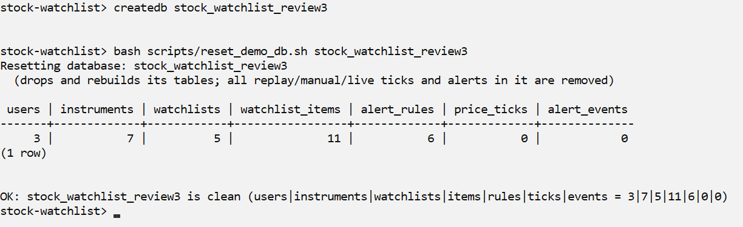
Screenshot R3_01
Explanation: A new empty database (stock_watchlist_review3) is created and the reset script runs all the SQL scripts in order: tables and constraints, seed data, ingest_tick() and the triggers, the index, and the views, procedures and roles. The last line checks the row counts: 3 users, 7 instruments, 5 watchlists, 11 items, 6 rules, 0 ticks and 0 alerts. The same script can be run again at any time and always gives the same clean state.
R3_02 – Loading prices with the replay feed
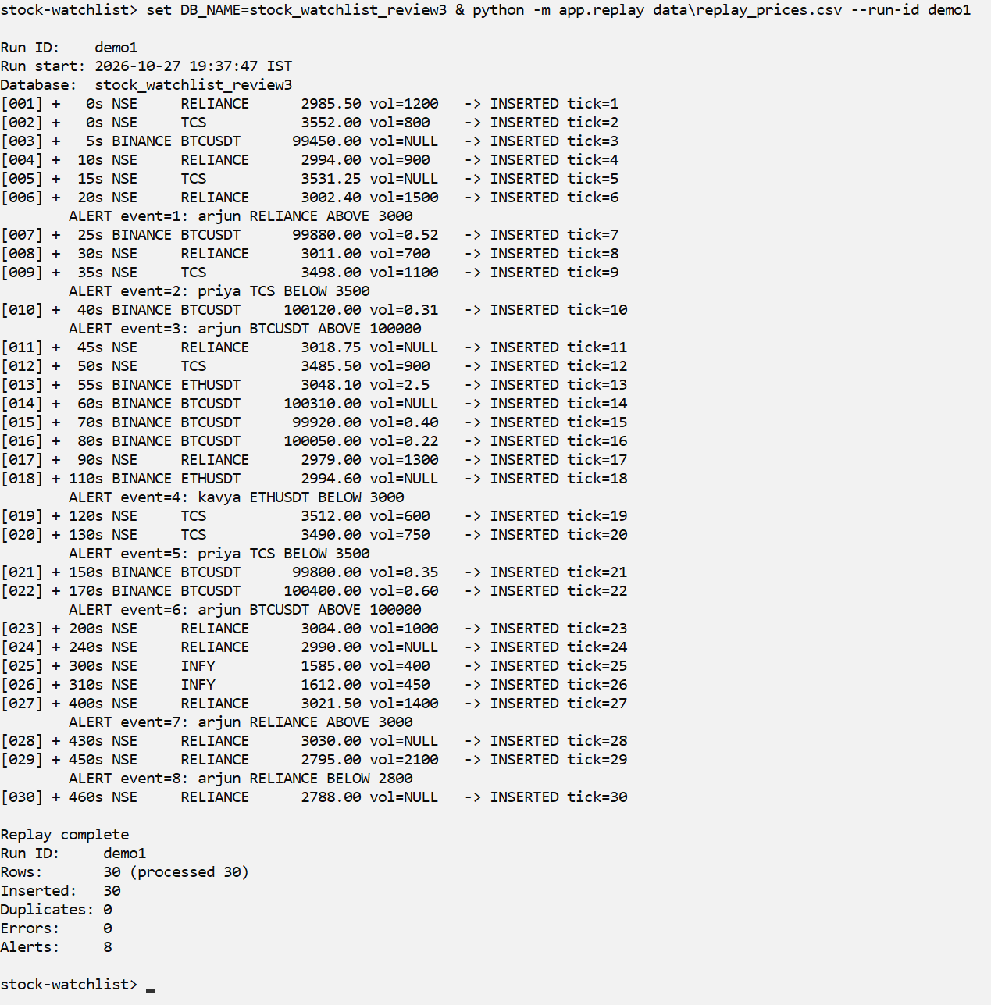
Screenshot R3_02
Explanation: The replay feed reads 30 prices from data/replay_prices.csv and sends each one to ingest_tick(). All 30 were inserted, with 0 duplicates and 0 errors. The trigger fired 8 alerts while the data was loading (the ALERT lines). After this step every table has data.

Transactions and Concurrency
A transaction is a group of SQL statements that either all succeed (COMMIT) or all have no effect (ROLLBACK). COMMIT, ROLLBACK and SAVEPOINT are shown in X01, X02 and P2. Our database runs at PostgreSQL's default isolation level, READ COMMITTED: each statement sees only data that other sessions have already committed.
Concurrency means two or more sessions using the database at the same time. The risky case in our project is two feeds sending prices for the same instrument at the same moment. To compare the previous price with the new one safely, ingest_tick() first locks the instrument's row (SELECT ... FOR NO KEY UPDATE). A second session that wants the same instrument has to wait until the first one commits. Different instruments do not block each other.
R3_03 – Demo step 6: two sessions send prices for the same instrument
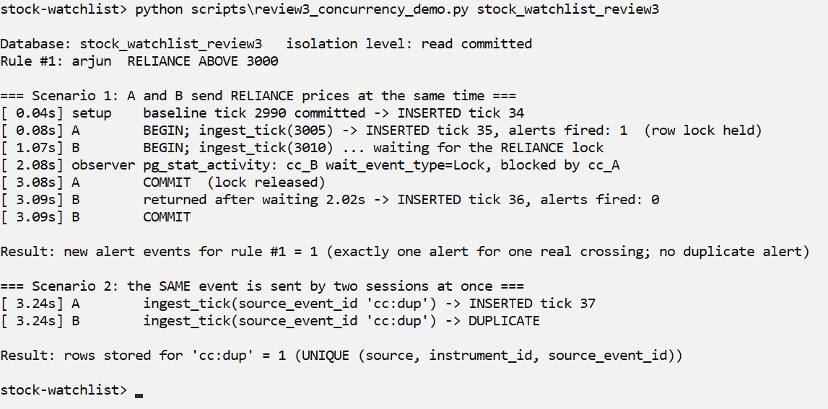
Screenshot R3_03
Scenario 1: The last committed RELIANCE price is 2990 and rule #1 is ABOVE 3000. Session A sends 3005 (this crosses 3000, so one alert fires) and keeps its transaction open for 3 seconds. One second later session B sends 3010. A third session (observer) sees in pg_stat_activity that B is waiting for a Lock held by A. When A commits, B continues after waiting 2.02 s. B now sees 3005 as the previous price, so 3005 → 3010 is not a new crossing and no second alert is made. Result: exactly 1 alert for 1 real crossing.
Without the lock: B would not wait. It would still see 2990 as the previous price (A had not committed yet), so 2990 → 3010 would also look like a crossing and the user would get the same alert twice.
Scenario 2: Both sessions send the same price event (source_event_id 'cc:dup') at the same time. One is INSERTED and the other gets DUPLICATE, because of UNIQUE (source, instrument_id, source_event_id). Only 1 row is stored.
The same behaviour is checked automatically by tests/concurrency_test.sh (17 checks with separate psql sessions), which is part of the test run in R3_04.

Indexing and Query Optimization
The most common search in our project is 'the latest prices of one instrument'. It is used by the dashboard, the watchlist page, the instrument history page and by the alert trigger, which needs the previous price for every new tick. For this search we created one B-tree index:
- ix_price_ticks_instrument_time ON price_ticks (instrument_id, observed_at DESC, tick_id DESC)
instrument_id comes first because every one of these queries filters on one instrument. observed_at DESC and tick_id DESC come next, so the newest ticks are already at the front of the index in the right order and PostgreSQL does not need a Sort step. The instrument search by exchange and symbol (used by ingest_tick()) is fast because of the index that PostgreSQL creates for UNIQUE (exchange, symbol).
The before/after comparison is shown in IX2 and IX3 (section 'Indexes and EXPLAIN Comparison'). On a test copy with 500,000 ticks, the query for the latest 50 RELIANCE ticks went from a Bitmap Heap Scan + Sort reading about 25,000 rows in 19.966 ms to an Index Scan reading 50 rows in 0.100 ms. The cost is extra disk space (19 MB) and a little extra work on every INSERT. On the small demo data (30 ticks) the index makes no visible difference, which is why the test was done on 500,000 rows.

Testing
We test the project with 9 automated test suites. The SQL suites run inside a transaction that is rolled back, and the Python suites use temporary databases, so the demo database is never changed. In total there are 221 checks plus the schema verifier, and all of them pass (screenshot R3_04). The table lists 20 of the test cases.
Test case | Expected result | Result
A1 duplicate username | Rejected by uq_users_username | PASS
A3 duplicate instrument (exchange, symbol) | Rejected by UNIQUE | PASS
A8 duplicate tick (source, instrument, event id) | Rejected by UNIQUE | PASS
B1 negative price | Rejected by CHECK | PASS
B4 NULL (unknown) volume | Accepted (volume may be unknown) | PASS
C1 watchlist for a user that does not exist | Rejected by FOREIGN KEY | PASS
D3 delete an instrument that has price history | Blocked by ON DELETE RESTRICT | PASS
E3 delete a user | Their watchlists, rules and alerts are deleted (CASCADE) | PASS
E7 delete a user | All price ticks are kept | PASS
01c first tick of an instrument | No alert (no previous price) | PASS
02b price 2999 → 3001 with rule ABOVE 3000 | Exactly one alert | PASS
03 price stays above 3001 → 3010 → 3020 | Still only one alert | PASS
09a second crossing inside the cooldown | No alert | PASS
13c late (out-of-order) tick above the threshold | Stored, but no alert | PASS
17a ingest_tick with an unknown symbol | Error SW001 | PASS
18d rollback to a savepoint | Tick and alert disappear together | PASS
Concurrency: two sessions, same instrument | Second session waits; one alert | PASS
API test_10 duplicate watchlist name | HTTP 409 with a readable message | PASS
API test_29 SQL-injection text as input | Stored as plain text, no harm | PASS
Index test_07 latest-N query | Uses the index, no Sort step | PASS

R3_04 – All test suites
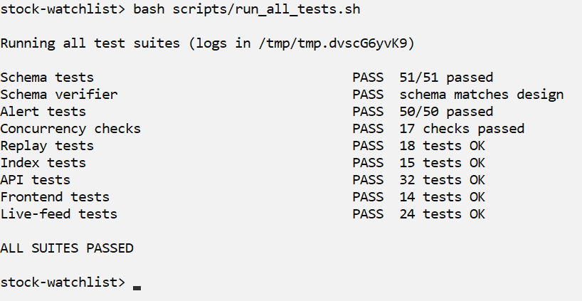
Screenshot R3_04
Explanation: scripts/run_all_tests.sh runs all 9 suites one after another and stops at the first failure. Every suite passed: schema tests 51/51, schema verifier, alert tests 50/50, concurrency 17, replay 18, index 15, API 32, frontend 14 and live feed 24. (This run was on Windows, where the two SQL test files send their hidden output to NUL instead of /dev/null.)

Working Modules of the Project (Web Application)
The web application has six modules: Dashboard, Watchlists, Alert Rules, Alert History, Instruments and Demo (manual tick). The browser only sends requests to FastAPI; all the data rules (keys, checks, the alert trigger) run inside PostgreSQL. The screenshots below were taken in this order as user arjun, right after the replay in R3_02.
UI01 – Dashboard
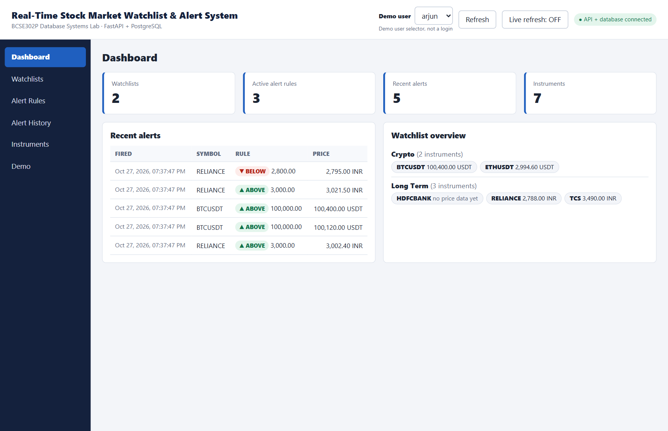
Screenshot UI01
Input: Choose the demo user (arjun) at the top. 'Refresh' and 'Live refresh' re-read the data.
Output: Counts of watchlists, active rules, recent alerts and instruments, the 5 latest alerts, and every watchlist with the latest price of each instrument (HDFCBANK has no price yet).
UI02 – Watchlists: create a watchlist and add instruments
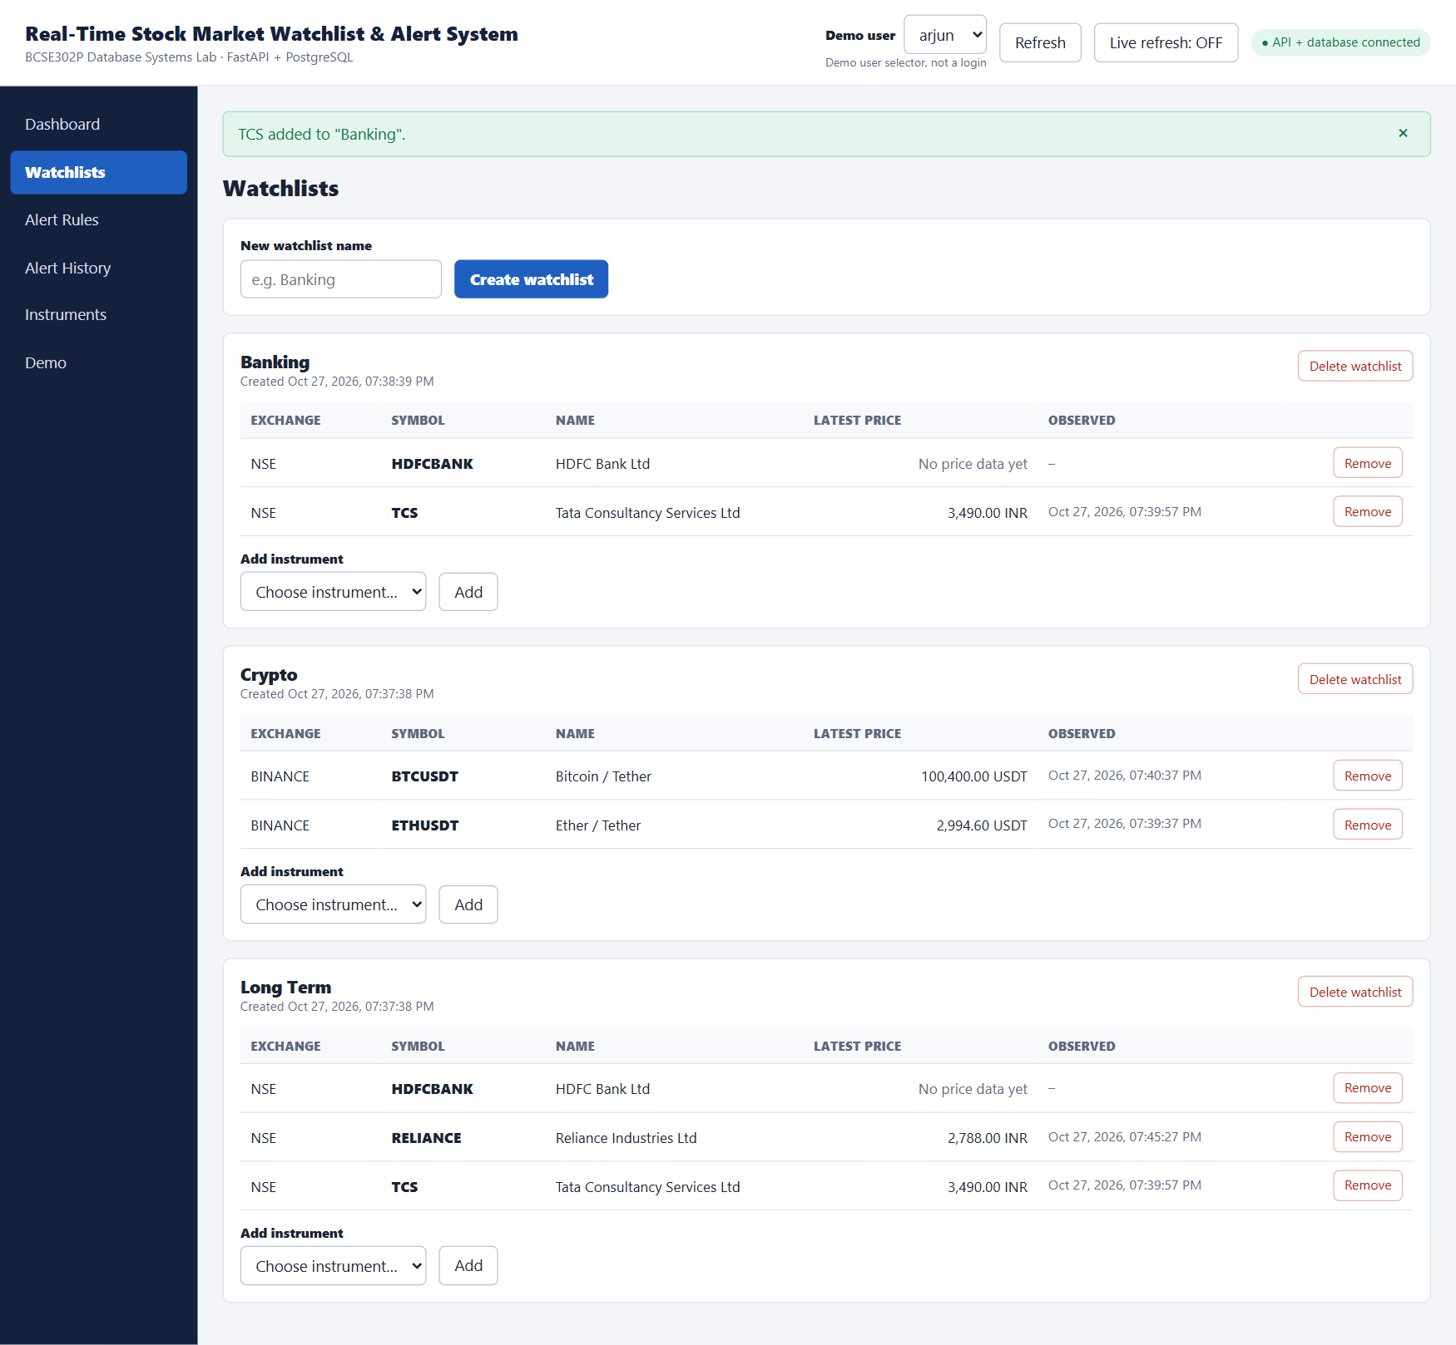
Screenshot UI02
Input: Name 'Banking' → Create watchlist; then 'Add instrument' HDFCBANK and TCS.
Output: The new watchlist with its 2 instruments and their latest prices. Each list can be deleted, and each instrument can be removed.
UI03 – Watchlists: a duplicate name is rejected
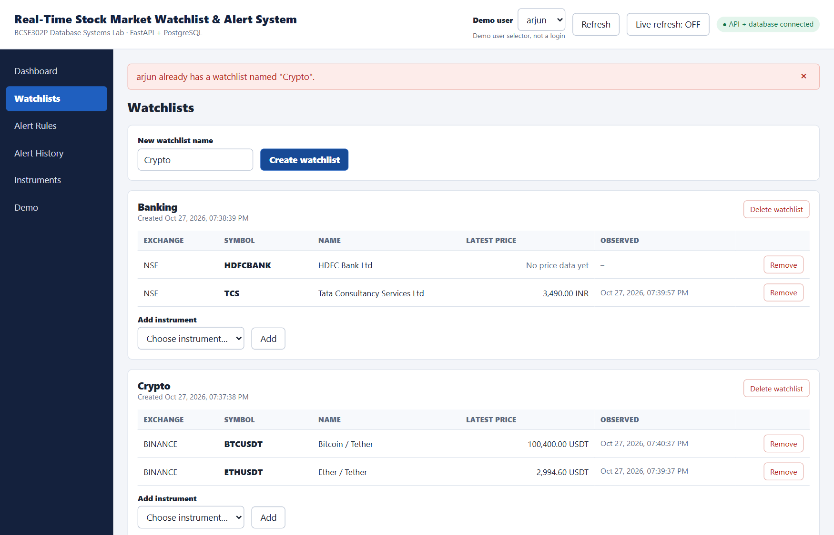
Screenshot UI03
Input: Create another watchlist called 'Crypto' for arjun, who already has one.
Output: The message 'arjun already has a watchlist named "Crypto"'. It comes from the UNIQUE (user_id, name) constraint in PostgreSQL. The API returns it as HTTP 409 and the page shows it as a readable message.
UI04 – Alert Rules: create a rule
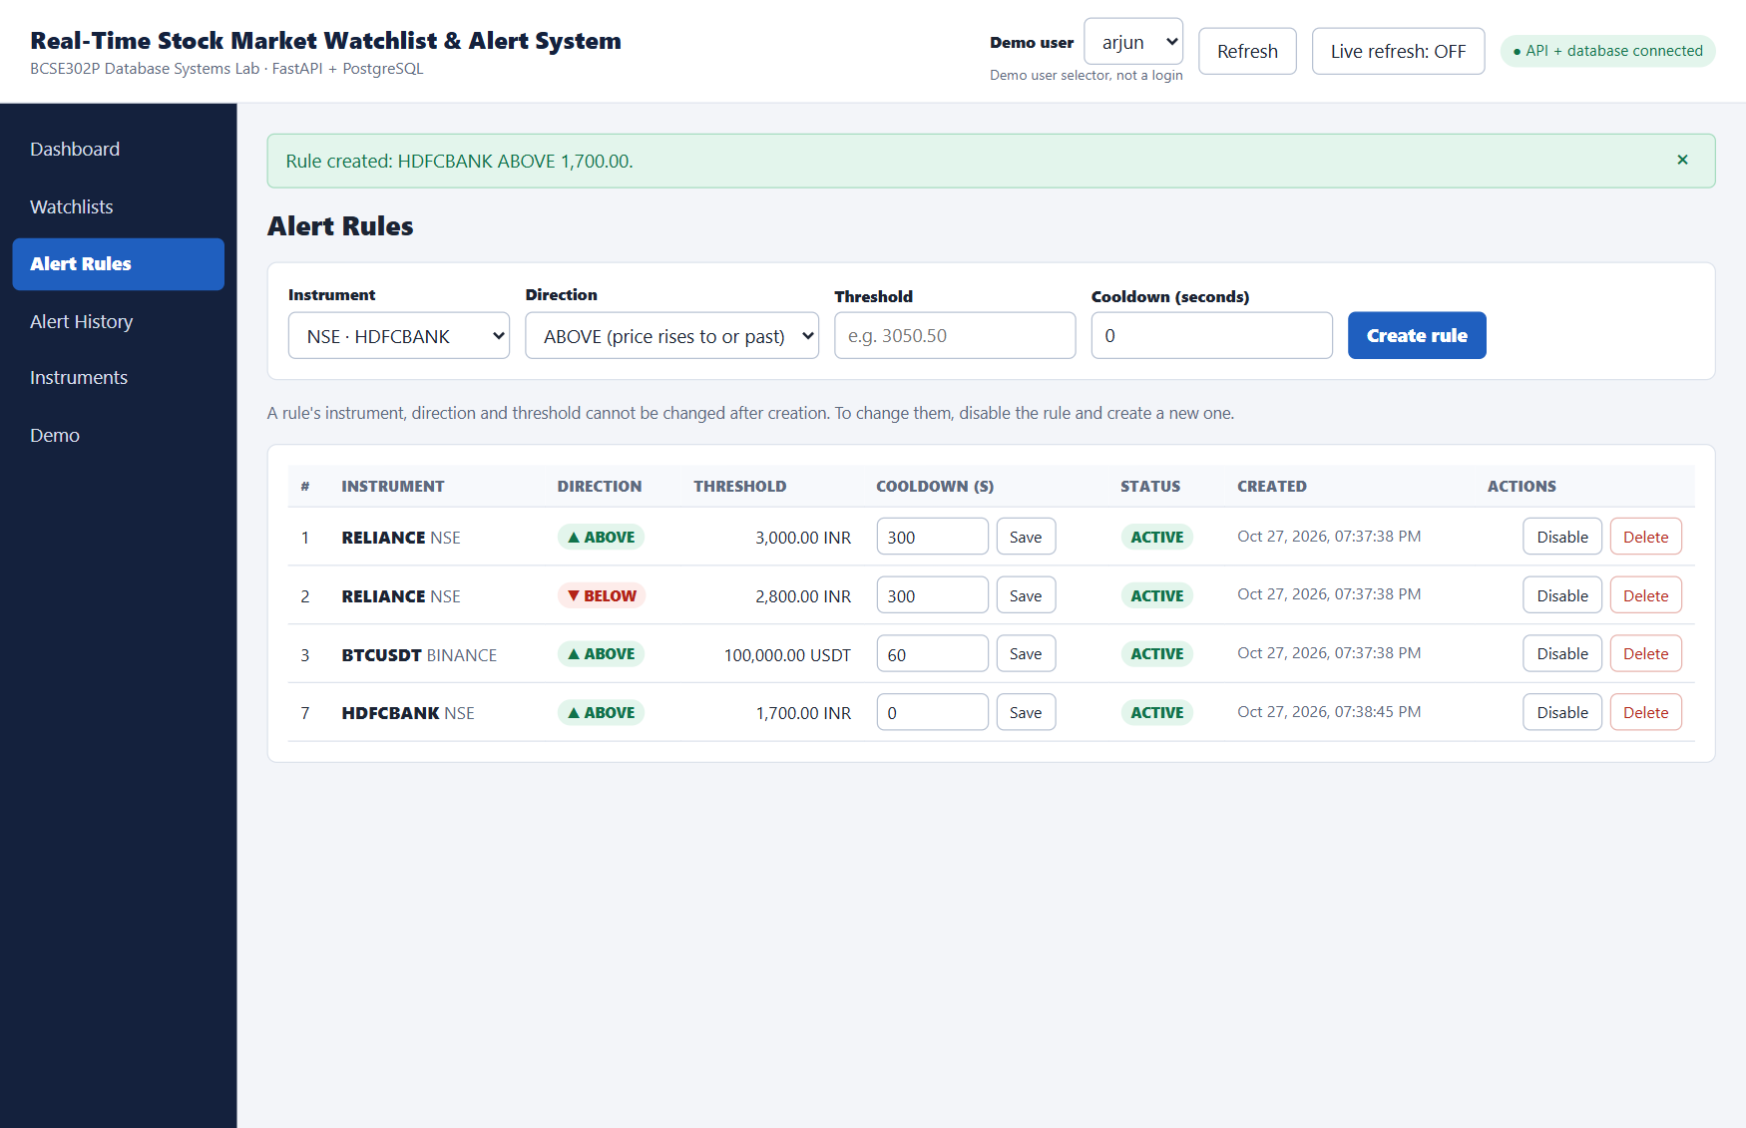
Screenshot UI04
Input: Instrument NSE · HDFCBANK, direction ABOVE, threshold 1700, cooldown 0 → Create rule.
Output: Rule #7 appears in the list as ACTIVE. Each rule can be disabled/enabled, its cooldown changed, or deleted. Instrument, direction and threshold cannot be edited (disable and create a new rule instead).
UI05 – Demo: manual tick that does not cross
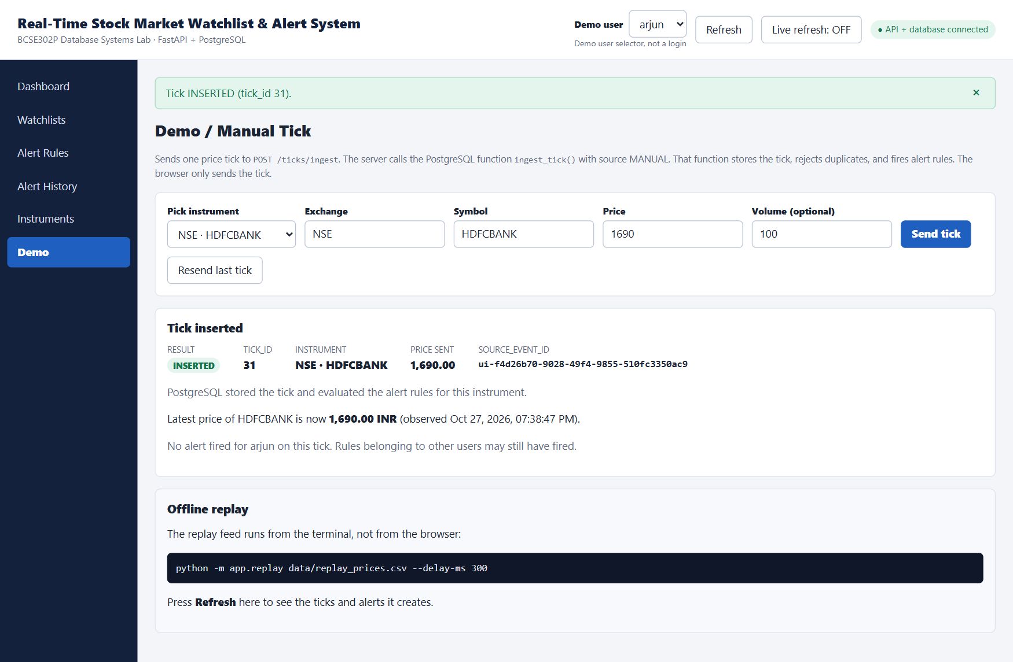
Screenshot UI05
Input: Pick HDFCBANK, price 1690, volume 100 → Send tick.
Output: Result INSERTED with its tick_id. This is the first HDFCBANK price, so there is no previous price and no alert.
UI06 – Demo: manual tick that fires an alert (trigger)
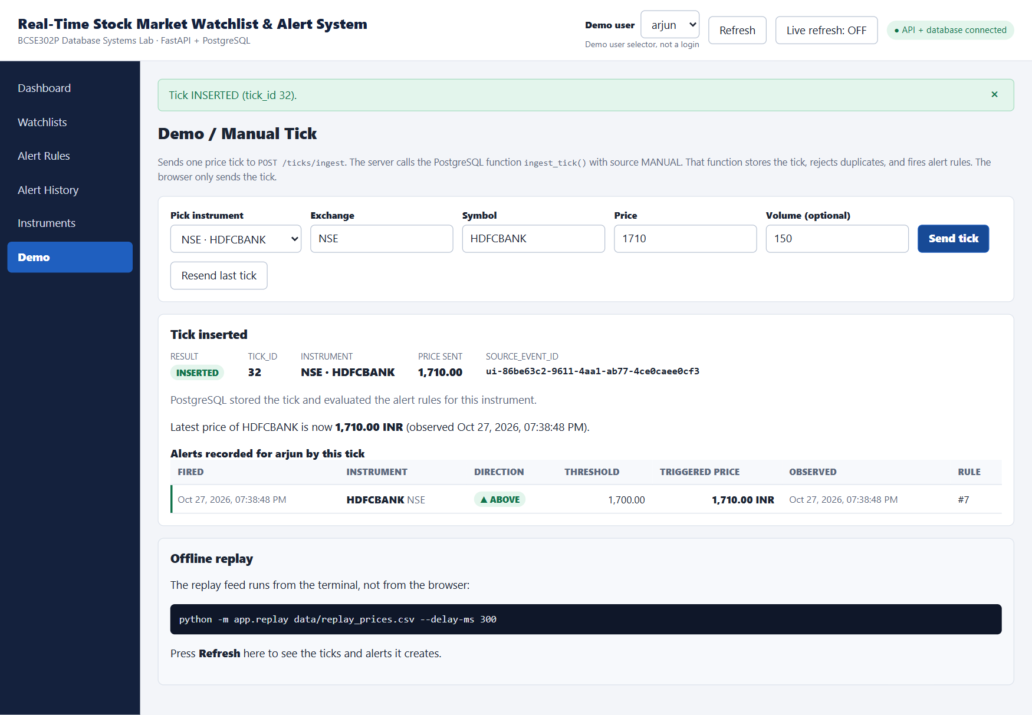
Screenshot UI06
Input: Same instrument, price 1710, volume 150 → Send tick.
Output: Tick 32 INSERTED. The price moved from 1690 to 1710 and crossed 1700, so the trigger recorded an alert for rule #7. The page shows the new alert row.
UI07 – Demo: the same tick sent again
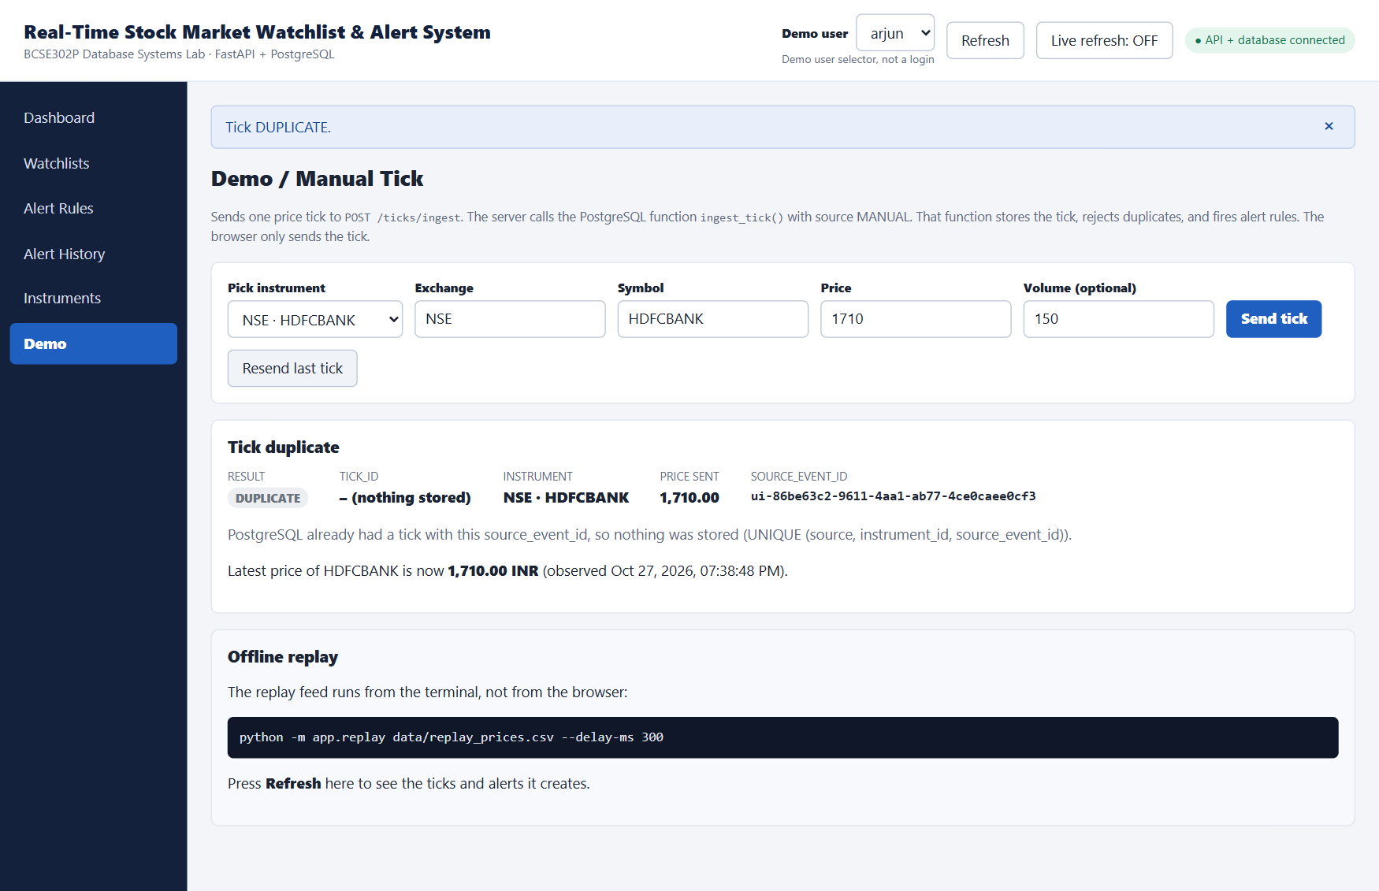
Screenshot UI07
Input: Resend last tick (same source_event_id).
Output: Result DUPLICATE, nothing stored, no second alert.
UI08 – Alert History
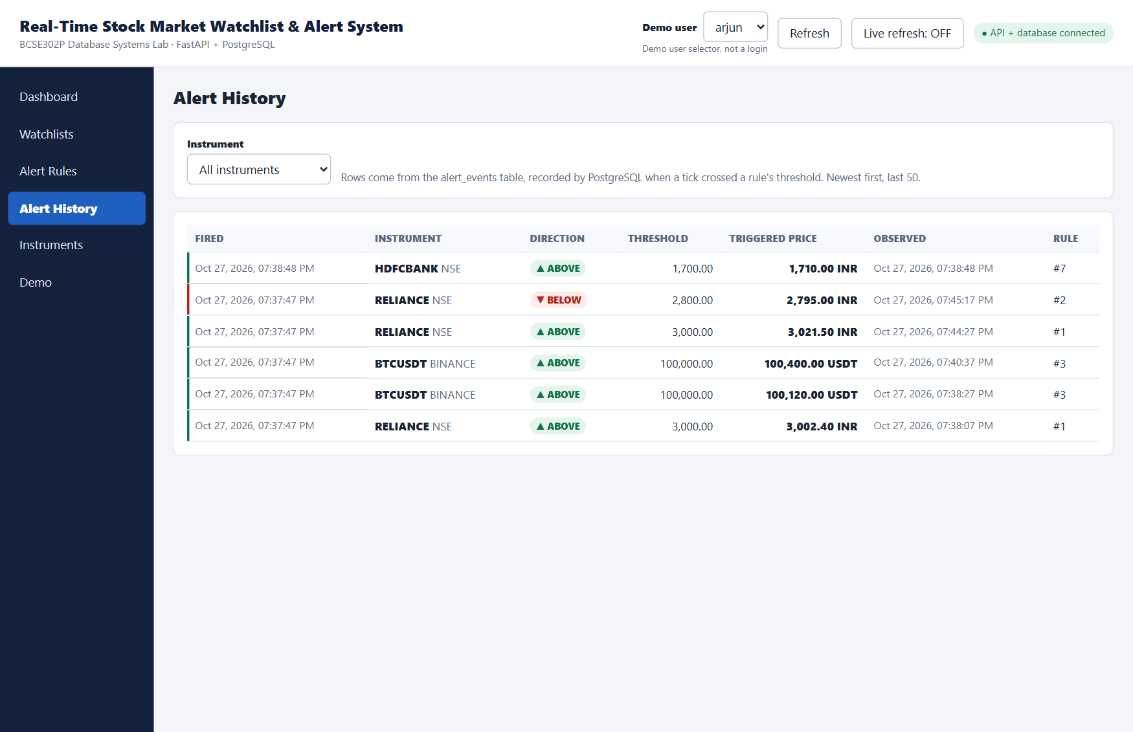
Screenshot UI08
Input: Open Alert History; optionally filter by instrument.
Output: arjun's alerts from alert_events joined with the rule and the tick: time fired, instrument, direction, threshold, the price that triggered it and the rule number, newest first.
UI09 – Instruments: search, latest price and price history
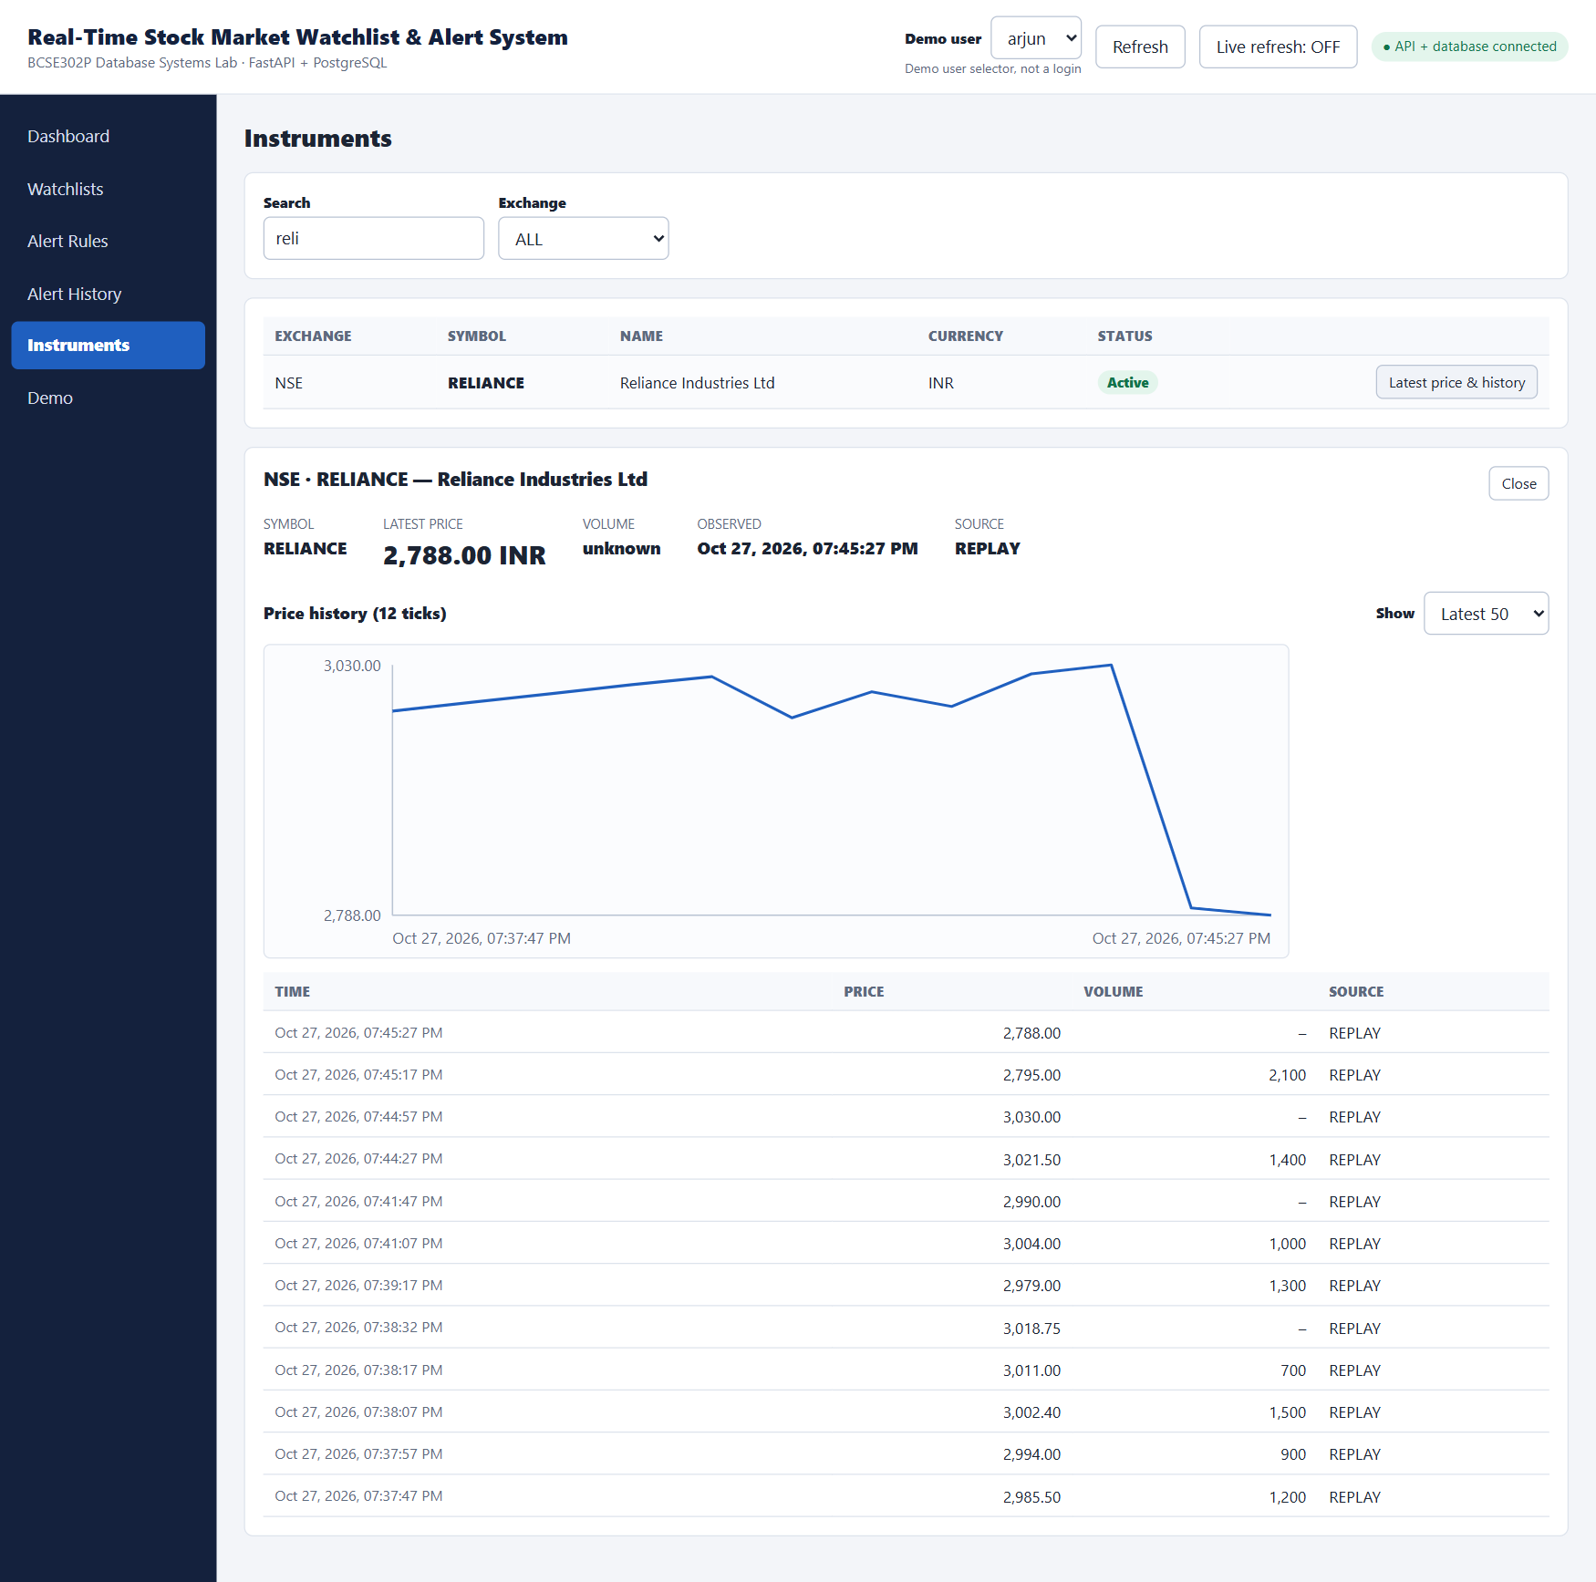
Screenshot UI09
Input: Type 'reli' in Search, then click 'Latest price & history' for RELIANCE.
Output: The latest price (2,788.00 INR), a price chart and the list of ticks, newest first. This page uses the latest-price and history queries that the index ix_price_ticks_instrument_time speeds up.
UI10 – Dashboard after the demo
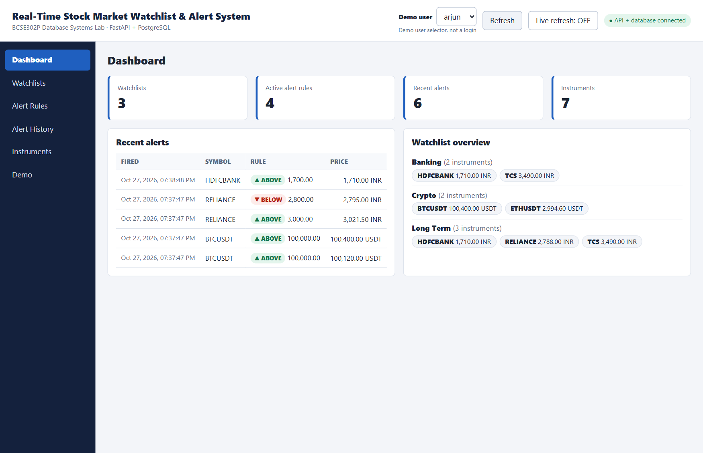
Screenshot UI10
Input: Return to Dashboard and press Refresh.
Output: 3 watchlists (with Banking), 4 active rules and the new HDFCBANK alert at the top.
UI11 – API documentation
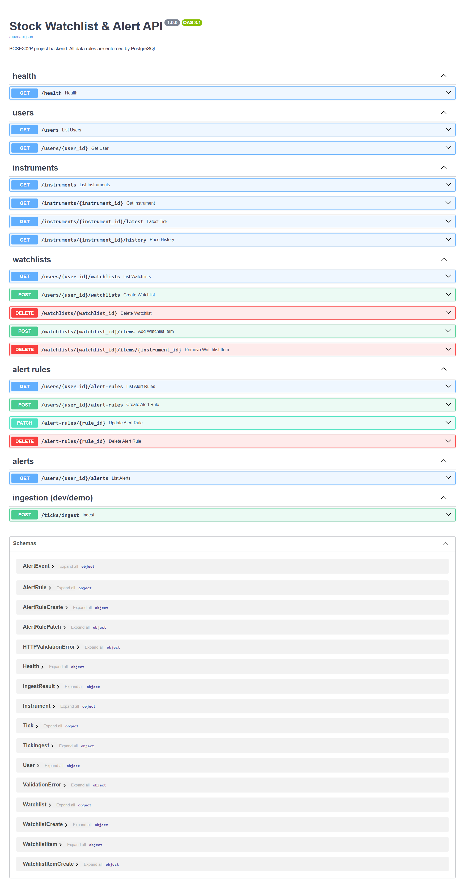
Screenshot UI11
Input: Open http://127.0.0.1:8000/docs.
Output: FastAPI's automatic page listing all endpoints. Each one can be tried from the browser.

Design Changes Since Review 2
Change | Reason
ER diagram redrawn: plain lines without arrows; Watchlist_item replaced by the M : N relationship CONTAINS (with added_at); join-only (foreign-key) attributes removed. | Review 2 feedback. The new diagram follows Chen notation and shows only real attributes of each entity.
Added Review 3 evidence: clean build, concurrency demo (scripts/review3_concurrency_demo.py), full test run and screenshots of all web modules. | Review 3 asks for concurrency, testing (≥ 15 cases), a live demo and screenshots of all working modules.
No change to the tables, constraints, functions or triggers. | The 7 tables were already in BCNF with 36 named constraints; the ER fixes are drawing corrections, not database changes.

Work break down
Team Member Registration Number | Name | Work Assigned
24BCE0372 | Aditi Bajpai | [to be filled by the team]
24BCE0378 | Arshmeet Kaur Marhala | [to be filled by the team]
24BCE0825 | Yatharth Tongia | [to be filled by the team]

REVIEW EVALUATION
COMPONENT | MARKS | Aditi | Arshmeet | Yatharth
Project work with screenshot | 5
Viva | 5
TOTAL | 10 MARKS

